**Project: UMR Portals**

***Preface***

*This document is an overview on the detailed automated healthcare system of Universal Medical Records institution. Variety of features like user information, user management, patient records, patient demographics, enroll providers, enroll patients etc. are thoroughly described in here. Three basic users of this application are Admin, Doctor and Nurse who can work with their own limitations. Uniform Resource Locator is also added here to navigate to all features directly.*

*If a child window is opened using frame source link, then there will be error.*

**Link:** [**http://umrtest.com/UMRPortals/LogIn.aspx**](http://umrtest.com/UMRPortals/LogIn.aspx)

**Username: admin**

**Pass: Admin#123**

**Done by: UMR QA Team**

***Index***

|  |  |  |  |
| --- | --- | --- | --- |
| **SL** | Uniform Resource Locator | **Feature Name** | **Page No** |
| 1 | <http://umrtest.com/UMRPortals/LogIn.aspx> | [Login](http://umrtest.com/UMRPortals/LogIn.aspx) | 4 |
| 2 | <http://umrtest.com/UMRPortals/SignUp/SignUp.aspx> | [Provider Enrollment](http://umrtest.com/UMRPortals/SignUp/SignUp.aspx) | 5 |
| 3 | <http://umrtest.com/UMRPortals/SignUp/SignUpPatient.aspx> | [Patient Enrollment](http://umrtest.com/UMRPortals/SignUp/SignUpPatient.aspx) | 6 |
| 4 | <http://umrtest.com/UMRPortals/ResetPassword/PasswordReset.aspx> | [Forgot Your Password](http://umrtest.com/UMRPortals/ResetPassword/PasswordReset.aspx) | 6 |
| 5 | <http://umrtest.com/UMRPortals/Home/Default.aspx> | [Admin Home](http://umrtest.com/UMRPortals/Home/Default.aspx) | 7 |
| 6 | <http://umrtest.com/UMRPortals/Account/Register.aspx> | [User Information](http://umrtest.com/UMRPortals/Account/Register.aspx) | 8 |
| 7 | <http://umrtest.com/UMRPortals/Administrative/UserSettings.aspx> | [User Settings](http://umrtest.com/UMRPortals/Administrative/UserSettings.aspx) | 8 |
| 8 | <http://umrtest.com/UMRPortals/Account/ChangePassword.aspx> | [Change Password](http://umrtest.com/UMRPortals/Account/ChangePassword.aspx) | 9 |
| 9 | <http://umrtest.com/UMRPortals/Administrative/UserManagement.aspx> | [User Management](http://umrtest.com/UMRPortals/Administrative/UserManagement.aspx) | 10 |
| 10 | <http://umrtest.com/UMRPortals/Administrative/GroupManagement.aspx> | [Group Management](http://umrtest.com/UMRPortals/Administrative/GroupManagement.aspx) | 11 |
| 11 | <http://umrtest.com/UMRPortals/Administrative/Usages.aspx> | [Usage History](http://umrtest.com/UMRPortals/Administrative/Usages.aspx) | 11 |
| 12 | <http://umrtest.com/UMRPortals/PatientFeatures/ProviderCalendar.aspx> | [Calendar](http://umrtest.com/UMRPortals/PatientFeatures/ProviderCalendar.aspx) | 12 |
| 13 | <http://umrtest.com/UMRPortals/PatientFeatures/PatientFeaturesSearch.aspx> | [Patient Records](http://umrtest.com/UMRPortals/PatientFeatures/PatientFeaturesSearch.aspx) | 13 |
| 13.1 | <http://umrtest.com/UMRPortals/PatientFeatures/PatientFeaturesPop.aspx?PatientKey=3> | [Medical History Index](http://umrtest.com/UMRPortals/PatientFeatures/PatientFeaturesPop.aspx?PatientKey=3) | 13 |
| 13.1.1 | <http://umrtest.com/UMRPortals/PatientFeatures/MPI.aspx?PatientKey=3> | [Master Patient Code Indexes](http://umrtest.com/UMRPortals/PatientFeatures/MPI.aspx?PatientKey=3) | 14 |
| 13.1.1.1 | <http://umrtest.com/UMRPortals/PatientFeatures/ViewMedcodeHistory.aspx?MedcodeGUID=26a9b6ec-d1ca-410a-984a-5e433007f131> | [Medcode History](http://umrtest.com/UMRPortals/PatientFeatures/ViewMedcodeHistory.aspx?MedcodeGUID=26a9b6ec-d1ca-410a-984a-5e433007f131) | 14 |
| 13.1.1.2 | <http://umrtest.com/UMRPortals/PatientFeatures/MPI.aspx?PatientKey=3> | [Related Disciplines](http://umrtest.com/UMRPortals/PatientFeatures/MPI.aspx?PatientKey=3) | 14 |
| 13.1.1.3 | <http://umrtest.com/UMRPortals/PatientFeatures/ProviderDetails.aspx?ID=21&DispType=S&HasCode=true&Code=99446&Type=CPT-4&Version=2015&CodeDate=1/8/2015%202:00:21%20PM&PatientKey=3&InstituteCode=UMHLD&DoctorID=211> | [Provider Locator](http://umrtest.com/UMRPortals/PatientFeatures/ProviderDetails.aspx?ID=21&DispType=S&HasCode=true&Code=99446&Type=CPT-4&Version=2015&CodeDate=1/8/2015%202:00:21%20PM&PatientKey=3&InstituteCode=UMHLD&DoctorID=211) | 15 |
| 13.1.1.4 | <http://umrtest.com/UMRPortals/PatientFeatures/InstitutionDetails.aspx?code=10004&PatientKey=3&HasCodeSingle=true&CodeMEDNDC=847.9&Type=ICD-9-CM&Version=2014&DoctorID=13&CodeDate=1/1/2008%2012:00:00%20AM&IsLP=1> | [Facility Locator](http://umrtest.com/UMRPortals/PatientFeatures/InstitutionDetails.aspx?code=10004&PatientKey=3&HasCodeSingle=true&CodeMEDNDC=847.9&Type=ICD-9-CM&Version=2014&DoctorID=13&CodeDate=1/1/2008%2012:00:00%20AM&IsLP=1) | 15 |
| 13.1.1.5 | <http://umrtest.com/UMRPortals/PatientFeatures/RDDetails.aspx?PatientKey=3&medCode=99446&disType=D&name=Test&desc=Test&rwndrnd=0.6989118887650952> | [Diagnosis Details](http://umrtest.com/UMRPortals/PatientFeatures/RDDetails.aspx?PatientKey=3&medCode=99446&disType=D&name=Test&desc=Test&rwndrnd=0.6989118887650952) | 16 |
| 13.1.1.6 | <http://umrtest.com/UMRPortals/AlertNetwork/ViewProviderSoap.aspx?AlertId=171063> | [S.O.A.P. Details](http://umrtest.com/UMRPortals/AlertNetwork/ViewProviderSoap.aspx?AlertId=171063) | 16 |
| 13.1.1.7 | <http://umrtest.com/UMRPortals/PatientFeatures/RDDetails.aspx?PatientKey=3&disType=N&name=NAPROXEN%20500MG%20TABLET&NDCCode=00378045105&ProviderID=13-LP&InstituteID=10004> | [Prescription and Medication Details](http://umrtest.com/UMRPortals/PatientFeatures/RDDetails.aspx?PatientKey=3&disType=N&name=NAPROXEN%20500MG%20TABLET&NDCCode=00378045105&ProviderID=13-LP&InstituteID=10004) | 17 |
| 13.1.1.8 | <http://umrtest.com/UMRPortals/PatientFeatures/RefillDetails.aspx?PatientKey=3&UMR_NDC_ID=b6e37e79-5e9a-4d40-9bb1-58253575ac3f&IsLP=1&ProviderID=13> | [Refill Details](http://umrtest.com/UMRPortals/PatientFeatures/RefillDetails.aspx?PatientKey=3&UMR_NDC_ID=b6e37e79-5e9a-4d40-9bb1-58253575ac3f&IsLP=1&ProviderID=13) | 17 |
| 13.1.1.9 | <http://umrtest.com/UMRPortals/PatientFeatures/InstituteWiseServiceList.aspx?code=UMHLD&PatientKey=3> | [Service List](http://umrtest.com/UMRPortals/PatientFeatures/InstituteWiseServiceList.aspx?code=UMHLD&PatientKey=3) | 18 |
| 13.1.1.10 | <http://umrtest.com/UMRPortals/PatientFeatures/MPI.aspx?PatientKey=3> | [Filter](http://umrtest.com/UMRPortals/PatientFeatures/MPI.aspx?PatientKey=3) | 18 |
| 13.1.1.11 | <http://umrtest.com/UMRPortals/PatientFeatures/MPI.aspx?PatientKey=3> | [Clear](http://umrtest.com/UMRPortals/PatientFeatures/MPI.aspx?PatientKey=3) | 19 |
| 13.1.1.12 | <http://umrtest.com/UMRPortals/PatientFeatures/MPIFax.aspx?PatientKey=3&PageCount=10&filterText=> | [Fax](http://umrtest.com/UMRPortals/PatientFeatures/MPIFax.aspx?PatientKey=3&PageCount=10&filterText=) | 19 |
| 13.1.1.13 | <http://umrtest.com/UMRPortals/PatientFeatures/MPIEmail.aspx?PatientKey=3&PageCount=10&filterText=> | [Email](http://umrtest.com/UMRPortals/PatientFeatures/MPIEmail.aspx?PatientKey=3&PageCount=10&filterText=) | 19 |
| 13.1.1.14 | <http://umrtest.com/UMRPortals/PatientFeatures/MPIPrintRange.aspx?PatientKey=3&PageCount=10&filterText=> | [Print](http://umrtest.com/UMRPortals/PatientFeatures/MPIPrintRange.aspx?PatientKey=3&PageCount=10&filterText=) | 20 |
| 13.1.2 | <http://umrtest.com/UMRPortals/PatientFeatures/LRA.aspx?PatientKey=3> | [Last Record Accessed Details](http://umrtest.com/UMRPortals/PatientFeatures/LRA.aspx?PatientKey=3) | 21 |
| 13.1.2.1 | <http://umrtest.com/UMRPortals/PatientFeatures/UserDetails.aspx?UserName=10091&AccessTime=4/4/2017%209:03:53%20AM> | [Accessor Details](http://umrtest.com/UMRPortals/PatientFeatures/UserDetails.aspx?UserName=10091&AccessTime=4/4/2017%209:03:53%20AM) | 21 |
| 13.1.2.2 | <http://umrtest.com/UMRPortals/PatientFeatures/InstitutionProvidersCodes.aspx?code=UMHLD&PatientKey=3> | [Service History](http://umrtest.com/UMRPortals/PatientFeatures/InstitutionProvidersCodes.aspx?code=UMHLD&PatientKey=3) | 21 |
| 13.1.2.3 | <http://umrtest.com/UMRPortals/PatientFeatures/LRA.aspx?PatientKey=3> | [Filter](http://umrtest.com/UMRPortals/PatientFeatures/MPI.aspx?PatientKey=3) | 22 |
| 13.1.2.4 | <http://umrtest.com/UMRPortals/PatientFeatures/LRAPrintRange.aspx?PatientKey=3&PageCount=353> | [Print](http://umrtest.com/UMRPortals/PatientFeatures/LRAPrintRange.aspx?PatientKey=3&PageCount=353) | 22 |
| 13.1.3 | <http://umrtest.com/UMRPortals/PatientFeatures/UnRD.aspx?PatientKey=3> | [Unremarkable Disciplines](http://umrtest.com/UMRPortals/PatientFeatures/UnRD.aspx?PatientKey=3) | 23 |
| 13.1.3.1 | <http://umrtest.com/UMRPortals/PatientFeatures/UnRD.aspx?PatientKey=3> | [Print](http://umrtest.com/UMRPortals/PatientFeatures/UnRD.aspx?PatientKey=3) | 23 |
| 13.1.3.2 | <http://umrtest.com/UMRPortals/PatientFeatures/Fax.aspx> | [Fax](http://umrtest.com/UMRPortals/PatientFeatures/Fax.aspx) | 23 |
| 13.1.3.3 | <http://umrtest.com/UMRPortals/PatientFeatures/Email.aspx> | [Email](http://umrtest.com/UMRPortals/PatientFeatures/Email.aspx) | 24 |
| 13.1.4 | <http://umrtest.com/UMRPortals/PatientFeatures/MultiProviderListDetails.aspx?PatientKey=3&DispType=M> | [Healthcare Providers](http://umrtest.com/UMRPortals/PatientFeatures/MultiProviderListDetails.aspx?PatientKey=3&DispType=M) | 24 |
| 13.1.5 | <http://umrtest.com/UMRPortals/PatientFeatures/AncilliaryHealthCareProviderList.aspx?PatientKey=3> | [Ancillary Healthcare Providers](http://umrtest.com/UMRPortals/PatientFeatures/AncilliaryHealthCareProviderList.aspx?PatientKey=3) | 25 |
| 13.1.6 | <http://umrtest.com/UMRPortals/PatientFeatures/AssociatedAncProvList.aspx?PatientKey=3> | [Ancillary Network Contacts](http://umrtest.com/UMRPortals/PatientFeatures/AssociatedAncProvList.aspx?PatientKey=3) | 25 |
| 13.1.7 | <http://umrtest.com/UMRPortals/PatientFeatures/HealthcareFacilities.aspx?PatientKey=3> | [Healthcare Facilities](http://umrtest.com/UMRPortals/PatientFeatures/HealthcareFacilities.aspx?PatientKey=3) | 26 |
| 13.1.8 | <http://umrtest.com/UMRPortals/PatientFeatures/AMD.aspx?PatientKey=3> | [Advanced Medical Directives](http://umrtest.com/UMRPortals/PatientFeatures/AMD.aspx?PatientKey=3) | 26 |
| 13.1.8.1 | <http://umrtest.com/UMRPortals/DataRecord/Report/MOLSTReport.aspx?PatientKey=3> | [MOLST Report](http://umrtest.com/UMRPortals/DataRecord/Report/MOLSTReport.aspx?PatientKey=3) | 27 |
| 13.1.8.2 | <http://umrtest.com/UMRPortals/DataRecord/Report/MOLSTReport.aspx?PatientKey=3> | [MOLST Report - Show](http://umrtest.com/UMRPortals/Telerik.ReportViewer.axd?instanceID=1b2bfaec1b1f4cc0b1f2f857164859e4&optype=Report&PageIndex=0&RenderID=1a96b7333c46426a8fa91816d7011487&RenderingFormat=HTML5Interactive) | 27 |
| 13.1.8.3 | <http://umrtest.com/UMRPortals/PatientFeatures/AMDEditor.aspx?PatientKey=3> | [Advanced Medical Directives Editor](http://umrtest.com/UMRPortals/PatientFeatures/AMDEditor.aspx?PatientKey=3) | 28 |
| 13.1.8.4 | <http://umrtest.com/UMRPortals/DataRecord/PatientMOLSTViewer.aspx?PatientKey=3> | [MOLST](http://umrtest.com/UMRPortals/DataRecord/PatientMOLSTViewer.aspx?PatientKey=3) | 28 |
| 13.1.9 | <http://umrtest.com/UMRPortals/PatientFeatures/Emergency.aspx?PatientKey=3> | [Emergency Information](http://umrtest.com/UMRPortals/PatientFeatures/Emergency.aspx?PatientKey=3) | 28 |
| 13.1.10 | <http://umrtest.com/UMRPortals/AlertNetwork/AlertChronologyList.aspx?PatientKey=3> | [S.O.A.P. Chronology](http://umrtest.com/UMRPortals/AlertNetwork/AlertChronologyList.aspx?PatientKey=3) | 29 |
| 13.1.10.1 | <http://umrtest.com/UMRPortals/AlertNetwork/ViewAssessmentDetails.aspx?AlertId=171058> | [Assessment](http://umrtest.com/UMRPortals/AlertNetwork/ViewAssessmentDetails.aspx?AlertId=171058) | 29 |
| 13.1.10.2 | <http://umrtest.com/UMRPortals/AlertNetwork/ViewTreatmentDetails.aspx?AlertId=171058> | [Treatment](http://umrtest.com/UMRPortals/AlertNetwork/ViewTreatmentDetails.aspx?AlertId=171058) | 29 |
| 13.1.10.3 | <http://umrtest.com/UMRPortals/AlertNetwork/AlertHistory.aspx?AlertId=171058> | [Alert History](http://umrtest.com/UMRPortals/AlertNetwork/AlertHistory.aspx?AlertId=171058) | 30 |
| 13.1.11 | <http://umrtest.com/UMRPortals/PatientFeatures/Demographic.aspx?PatientKey=3> | [Patient Demographics](http://umrtest.com/UMRPortals/PatientFeatures/Demographic.aspx?PatientKey=3) | 30 |
| 13.1.12 | <http://umrtest.com/UMRPortals/PatientFeatures/Insurance.aspx?PatientKey=3> | [Insurance Information](http://umrtest.com/UMRPortals/PatientFeatures/Insurance.aspx?PatientKey=3) | 31 |
| 13.1.13 | <http://umrtest.com/UMRPortals/PatientFeatures/PatientSchedule.aspx?PatientKey=3> | [Patient Schedule](http://umrtest.com/UMRPortals/PatientFeatures/PatientSchedule.aspx?PatientKey=3) | 31 |
| 13.1.14 | <http://umrtest.com/UMRPortals/PatientFeatures/Legend.aspx?PatientKey=3> | [Legend](http://umrtest.com/UMRPortals/PatientFeatures/Legend.aspx?PatientKey=3) | 32 |
| 13.1.15 | <http://umrtest.com/UMRPortals/PatientFeatures/Disclaimer.aspx> | [Disclaimer](http://umrtest.com/UMRPortals/PatientFeatures/Disclaimer.aspx) | 32 |
| 13.1.16 | <http://umrtest.com/UMRPortals/PatientFeatures/RDNew.aspx?PatientKey=3&DisCode=9&DisType=D&DisName=Gastroenterology&CodeType=(CODE_TYPE=@1@%20OR%20CODE_TYPE=@2@%20OR%20CODE_TYPE=@3@%20OR%20CODE_TYPE=@5@)> | [Remarkable Disciplines](http://umrtest.com/UMRPortals/PatientFeatures/RDNew.aspx?PatientKey=3&DisCode=9&DisType=D&DisName=Gastroenterology&CodeType=(CODE_TYPE=@1@%20OR%20CODE_TYPE=@2@%20OR%20CODE_TYPE=@3@%20OR%20CODE_TYPE=@5@)) | 33 |
| 13.1.17 | <http://umrtest.com/UMRPortals/PatientFeatures/PrintPreview.aspx?PatientKey=3&SelectedCodeIndex=0,1,2,4> | [Preview](http://umrtest.com/UMRPortals/PatientFeatures/PrintPreview.aspx?PatientKey=3&SelectedCodeIndex=0,1,2,4) | 34 |
| 13.2 | <http://umrtest.com/UMRPortals/PatientFeatures/SOAPSelectionWindow.aspx?UserId=10967&PatientKey=3&LastIncompleteStatus=false> | [S.O.A.P. Entry/Edit Selection-1](http://umrtest.com/UMRPortals/PatientFeatures/SOAPSelectionWindow.aspx?UserId=10967&PatientKey=3&LastIncompleteStatus=false) | 35 |
| 13.2.1 | <http://umrtest.com/UMRPortals/AlertNetwork/ProviderNotesPop.aspx?PatientKey=3> | [S.O.A.P. Entry/Edit Selection-2](http://umrtest.com/UMRPortals/AlertNetwork/ProviderNotesPop.aspx?PatientKey=3) | 35 |
| 13.2.2 | <http://umrtest.com/UMRPortals/AlertNetwork/ProviderNotesPop.aspx?AlertIdToEdit=171065> | [S.O.A.P. Entry/Edit Selection-3](http://umrtest.com/UMRPortals/AlertNetwork/ProviderNotesPop.aspx?AlertIdToEdit=171065) | 35 |
| 13.2.3 | <http://umrtest.com/UMRPortals/AlertNetwork/ProviderNotesPop.aspx?AlertIdToEdit=171065> | [S.O.A.P. Entry/Edit Selection-4](http://umrtest.com/UMRPortals/AlertNetwork/ProviderNotesPop.aspx?AlertIdToEdit=171065) | 36 |
| 13.2.4 | <http://umrtest.com/UMRPortals/AlertNetwork/ProviderNotesPop.aspx?AlertIdToEdit=171065> | [S.O.A.P. Entry/Edit Selection-5](http://umrtest.com/UMRPortals/AlertNetwork/ProviderNotesPop.aspx?AlertIdToEdit=171065) | 36 |
| 13.2.5 | <http://umrtest.com/UMRPortals/AlertNetwork/ProviderNotesPop.aspx?AlertIdToEdit=171065> | [S.O.A.P. Entry/Edit Selection-6](http://umrtest.com/UMRPortals/AlertNetwork/ProviderNotesPop.aspx?AlertIdToEdit=171065) | 36 |
| 13.2.6 | <http://umrtest.com/UMRPortals/AlertNetwork/ProviderNotesPop.aspx?AlertIdToEdit=171065> | [S.O.A.P. Entry/Edit Selection-7](http://umrtest.com/UMRPortals/AlertNetwork/ProviderNotesPop.aspx?AlertIdToEdit=171065) | 36 |
| 14 | <http://umrtest.com/UMRPortals/PatientFeatures/PatientFeatures.aspx> | [Record Viewer](http://umrtest.com/UMRPortals/PatientFeatures/PatientFeatures.aspx) | 37 |
| 15 | <http://umrtest.com/UMRPortals/DataRecord/PatientDemographics.aspx> | [Demographics >> Additional Information](http://umrtest.com/UMRPortals/DataRecord/PatientDemographics.aspx) | 37 |
| 15.1 | <http://umrtest.com/UMRPortals/DataRecord/PatientDemographics.aspx> | [Demographics–Address](http://umrtest.com/UMRPortals/DataRecord/PatientDemographics.aspx) | 38 |
| 15.2 | <http://umrtest.com/UMRPortals/DataRecord/PatientDemographics.aspx> | [Demographics–Phone](http://umrtest.com/UMRPortals/DataRecord/PatientDemographics.aspx) | 38 |
| 15.3 | <http://umrtest.com/UMRPortals/DataRecord/PatientDemographics.aspx> | [Demographics-Education](http://umrtest.com/UMRPortals/DataRecord/PatientDemographics.aspx) | 39 |
| 15.4 | <http://umrtest.com/UMRPortals/DataRecord/PatientDemographics.aspx> | [Demographics–Employment](http://umrtest.com/UMRPortals/DataRecord/PatientDemographics.aspx) | 39 |
| 15.5 | <http://umrtest.com/UMRPortals/DataRecord/PatientDemographics.aspx> | [Demographics–Advanced Medical Directive](http://umrtest.com/UMRPortals/DataRecord/PatientDemographics.aspx) | 40 |
| 16 | <http://umrtest.com/UMRPortals/DataRecord/DemographicsViewer.aspx> | [Demographics Viewer](http://umrtest.com/UMRPortals/DataRecord/DemographicsViewer.aspx) | 41 |
| 16.1 | <http://umrtest.com/UMRPortals/DataRecord/DemographicsViewer.aspx> | [Demographics Viewer Show](http://umrtest.com/UMRPortals/DataRecord/DemographicsViewer.aspx) | 42 |
| 17 | <http://umrtest.com/UMRPortals/DataRecord/DemographicsEditor.aspx> | [Demographics Editor](http://umrtest.com/UMRPortals/DataRecord/DemographicsEditor.aspx) | 43 |
| 17.1 | <http://umrtest.com/UMRPortals/DataRecord/PatientDemographicsPop.aspx?PatientKey=3> | [Demographics Editor-Edit](http://umrtest.com/UMRPortals/DataRecord/PatientDemographicsPop.aspx?PatientKey=3) | 43 |
| 17.2 | <http://umrtest.com/UMRPortals/DataRecord/PatientDemographicsPop.aspx?PatientKey=3> | [Demographics Editor-Address](http://umrtest.com/UMRPortals/DataRecord/PatientDemographicsPop.aspx?PatientKey=3) | 43 |
| 17.3 | <http://umrtest.com/UMRPortals/DataRecord/PatientDemographicsPop.aspx?PatientKey=3> | [Demographics Editor-Phone](http://umrtest.com/UMRPortals/DataRecord/PatientDemographicsPop.aspx?PatientKey=3) | 44 |
| 17.4 | <http://umrtest.com/UMRPortals/DataRecord/PatientDemographicsPop.aspx?PatientKey=3> | [Demographics Editor-Education](http://umrtest.com/UMRPortals/DataRecord/PatientDemographicsPop.aspx?PatientKey=3) | 44 |
| 17.5 | <http://umrtest.com/UMRPortals/DataRecord/PatientDemographicsPop.aspx?PatientKey=3> | [Demographics Editor-Employment](http://umrtest.com/UMRPortals/DataRecord/PatientDemographicsPop.aspx?PatientKey=3) | 44 |
| 17.6 | <http://umrtest.com/UMRPortals/DataRecord/PatientDemographicsPop.aspx?PatientKey=3> | [Demographics Editor- Advanced Medical Directive](http://umrtest.com/UMRPortals/DataRecord/PatientDemographicsPop.aspx?PatientKey=3) | 44 |
| 17.7 | <http://umrtest.com/UMRPortals/DataRecord/PatientDemographicsPop.aspx?PatientKey=3> | [Demographics Editor-Photo Upload](http://umrtest.com/UMRPortals/DataRecord/PatientDemographicsPop.aspx?PatientKey=3) | 45 |
| 18 | <http://umrtest.com/UMRPortals/AlertNetwork/ProviderNotes.aspx> | [Alert Networks>>Create S.O.A.P. Notes](http://umrtest.com/UMRPortals/AlertNetwork/ProviderNotes.aspx) | 45 |
| 18.1 | <http://umrtest.com/UMRPortals/AlertNetwork/AlertNetworkManagement.aspx> | [Alert Networks>>Alert Management](http://umrtest.com/UMRPortals/AlertNetwork/AlertNetworkManagement.aspx) | 46 |
| 18..1.1 | <http://umrtest.com/UMRPortals/AlertNetwork/ViewProviderSoap.aspx?AlertId=171063> | [Alert Networks>>Alert Management-S.O.A.P Details](http://umrtest.com/UMRPortals/AlertNetwork/ViewProviderSoap.aspx?AlertId=171063) | 46 |
| 18.1.2 | <http://umrtest.com/UMRPortals/AlertNetwork/AlertHistory.aspx?AlertId=171063> | [Alert Networks>>Alert Management-View History](http://umrtest.com/UMRPortals/AlertNetwork/AlertHistory.aspx?AlertId=171063) | 47 |
| 18.1.3 | <http://umrtest.com/UMRPortals/AlertNetwork/Dispatcher.aspx?AlertId=171063> | [Alert Networks>>Alert Management>> Dispatch Email Notification](http://umrtest.com/UMRPortals/AlertNetwork/Dispatcher.aspx?AlertId=171063) | 47 |
| 18.2 | <http://umrtest.com/UMRPortals/AlertNetwork/IncomingAlert.aspx> | [Alert Networks>>Incoming S.O.A.P. Alerts](http://umrtest.com/UMRPortals/AlertNetwork/IncomingAlert.aspx) | 47 |
| 18.3 | <http://umrtest.com/UMRPortals/AlertNetwork/OutgoingAlert.aspx> | [Alert Networks>>Outgoing S.O.A.P. Alerts](http://umrtest.com/UMRPortals/AlertNetwork/OutgoingAlert.aspx) | 48 |
| 18.4 | <http://umrtest.com/UMRPortals/AlertNetwork/AlertChronology.aspx> | [Alert Networks>>S.O.A.P. Chronology](http://umrtest.com/UMRPortals/AlertNetwork/AlertChronology.aspx) | 48 |
| 18.4.1 | <http://umrtest.com/UMRPortals/AlertNetwork/AlertChronologyList.aspx?PatientKey=3> | [Alert Networks>>S.O.A.P. Chronology-List](http://umrtest.com/UMRPortals/AlertNetwork/AlertChronologyList.aspx?PatientKey=3) | 49 |
| 19 | <http://umrtest.com/UMRPortals/PatientFeatures/PatientSecondUserMgt.aspx> | [Patient's Ancillary Providers](http://umrtest.com/UMRPortals/PatientFeatures/PatientSecondUserMgt.aspx) | 49 |
| 20 | <http://umrtest.com/UMRPortals/Administrative/ManageSecondaryUser.aspx> | [Admin's Ancillary Providers](http://umrtest.com/UMRPortals/Administrative/ManageSecondaryUser.aspx) | 50 |
| 21 | <http://umrtest.com/UMRPortals/Administrative/SignUpAprroval.aspx> | [Enroll Providers](http://umrtest.com/UMRPortals/Administrative/SignUpAprroval.aspx) | 51 |
| 22 | <http://umrtest.com/UMRPortals/Administrative/SingUpApprovalPatient.aspx> | [Enroll Patients](http://umrtest.com/UMRPortals/Administrative/SingUpApprovalPatient.aspx) | 51 |

**1)** [**http://umrtest.com/UMRPortals/LogIn.aspx**](http://umrtest.com/UMRPortals/LogIn.aspx)

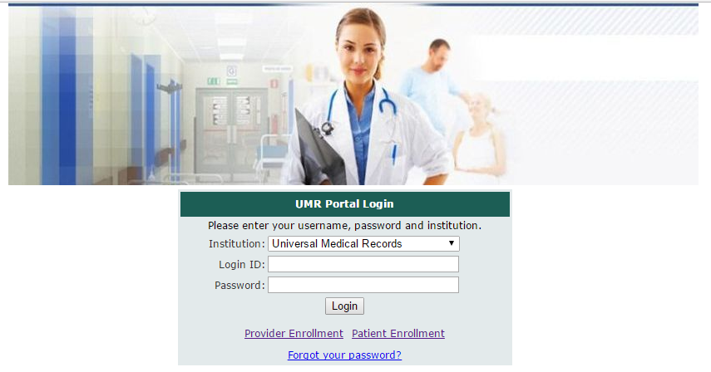

**(Image 1: Login)**

**2)** [**http://umrtest.com/UMRPortals/SignUp/SignUp.aspx**](http://umrtest.com/UMRPortals/SignUp/SignUp.aspx)

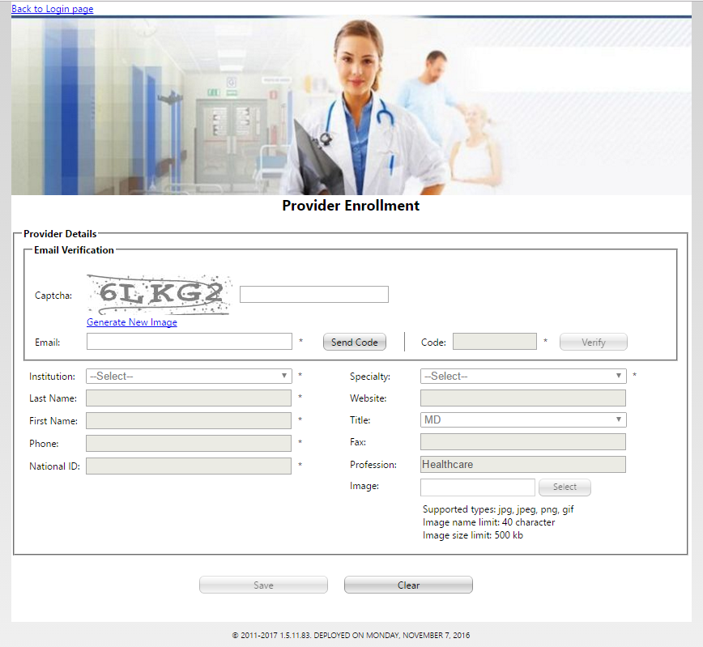

**(Image 2: Provider Enrollment)**

**3)** [**http://umrtest.com/UMRPortals/SignUp/SignUpPatient.aspx**](http://umrtest.com/UMRPortals/SignUp/SignUpPatient.aspx)

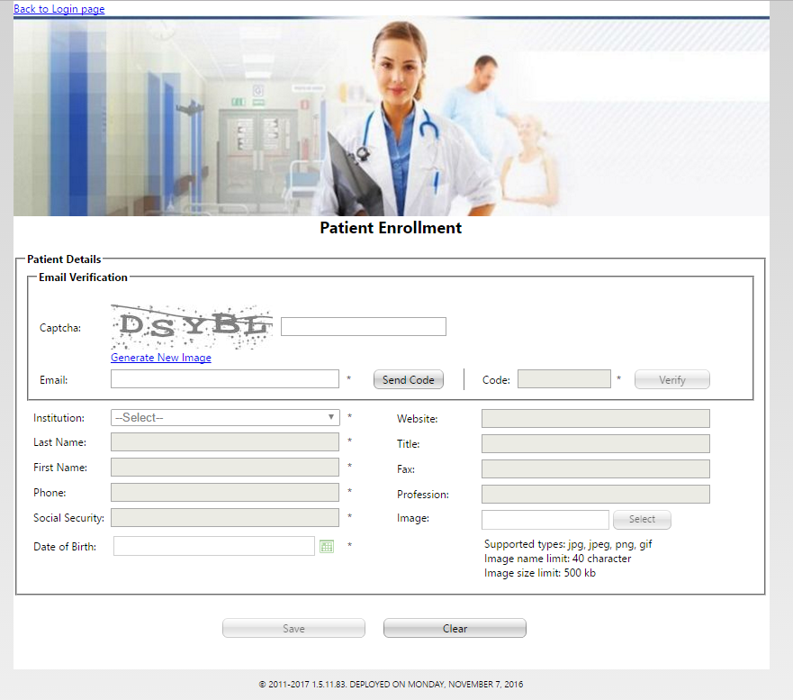

**(Image 3: Patient Enrollment)**

**4)** [**http://umrtest.com/UMRPortals/ResetPassword/PasswordReset.aspx**](http://umrtest.com/UMRPortals/ResetPassword/PasswordReset.aspx)

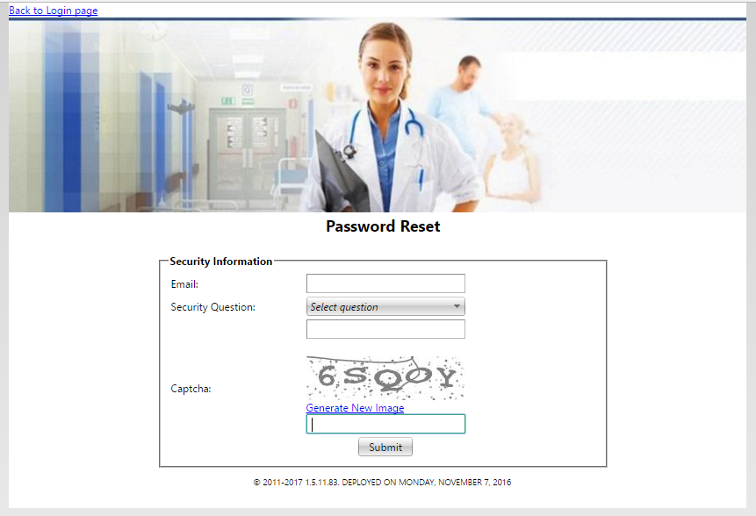

**(Image 4: Forgot Your Password)**

**5)** [**http://umrtest.com/UMRPortals/Home/Default.aspx**](http://umrtest.com/UMRPortals/Home/Default.aspx)

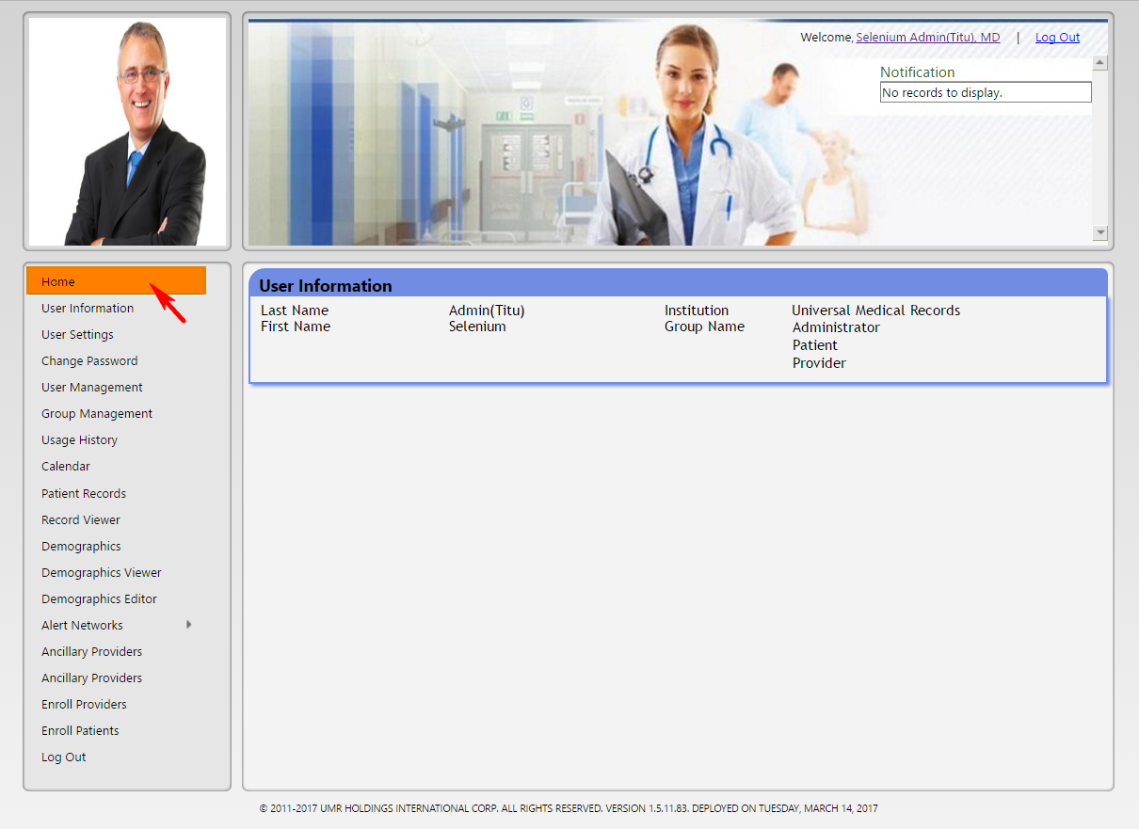

**(Image 5: Admin Home)**

**6)** [**http://umrtest.com/UMRPortals/Account/Register.aspx**](http://umrtest.com/UMRPortals/Account/Register.aspx)

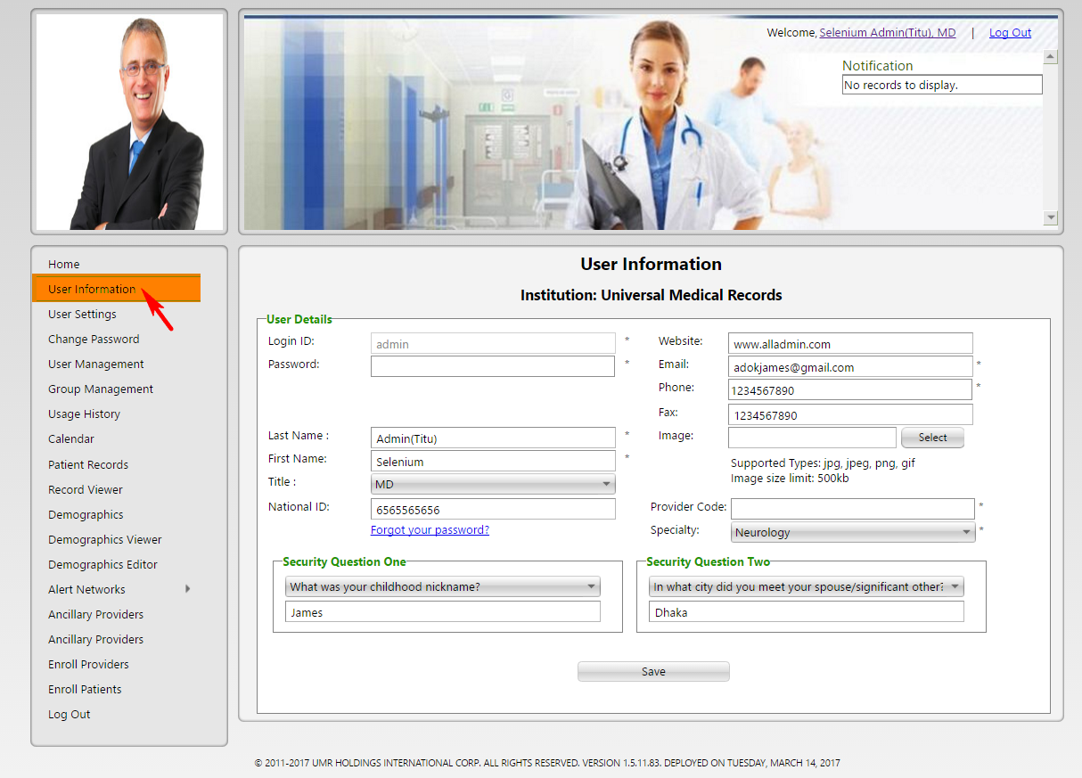

**(Image 6: User Information)**

**7)** [**http://umrtest.com/UMRPortals/Administrative/UserSettings.aspx**](http://umrtest.com/UMRPortals/Administrative/UserSettings.aspx)

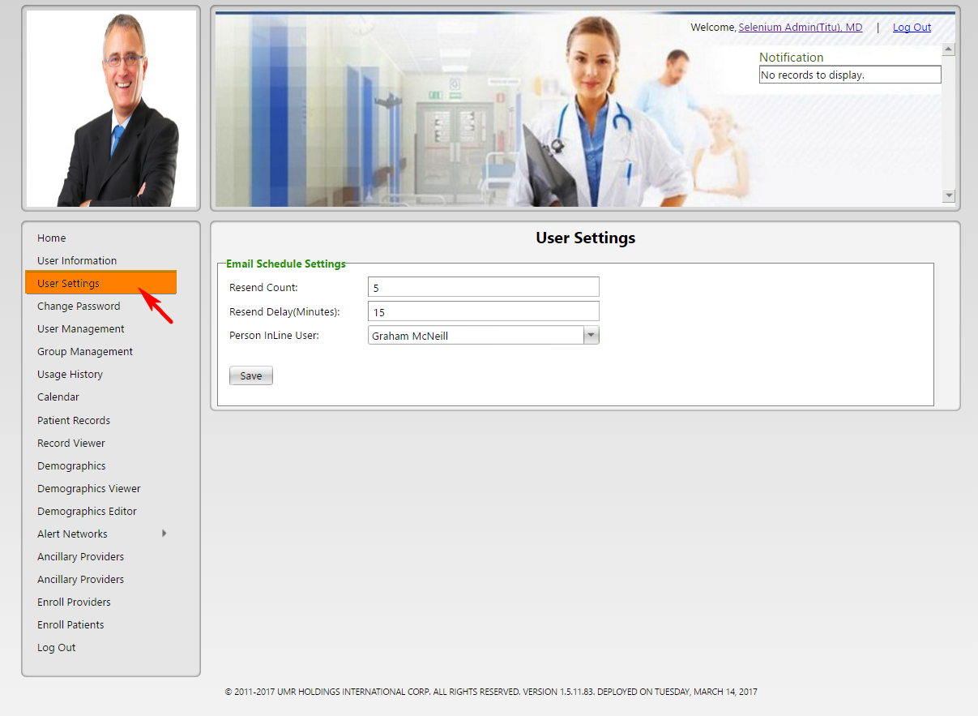

**(Image 7: User Settings)**

**8)** [**http://umrtest.com/UMRPortals/Account/ChangePassword.aspx**](http://umrtest.com/UMRPortals/Account/ChangePassword.aspx)

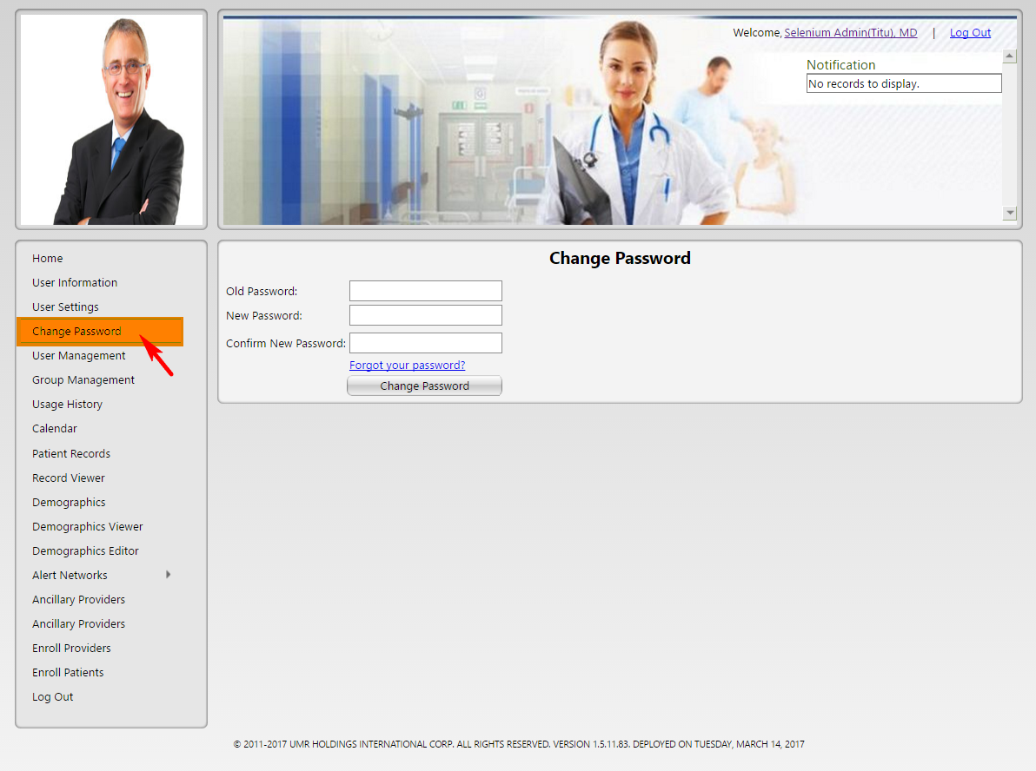

**(Image 8: Change Password)**

**9)** [**http://umrtest.com/UMRPortals/Administrative/UserManagement.aspx**](http://umrtest.com/UMRPortals/Administrative/UserManagement.aspx)

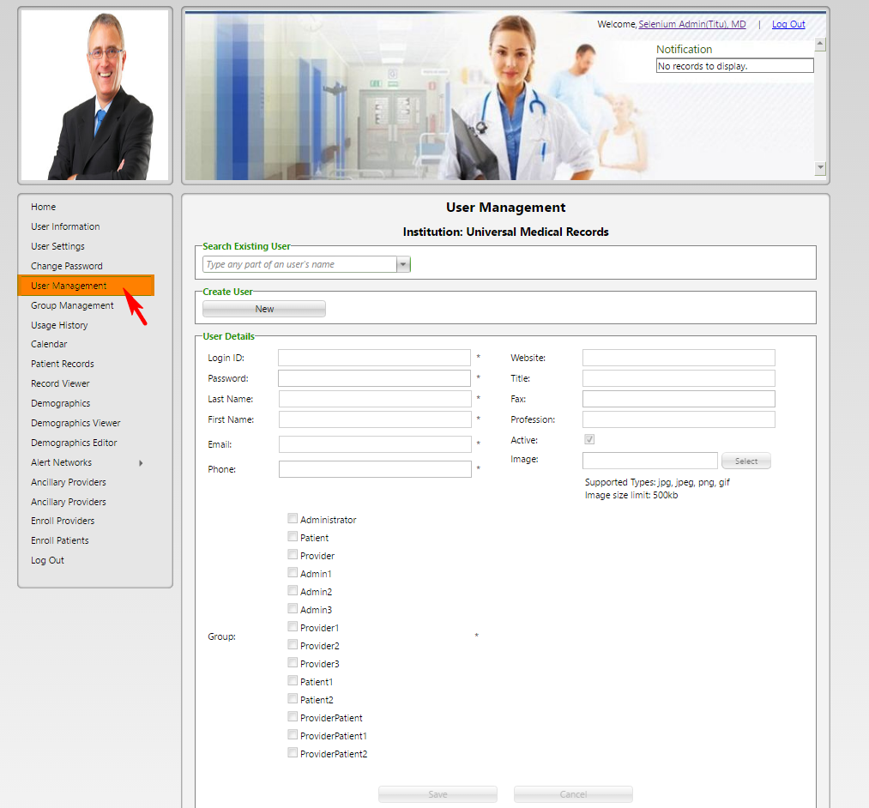

**(Image 9: User Management)**

**10)** [**http://umrtest.com/UMRPortals/Administrative/GroupManagement.aspx**](http://umrtest.com/UMRPortals/Administrative/GroupManagement.aspx)

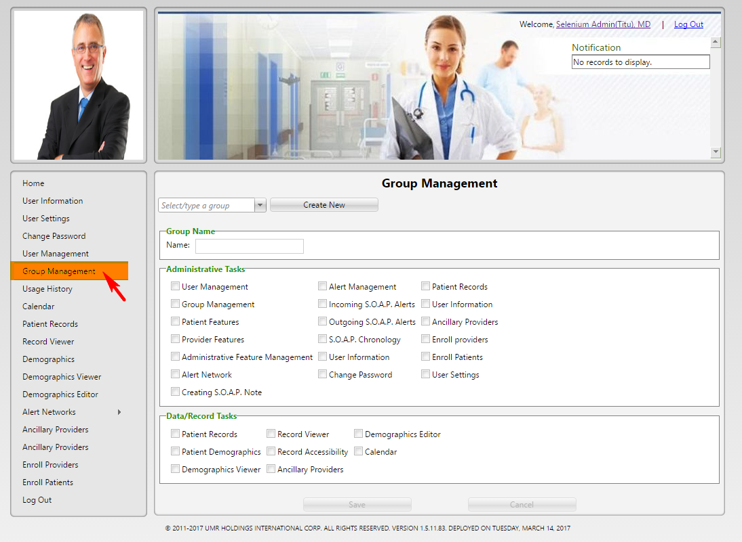

**(Image 10: Group Management)**

**11)** [**http://umrtest.com/UMRPortals/Administrative/Usages.aspx**](http://umrtest.com/UMRPortals/Administrative/Usages.aspx)

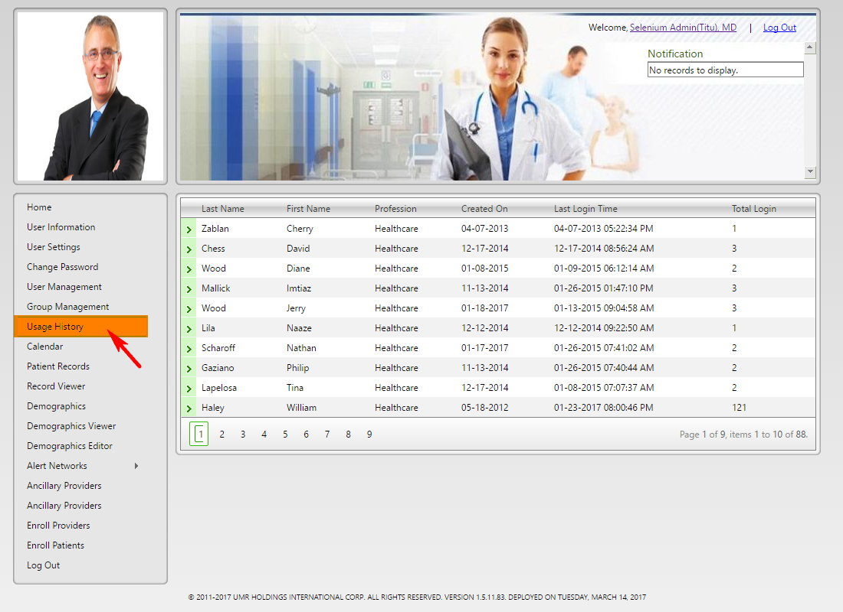

**(Image 11: Usage History)**

**12)** [**http://umrtest.com/UMRPortals/PatientFeatures/ProviderCalendar.aspx**](http://umrtest.com/UMRPortals/PatientFeatures/ProviderCalendar.aspx)

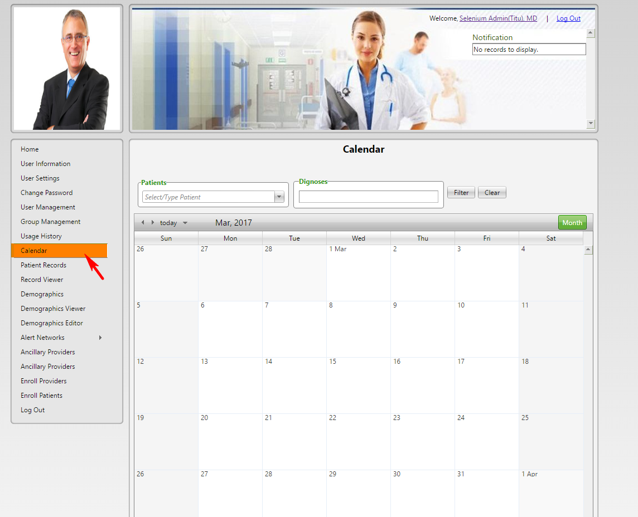

**(Image 12: Calendar)**

**13)** [**http://umrtest.com/UMRPortals/PatientFeatures/PatientFeaturesSearch.aspx**](http://umrtest.com/UMRPortals/PatientFeatures/PatientFeaturesSearch.aspx)

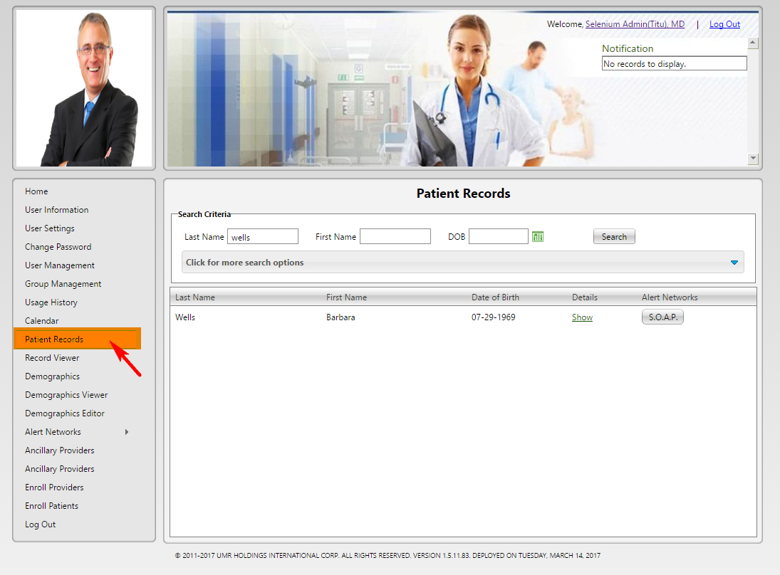

**(Image 13: Patient Records)**

**13.1)** [**http://umrtest.com/UMRPortals/PatientFeatures/PatientFeaturesSearch.aspx**](http://umrtest.com/UMRPortals/PatientFeatures/PatientFeaturesSearch.aspx)

[**http://umrtest.com/UMRPortals/PatientFeatures/PatientFeaturesPop.aspx?PatientKey=3**](http://umrtest.com/UMRPortals/PatientFeatures/PatientFeaturesPop.aspx?PatientKey=3)

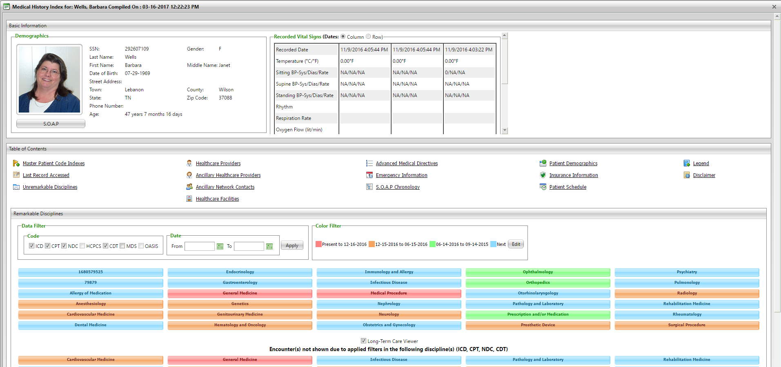

**(Image 13.1: Medical History Index )**

**13.1.1)** [**http://umrtest.com/UMRPortals/PatientFeatures/PatientFeaturesSearch.aspx**](http://umrtest.com/UMRPortals/PatientFeatures/PatientFeaturesSearch.aspx)

[**http://umrtest.com/UMRPortals/PatientFeatures/MPI.aspx?PatientKey=3**](http://umrtest.com/UMRPortals/PatientFeatures/MPI.aspx?PatientKey=3)

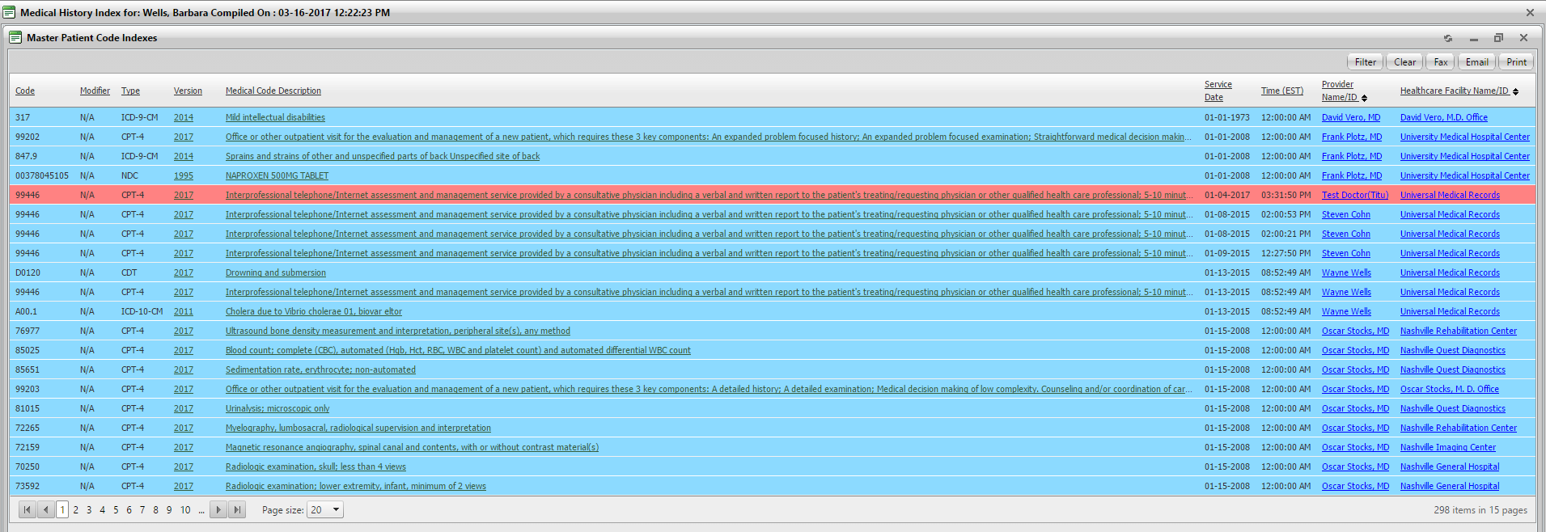

**(Image 13.1.1: Master Patient Code Indexes )**

**13.1.1.1)** [**http://umrtest.com/UMRPortals/PatientFeatures/PatientFeaturesSearch.aspx**](http://umrtest.com/UMRPortals/PatientFeatures/PatientFeaturesSearch.aspx)

[**http://umrtest.com/UMRPortals/PatientFeatures/ViewMedcodeHistory.aspx?MedcodeGUID=26a9b6ec-d1ca-410a-984a-5e433007f131**](http://umrtest.com/UMRPortals/PatientFeatures/ViewMedcodeHistory.aspx?MedcodeGUID=26a9b6ec-d1ca-410a-984a-5e433007f131)

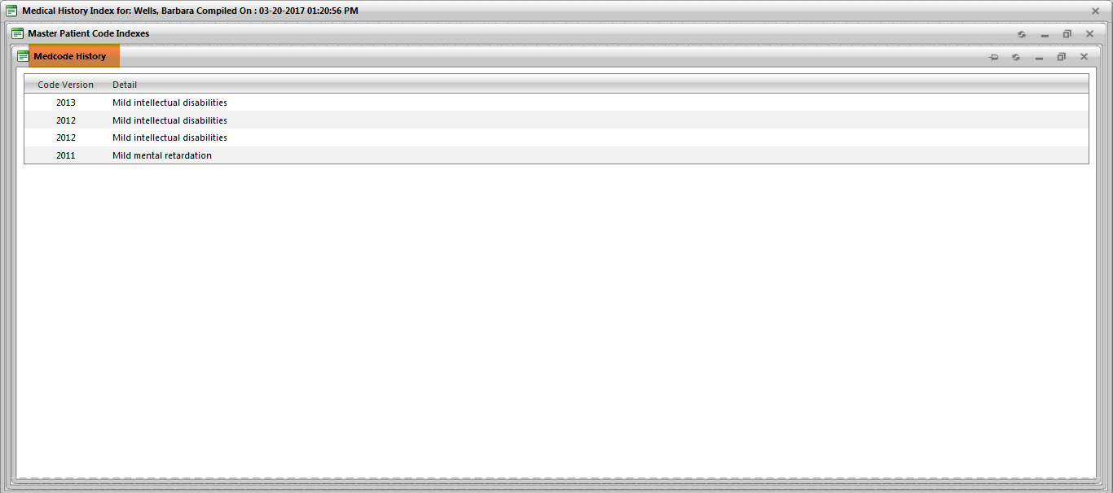

**(Image 13.1.1.1: Medcode History)**

**13.1.1.2)** [**http://umrtest.com/UMRPortals/PatientFeatures/PatientFeaturesSearch.aspx**](http://umrtest.com/UMRPortals/PatientFeatures/PatientFeaturesSearch.aspx)

[**http://umrtest.com/UMRPortals/PatientFeatures/MPI.aspx?PatientKey=3**](http://umrtest.com/UMRPortals/PatientFeatures/MPI.aspx?PatientKey=3)

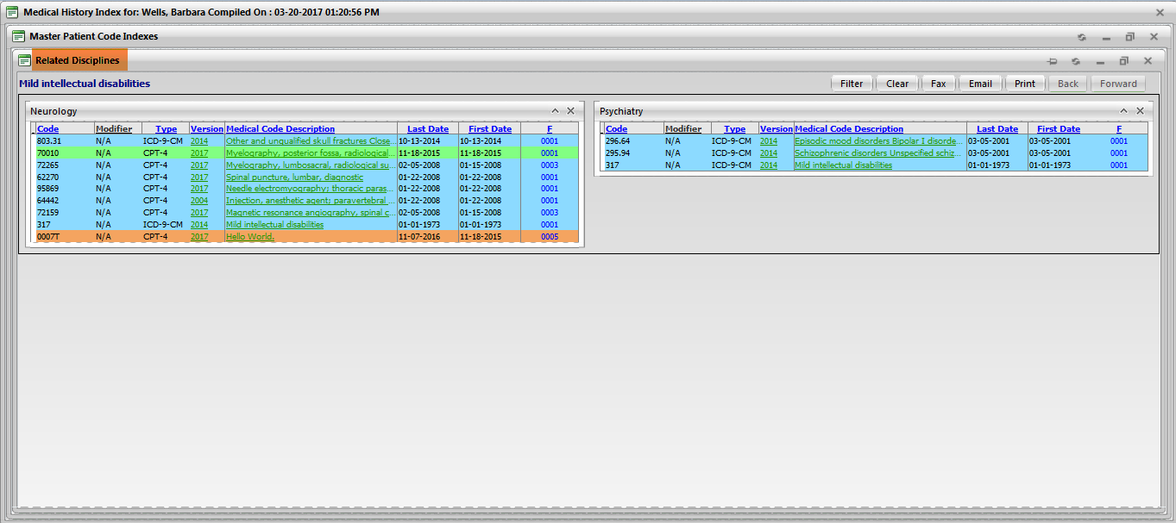

**(Image 13.1.1.2: Related Disciplines)**

**NOTE: Other links are related to Medcode History(Image 13.1.1.1), Related Disciplines(Image 13.1.1.2 All).**

**13.1.1.3)** [**http://umrtest.com/UMRPortals/PatientFeatures/PatientFeaturesSearch.aspx**](http://umrtest.com/UMRPortals/PatientFeatures/PatientFeaturesSearch.aspx)

[**http://umrtest.com/UMRPortals/PatientFeatures/ProviderDetails.aspx?ID=21&DispType=S&HasCode=true&Code=99446&Type=CPT-4&Version=2015&CodeDate=1/8/2015%202:00:21%20PM&PatientKey=3&InstituteCode=UMHLD&DoctorID=211**](http://umrtest.com/UMRPortals/PatientFeatures/ProviderDetails.aspx?ID=21&DispType=S&HasCode=true&Code=99446&Type=CPT-4&Version=2015&CodeDate=1/8/2015%202:00:21%20PM&PatientKey=3&InstituteCode=UMHLD&DoctorID=211)

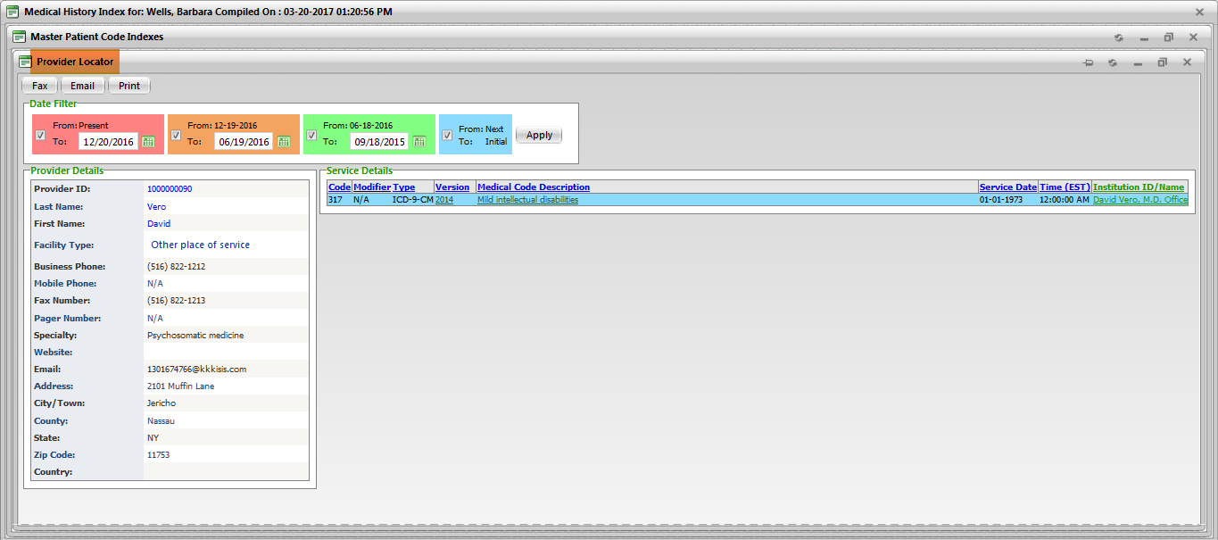

**(Image 13.1.1.3: Provider Locator)**

**13.1.1.4)** [**http://umrtest.com/UMRPortals/PatientFeatures/PatientFeaturesSearch.aspx**](http://umrtest.com/UMRPortals/PatientFeatures/PatientFeaturesSearch.aspx)

[**http://umrtest.com/UMRPortals/PatientFeatures/InstitutionDetails.aspx?code=10004&PatientKey=3&HasCodeSingle=true&CodeMEDNDC=847.9&Type=ICD-9-CM&Version=2014&DoctorID=13&CodeDate=1/1/2008%2012:00:00%20AM&IsLP=1**](http://umrtest.com/UMRPortals/PatientFeatures/InstitutionDetails.aspx?code=10004&PatientKey=3&HasCodeSingle=true&CodeMEDNDC=847.9&Type=ICD-9-CM&Version=2014&DoctorID=13&CodeDate=1/1/2008%2012:00:00%20AM&IsLP=1)

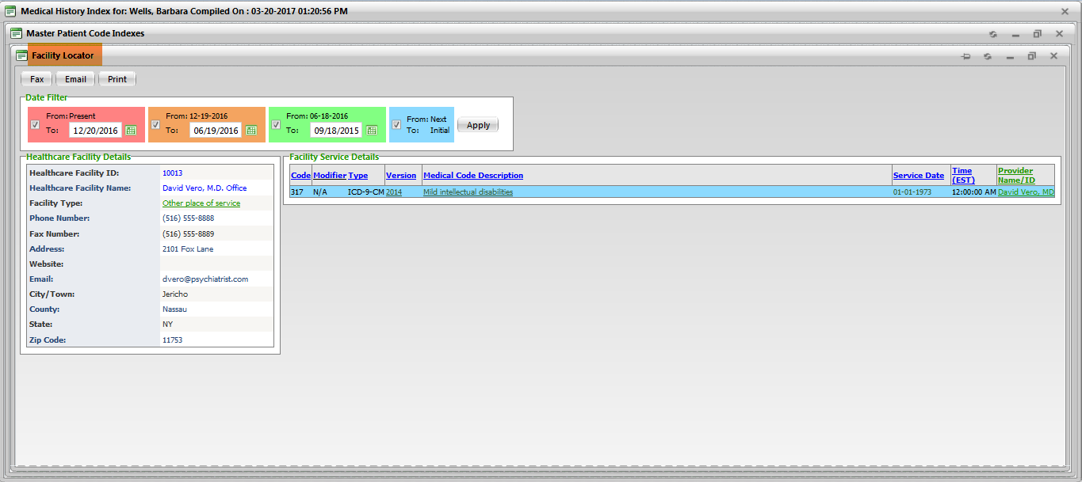

**(Image 13.1.1.4: Facility Locator)**

**13.1.1.5)** [**http://umrtest.com/UMRPortals/PatientFeatures/PatientFeaturesSearch.aspx**](http://umrtest.com/UMRPortals/PatientFeatures/PatientFeaturesSearch.aspx)

[**http://umrtest.com/UMRPortals/PatientFeatures/RDDetails.aspx?PatientKey=3&medCode=99446&disType=D&name=Test&desc=Test&rwndrnd=0.6989118887650952**](http://umrtest.com/UMRPortals/PatientFeatures/RDDetails.aspx?PatientKey=3&medCode=99446&disType=D&name=Test&desc=Test&rwndrnd=0.6989118887650952)

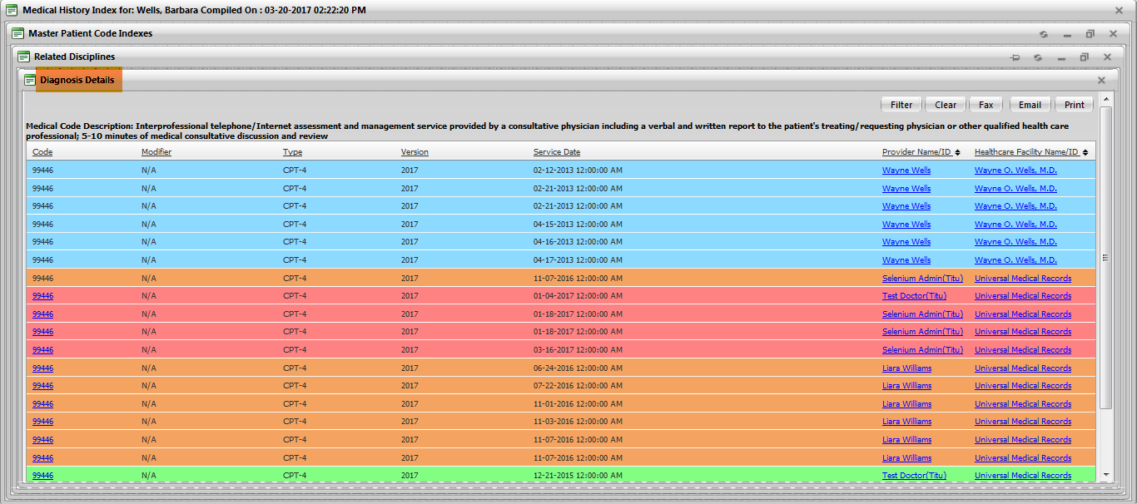

**(Image 13.1.1.5: Diagnosis Details)**

**NOTE: Other links are related to Provider Locator(Image 13.1.1.3 All), Facility Locator(Image 13.1.1.4 All).**

**13.1.1.6)** [**http://umrtest.com/UMRPortals/PatientFeatures/PatientFeaturesSearch.aspx**](http://umrtest.com/UMRPortals/PatientFeatures/PatientFeaturesSearch.aspx)

[**http://umrtest.com/UMRPortals/AlertNetwork/ViewProviderSoap.aspx?AlertId=171063**](http://umrtest.com/UMRPortals/AlertNetwork/ViewProviderSoap.aspx?AlertId=171063)

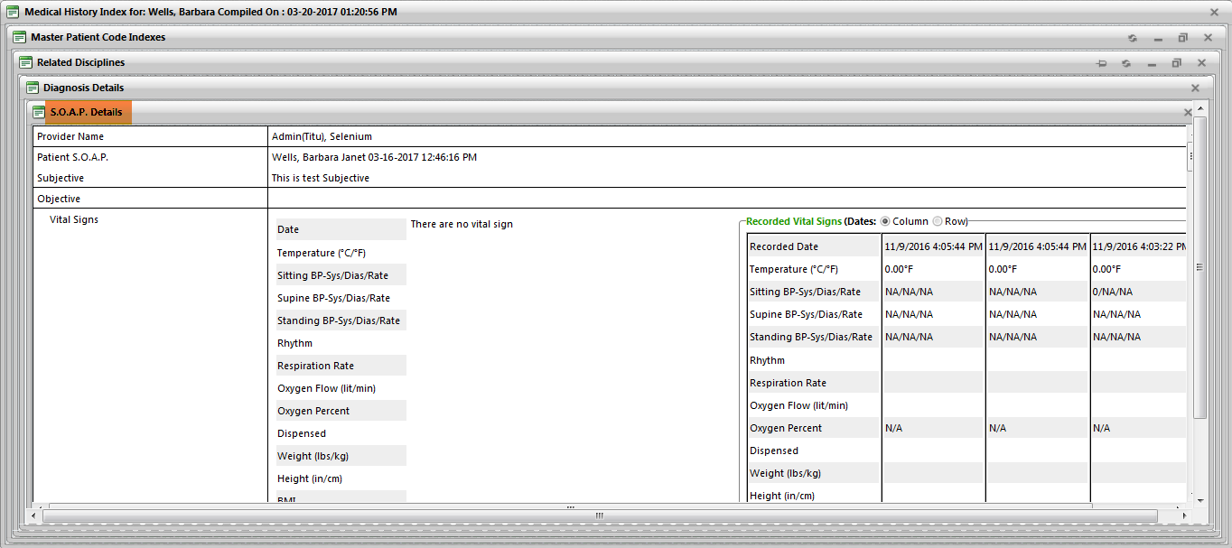

**(Image 13.1.1.6: S.O.A.P. Details)**

**13.1.1.7)** [**http://umrtest.com/UMRPortals/PatientFeatures/PatientFeaturesSearch.aspx**](http://umrtest.com/UMRPortals/PatientFeatures/PatientFeaturesSearch.aspx)

[**http://umrtest.com/UMRPortals/PatientFeatures/RDDetails.aspx?PatientKey=3&disType=N&name=NAPROXEN%20500MG%20TABLET&NDCCode=00378045105&ProviderID=13-LP&InstituteID=10004**](http://umrtest.com/UMRPortals/PatientFeatures/RDDetails.aspx?PatientKey=3&disType=N&name=NAPROXEN%20500MG%20TABLET&NDCCode=00378045105&ProviderID=13-LP&InstituteID=10004)

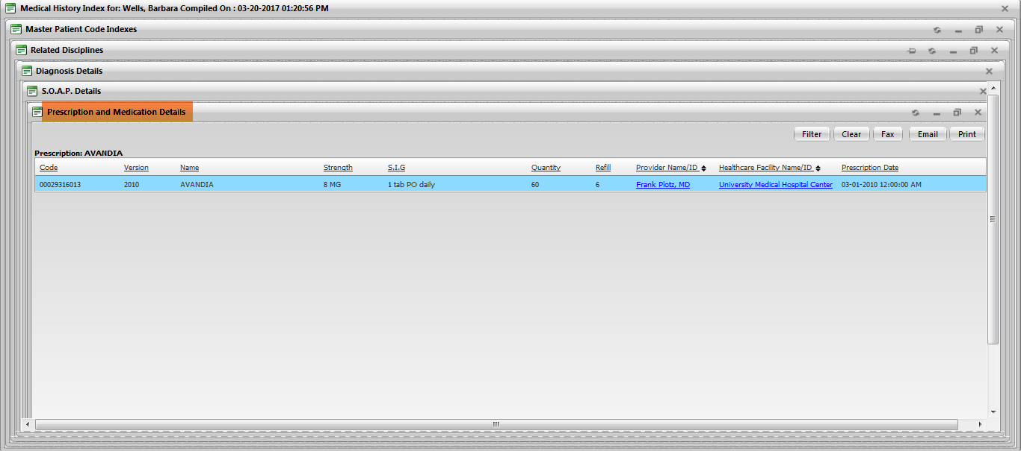

**(Image 13.1.1.7: Prescription and Medication Details)**

**NOTE: Other links are related to Provider Locator(Image 13.1.1.3 All), Facility Locator(Image 13.1.1.4 All).**

**13.1.1.8)** [**http://umrtest.com/UMRPortals/PatientFeatures/PatientFeaturesSearch.aspx**](http://umrtest.com/UMRPortals/PatientFeatures/PatientFeaturesSearch.aspx)

[**http://umrtest.com/UMRPortals/PatientFeatures/RefillDetails.aspx?PatientKey=3&UMR_NDC_ID=b6e37e79-5e9a-4d40-9bb1-58253575ac3f&IsLP=1&ProviderID=13**](http://umrtest.com/UMRPortals/PatientFeatures/RefillDetails.aspx?PatientKey=3&UMR_NDC_ID=b6e37e79-5e9a-4d40-9bb1-58253575ac3f&IsLP=1&ProviderID=13)

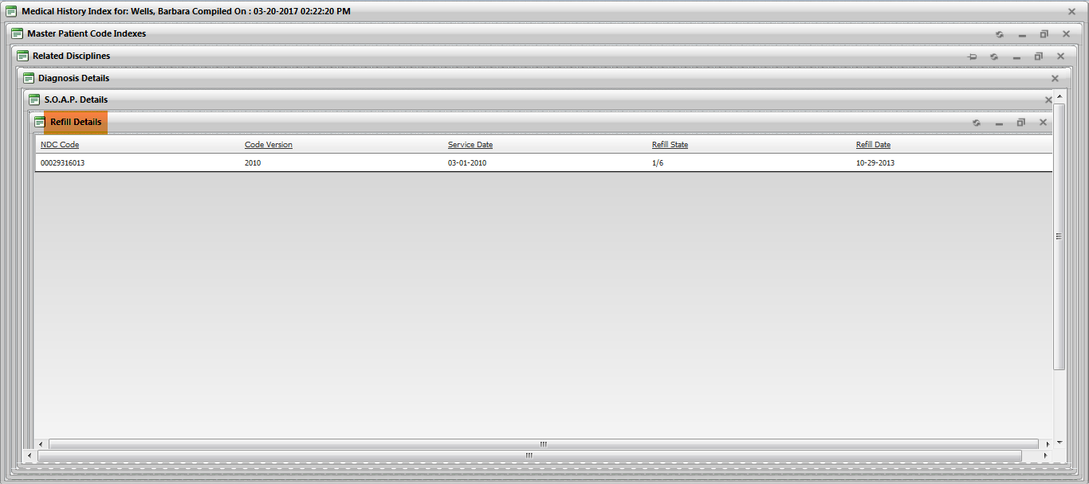

**(Image 13.1.1.8: Refill Details)**

**13.1.1.9)** [**http://umrtest.com/UMRPortals/PatientFeatures/PatientFeaturesSearch.aspx**](http://umrtest.com/UMRPortals/PatientFeatures/PatientFeaturesSearch.aspx)

[**http://umrtest.com/UMRPortals/PatientFeatures/InstituteWiseServiceList.aspx?code=UMHLD&PatientKey=3**](http://umrtest.com/UMRPortals/PatientFeatures/InstituteWiseServiceList.aspx?code=UMHLD&PatientKey=3)

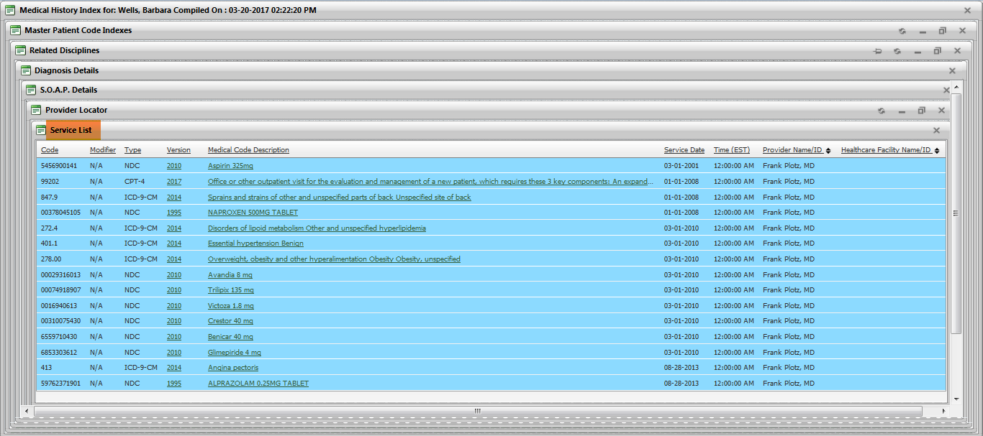

**(Image 13.1.1.9: Service List)**

**NOTE: Other links are related to Medcode History(Image 13.1.1.1), Related Disciplines(Image 13.1.1.2 All).**

**13.1.1.10)** [**http://umrtest.com/UMRPortals/PatientFeatures/PatientFeaturesSearch.aspx**](http://umrtest.com/UMRPortals/PatientFeatures/PatientFeaturesSearch.aspx)

[**http://umrtest.com/UMRPortals/PatientFeatures/MPI.aspx?PatientKey=3**](http://umrtest.com/UMRPortals/PatientFeatures/MPI.aspx?PatientKey=3)

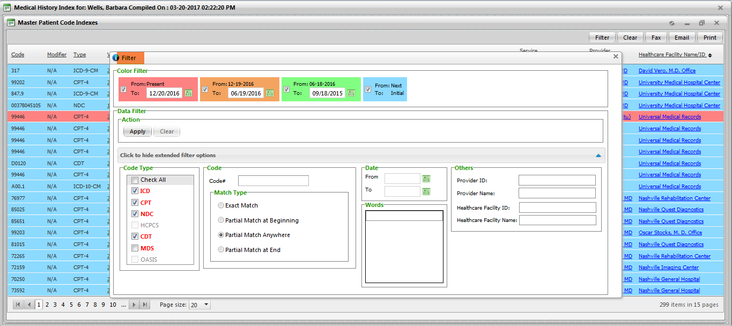

**(Image 13.1.1.10: Filter)**

**13.1.1.11)** [**http://umrtest.com/UMRPortals/PatientFeatures/PatientFeaturesSearch.aspx**](http://umrtest.com/UMRPortals/PatientFeatures/PatientFeaturesSearch.aspx)

[**http://umrtest.com/UMRPortals/PatientFeatures/MPI.aspx?PatientKey=3**](http://umrtest.com/UMRPortals/PatientFeatures/MPI.aspx?PatientKey=3)

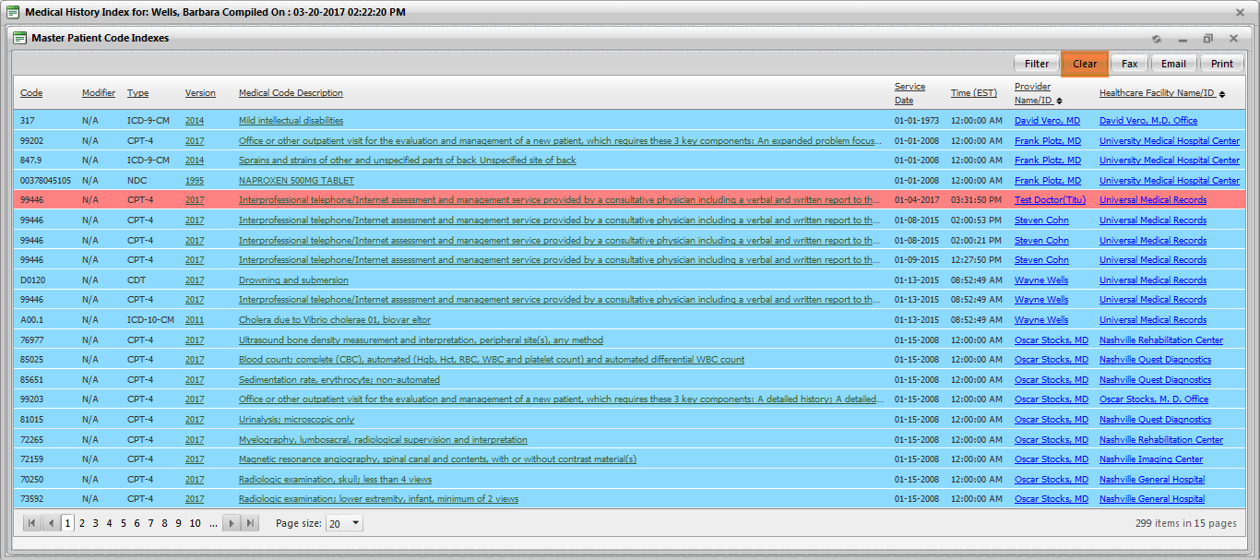

**(Image 13.1.1.11: Clear)**

**13.1.1.12)** [**http://umrtest.com/UMRPortals/PatientFeatures/PatientFeaturesSearch.aspx**](http://umrtest.com/UMRPortals/PatientFeatures/PatientFeaturesSearch.aspx)

[**http://umrtest.com/UMRPortals/PatientFeatures/MPIFax.aspx?PatientKey=3&PageCount=10&filterText=**](http://umrtest.com/UMRPortals/PatientFeatures/MPIFax.aspx?PatientKey=3&PageCount=10&filterText=)

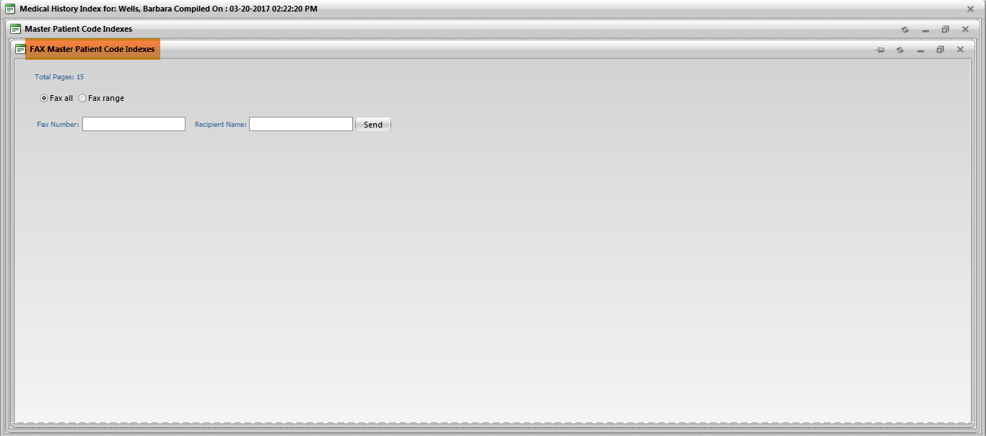

**(Image 13.1.1.12: Fax)**

**13.1.1.13)** [**http://umrtest.com/UMRPortals/PatientFeatures/PatientFeaturesSearch.aspx**](http://umrtest.com/UMRPortals/PatientFeatures/PatientFeaturesSearch.aspx)

[**http://umrtest.com/UMRPortals/PatientFeatures/MPIEmail.aspx?PatientKey=3&PageCount=10&filterText=**](http://umrtest.com/UMRPortals/PatientFeatures/MPIEmail.aspx?PatientKey=3&PageCount=10&filterText=)

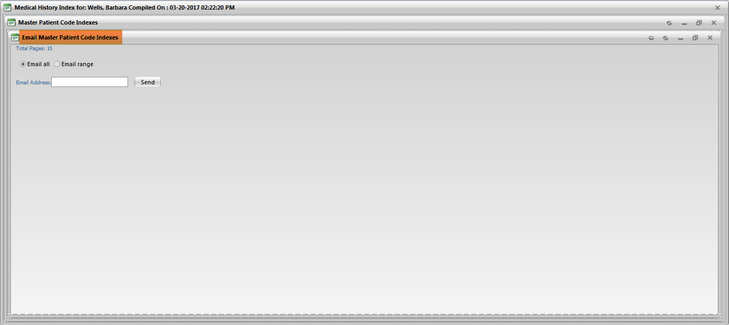

**(Image 13.1.1.13: Email)**

**13.1.1.14)** [**http://umrtest.com/UMRPortals/PatientFeatures/PatientFeaturesSearch.aspx**](http://umrtest.com/UMRPortals/PatientFeatures/PatientFeaturesSearch.aspx)

[**http://umrtest.com/UMRPortals/PatientFeatures/MPIPrintRange.aspx?PatientKey=3&PageCount=10&filterText=**](http://umrtest.com/UMRPortals/PatientFeatures/MPIPrintRange.aspx?PatientKey=3&PageCount=10&filterText=)

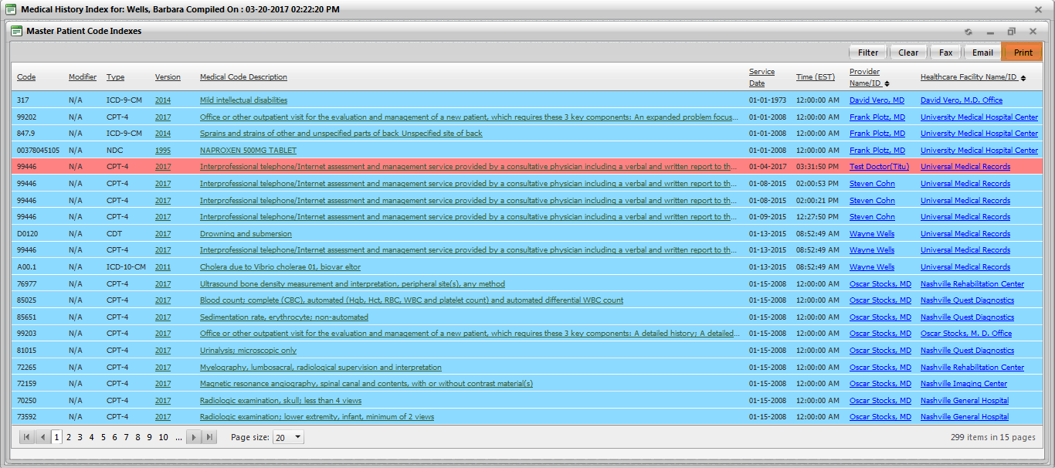

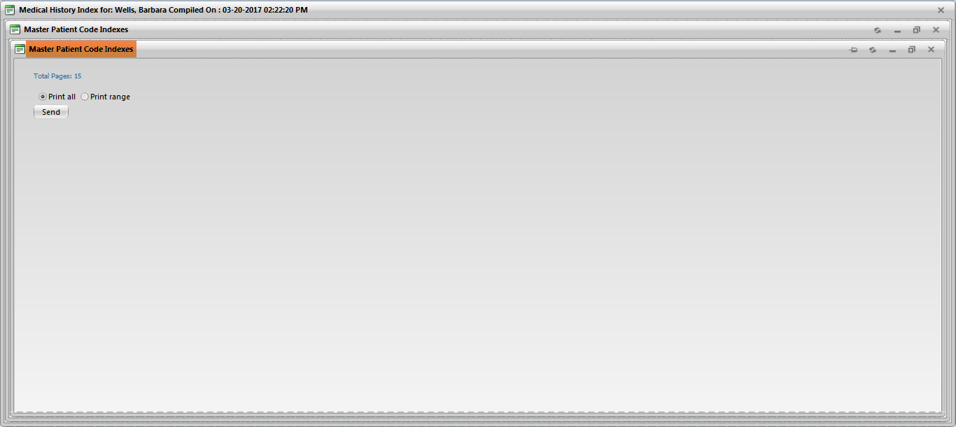

**(Image 13.1.1.14: Print)**

**13.1.2)** [**http://umrtest.com/UMRPortals/PatientFeatures/PatientFeaturesSearch.aspx**](http://umrtest.com/UMRPortals/PatientFeatures/PatientFeaturesSearch.aspx)

[**http://umrtest.com/UMRPortals/PatientFeatures/LRA.aspx?PatientKey=3**](http://umrtest.com/UMRPortals/PatientFeatures/LRA.aspx?PatientKey=3)

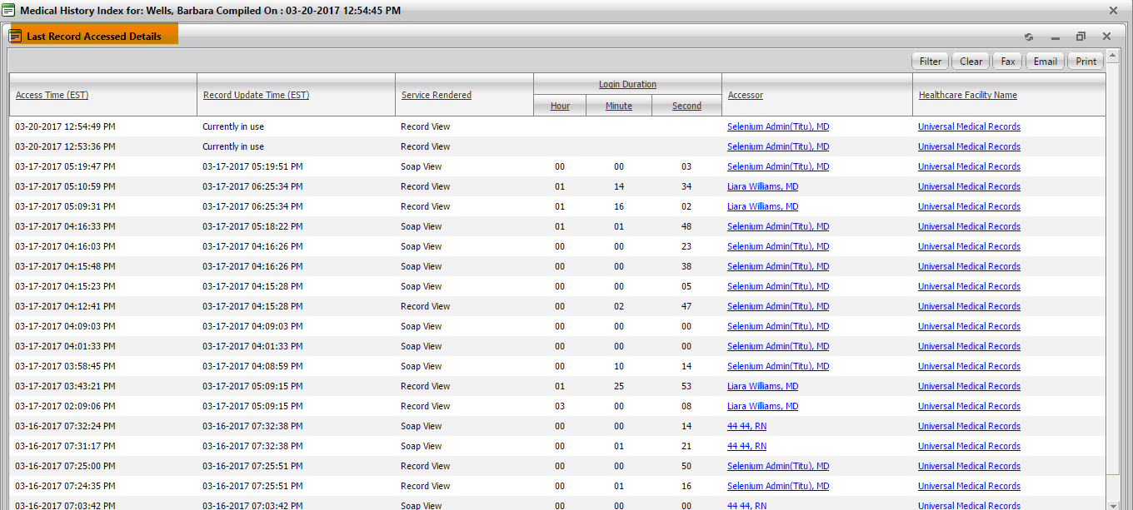

**(Image 13.1.2: Last Record Accessed Details)**

**13.1.2.1)** [**http://umrtest.com/UMRPortals/PatientFeatures/PatientFeaturesSearch.aspx**](http://umrtest.com/UMRPortals/PatientFeatures/PatientFeaturesSearch.aspx)

[**http://umrtest.com/UMRPortals/PatientFeatures/UserDetails.aspx?UserName=10091&AccessTime=4/4/2017%209:03:53%20AM**](http://umrtest.com/UMRPortals/PatientFeatures/UserDetails.aspx?UserName=10091&AccessTime=4/4/2017%209:03:53%20AM)

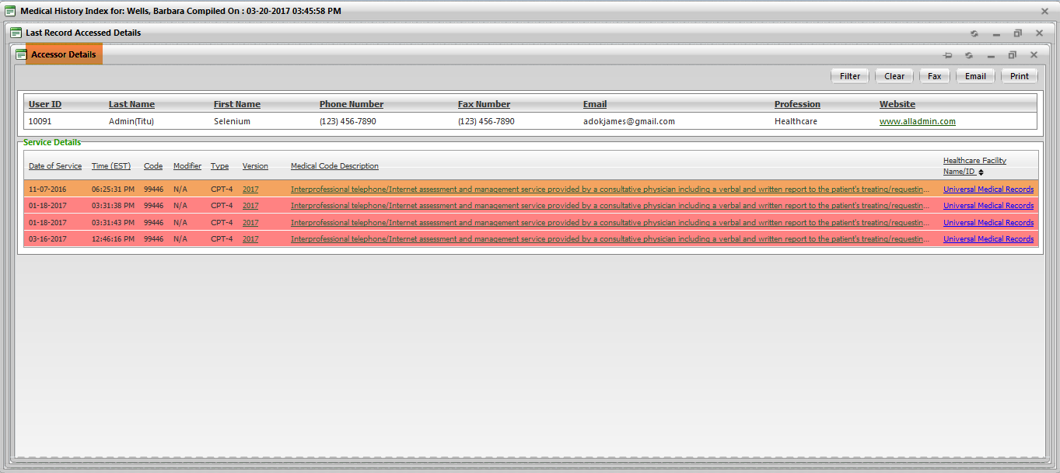

**(Image 13.1.2.1: Accessor Details)**

**NOTE: Other links are related to Medcode History(Image 13.1.1.1), Related Disciplines(Image 13.1.1.2 All), Facility Locator(Image 13.1.1.5 All)**

**13.1.2.2)** [**http://umrtest.com/UMRPortals/PatientFeatures/PatientFeaturesSearch.aspx**](http://umrtest.com/UMRPortals/PatientFeatures/PatientFeaturesSearch.aspx)

[**http://umrtest.com/UMRPortals/PatientFeatures/InstitutionProvidersCodes.aspx?code=UMHLD&PatientKey=3**](http://umrtest.com/UMRPortals/PatientFeatures/InstitutionProvidersCodes.aspx?code=UMHLD&PatientKey=3)

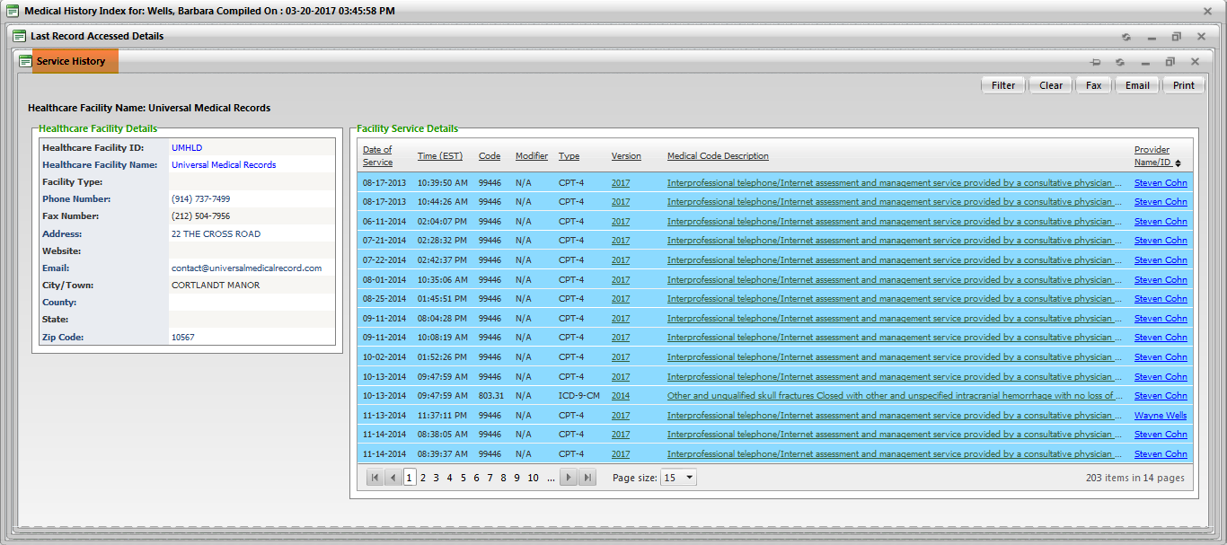

**(Image 13.1.2.2: Service History)**

**NOTE: Other links are related to Medcode History(Image 13.1.1.1), Related Disciplines(Image 13.1.1.2 All), Provider Locator(Image 13.1.1.4 All), Service List(Image 13.1.1.9 All)**

**13.1.2.3)** [**http://umrtest.com/UMRPortals/PatientFeatures/PatientFeaturesSearch.aspx**](http://umrtest.com/UMRPortals/PatientFeatures/PatientFeaturesSearch.aspx)

[**http://umrtest.com/UMRPortals/PatientFeatures/LRA.aspx?PatientKey=3**](http://umrtest.com/UMRPortals/PatientFeatures/LRA.aspx?PatientKey=3)

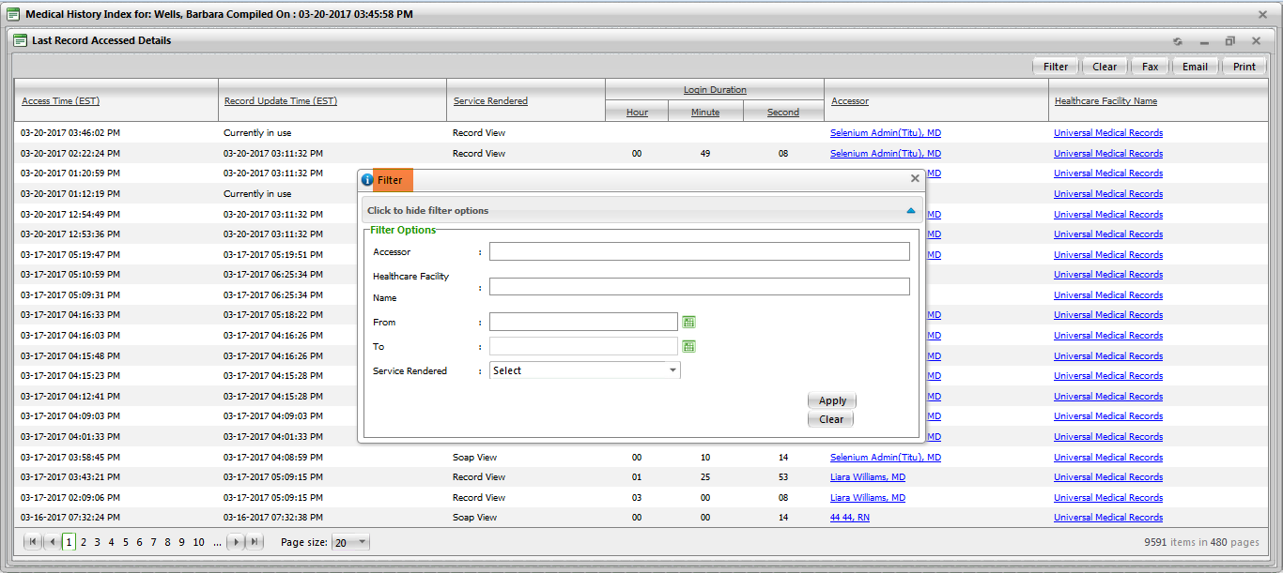

**(Image 13.1.2.3: Filter)**

**13.1.2.4)** [**http://umrtest.com/UMRPortals/PatientFeatures/PatientFeaturesSearch.aspx**](http://umrtest.com/UMRPortals/PatientFeatures/PatientFeaturesSearch.aspx)

[**http://umrtest.com/UMRPortals/PatientFeatures/LRAPrintRange.aspx?PatientKey=3&PageCount=353**](http://umrtest.com/UMRPortals/PatientFeatures/LRAPrintRange.aspx?PatientKey=3&PageCount=353)

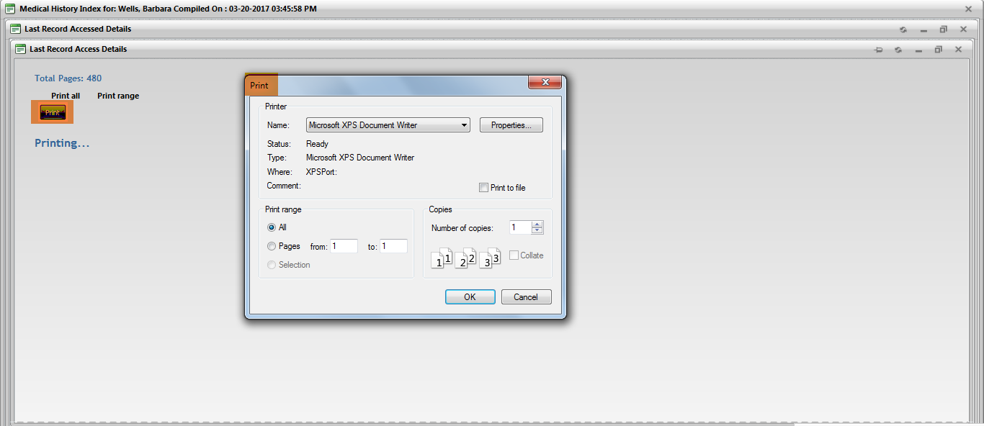

**(Image 13.1.2.4: Print)**

**NOTE: Fax, Clear and Email links are related to Fax(Image 13.1.1.12), Clear(Image 13.1.1.11) and Email(Image 13.1.1.13).**

**13.1.3)** [**http://umrtest.com/UMRPortals/PatientFeatures/PatientFeaturesSearch.aspx**](http://umrtest.com/UMRPortals/PatientFeatures/PatientFeaturesSearch.aspx)

[**http://umrtest.com/UMRPortals/PatientFeatures/UnRD.aspx?PatientKey=3**](http://umrtest.com/UMRPortals/PatientFeatures/UnRD.aspx?PatientKey=3)

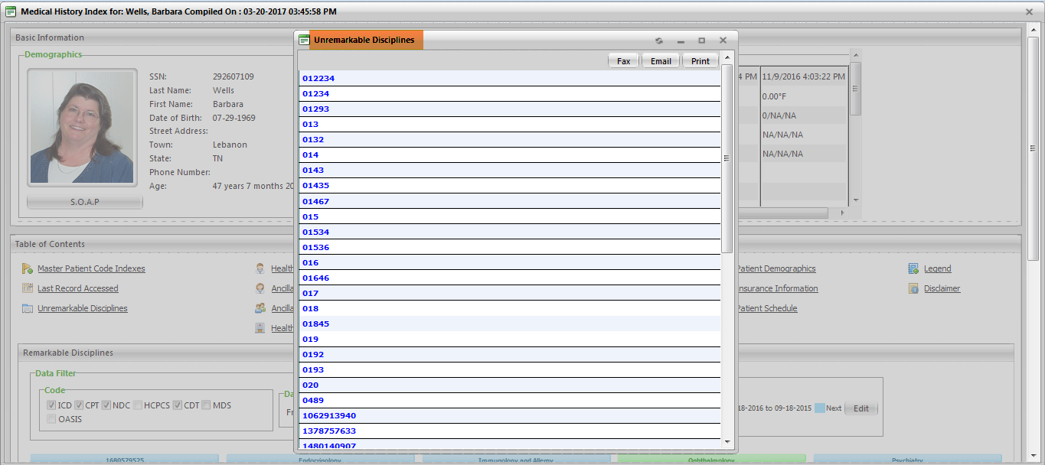

**(Image 13.1.3: Unremarkable Disciplines)**

**13.1.3.1)** [**http://umrtest.com/UMRPortals/PatientFeatures/PatientFeaturesSearch.aspx**](http://umrtest.com/UMRPortals/PatientFeatures/PatientFeaturesSearch.aspx)

[**http://umrtest.com/UMRPortals/PatientFeatures/UnRD.aspx?PatientKey=3**](http://umrtest.com/UMRPortals/PatientFeatures/UnRD.aspx?PatientKey=3)

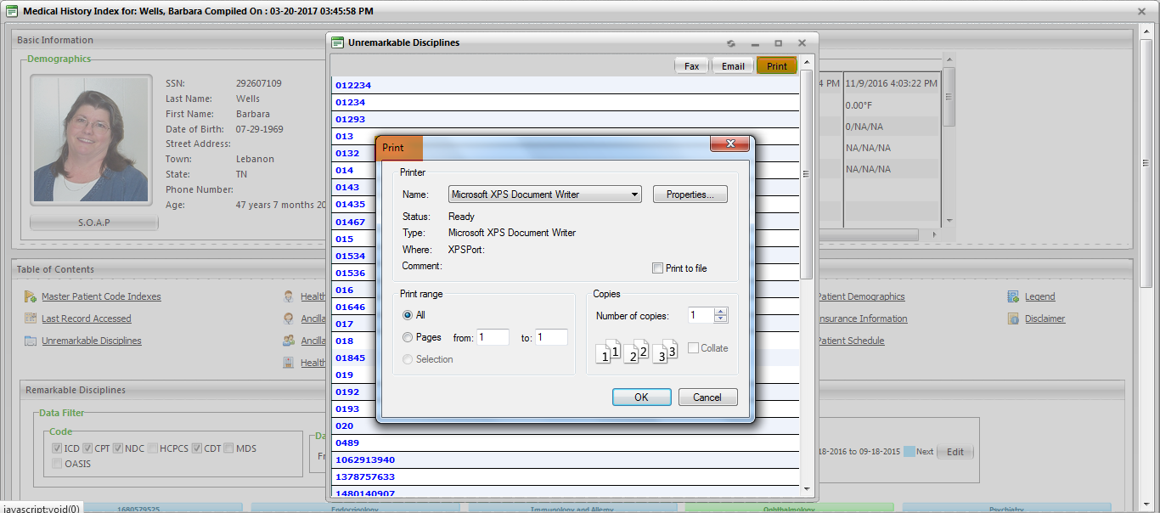

**(Image 13.1.3.1: Print)**

**13.1.3.2)** [**http://umrtest.com/UMRPortals/PatientFeatures/PatientFeaturesSearch.aspx**](http://umrtest.com/UMRPortals/PatientFeatures/PatientFeaturesSearch.aspx)

[**http://umrtest.com/UMRPortals/PatientFeatures/Fax.aspx**](http://umrtest.com/UMRPortals/PatientFeatures/Fax.aspx)

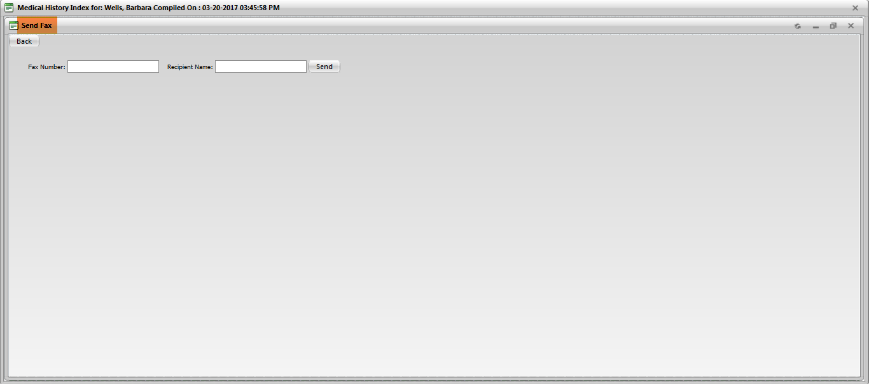

**(Image 13.1.3.2: Fax)**

**13.1.3.3)** [**http://umrtest.com/UMRPortals/PatientFeatures/PatientFeaturesSearch.aspx**](http://umrtest.com/UMRPortals/PatientFeatures/PatientFeaturesSearch.aspx)

[**http://umrtest.com/UMRPortals/PatientFeatures/Email.aspx**](http://umrtest.com/UMRPortals/PatientFeatures/Email.aspx)

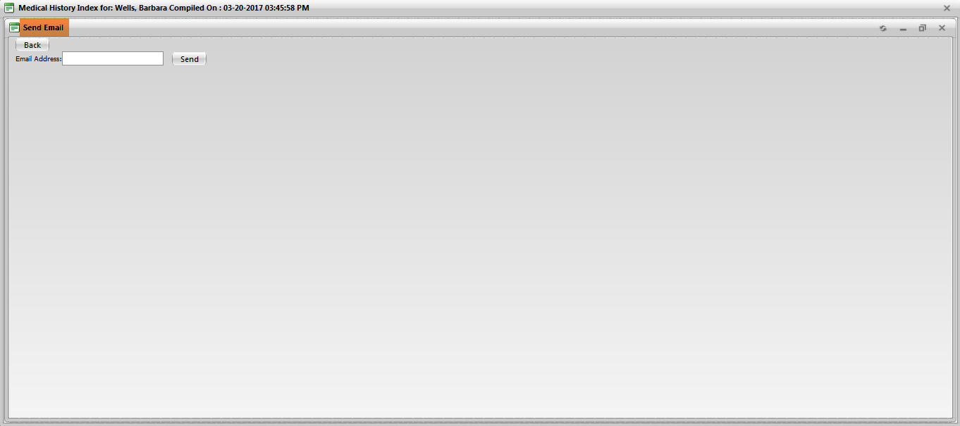

**(Image 13.1.3.3: Email)**

**13.1.4)** [**http://umrtest.com/UMRPortals/PatientFeatures/PatientFeaturesSearch.aspx**](http://umrtest.com/UMRPortals/PatientFeatures/PatientFeaturesSearch.aspx)

[**http://umrtest.com/UMRPortals/PatientFeatures/MultiProviderListDetails.aspx?PatientKey=3&DispType=M**](http://umrtest.com/UMRPortals/PatientFeatures/MultiProviderListDetails.aspx?PatientKey=3&DispType=M)

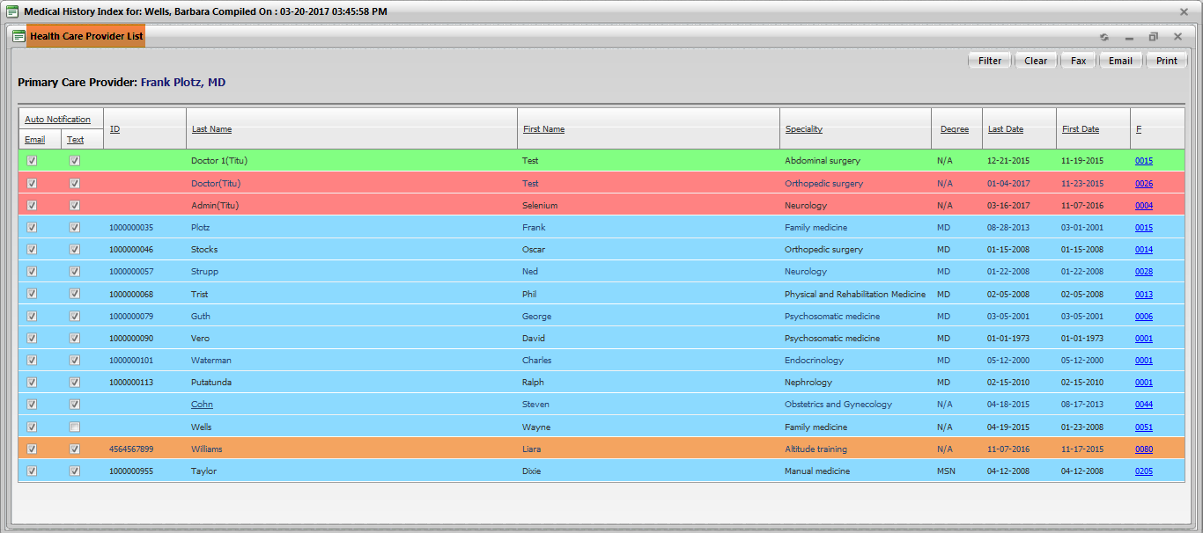

**(Image 13.1.4: Healthcare Providers)**

**NOTE: Filter, Clear, Fax, Email and Print buttons are related to Filter(Image 13.1.1.10), Clear(Image 13.1.1.11), Fax(Image 13.1.3.2), Email(Image 13.1.3.3), Print(Image 13.1.3.1), Service History(Image 13.1.2.2), Service List(Image 13.1.1.9 All).**

**13.1.5)** [**http://umrtest.com/UMRPortals/PatientFeatures/PatientFeaturesSearch.aspx**](http://umrtest.com/UMRPortals/PatientFeatures/PatientFeaturesSearch.aspx)

[**http://umrtest.com/UMRPortals/PatientFeatures/AncilliaryHealthCareProviderList.aspx?PatientKey=3**](http://umrtest.com/UMRPortals/PatientFeatures/AncilliaryHealthCareProviderList.aspx?PatientKey=3)

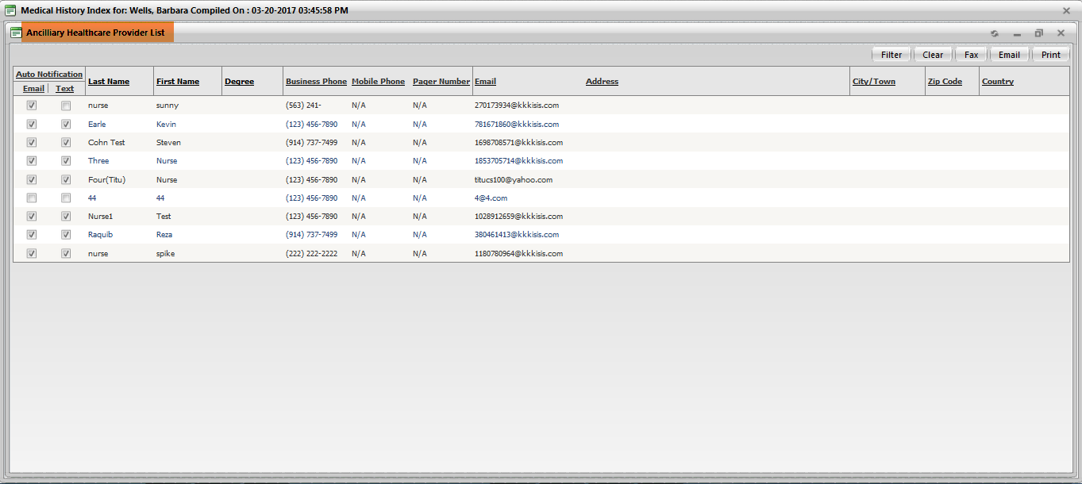

**(Image 13.1.5: Ancillary Healthcare Providers)**

**NOTE: Filter, Fax, Email, Clear and Print links are related to Filter(Image 13.1.2.3), Fax(Image 13.1.3.2), Email(Image 13.1.3.3), Clear(Image 13.1.1.11) and Print(Image 13.1.3.1).**

**13.1.6)** [**http://umrtest.com/UMRPortals/PatientFeatures/PatientFeaturesSearch.aspx**](http://umrtest.com/UMRPortals/PatientFeatures/PatientFeaturesSearch.aspx)

[**http://umrtest.com/UMRPortals/PatientFeatures/AssociatedAncProvList.aspx?PatientKey=3**](http://umrtest.com/UMRPortals/PatientFeatures/AssociatedAncProvList.aspx?PatientKey=3)

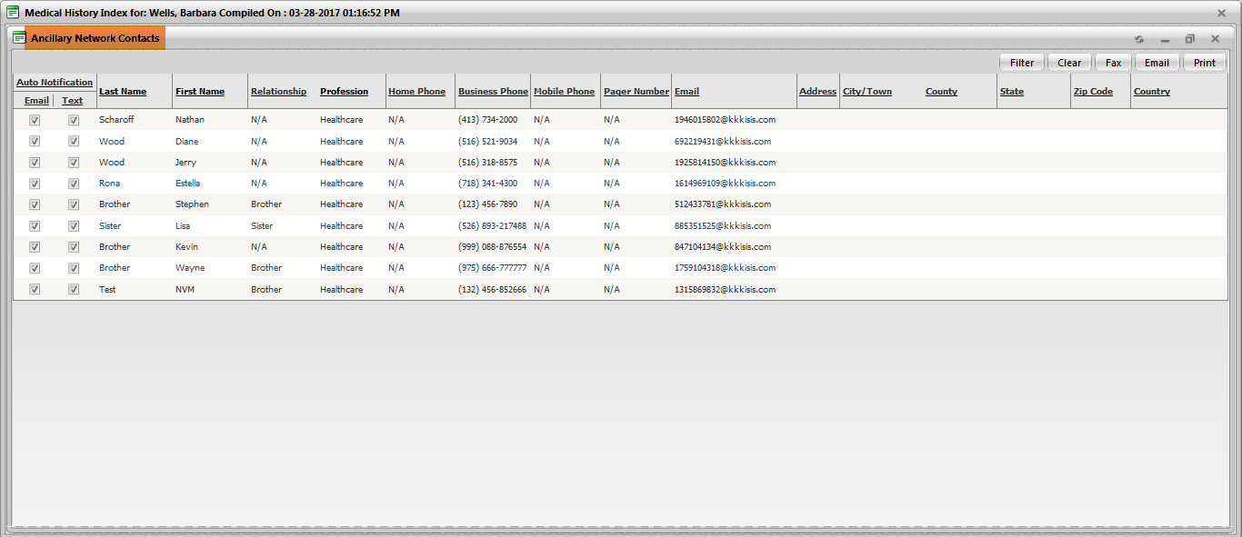

**(Image 13.1.6: Ancillary Network Contacts)**

**NOTE: Filter, Fax, Email, Clear and Print links are related to Filter(Image 13.1.2.3), Fax(Image 13.1.3.2), Email(Image 13.1.3.3), Clear(Image 13.1.1.11) and Print(Image 13.1.3.1).**

**13.1.7)** [**http://umrtest.com/UMRPortals/PatientFeatures/PatientFeaturesSearch.aspx**](http://umrtest.com/UMRPortals/PatientFeatures/PatientFeaturesSearch.aspx)

[**http://umrtest.com/UMRPortals/PatientFeatures/HealthcareFacilities.aspx?PatientKey=3**](http://umrtest.com/UMRPortals/PatientFeatures/HealthcareFacilities.aspx?PatientKey=3)

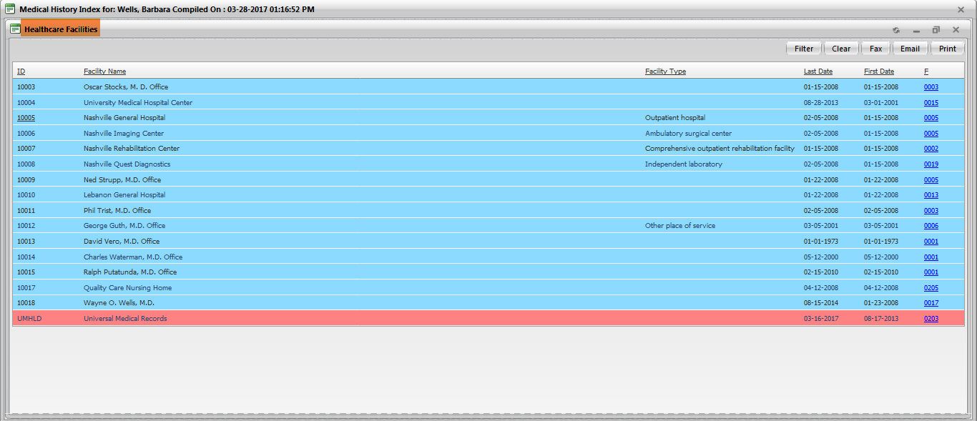

**(Image 13.1.7: Healthcare Facilities)**

**NOTE: Service History, Filter, Fax, Clear, Email and Print links are related to Service History(Image 13.1.2.2), Filter(Image 13.1.1.10), Fax(Image 13.1.3.2), Clear(Image 13.1.1.11), Email(Image 13.1.3.3) and Print(Image 13.1.3.1).**

**13.1.8)** [**http://umrtest.com/UMRPortals/PatientFeatures/PatientFeaturesSearch.aspx**](http://umrtest.com/UMRPortals/PatientFeatures/PatientFeaturesSearch.aspx)

[**http://umrtest.com/UMRPortals/PatientFeatures/AMD.aspx?PatientKey=3**](http://umrtest.com/UMRPortals/PatientFeatures/AMD.aspx?PatientKey=3)

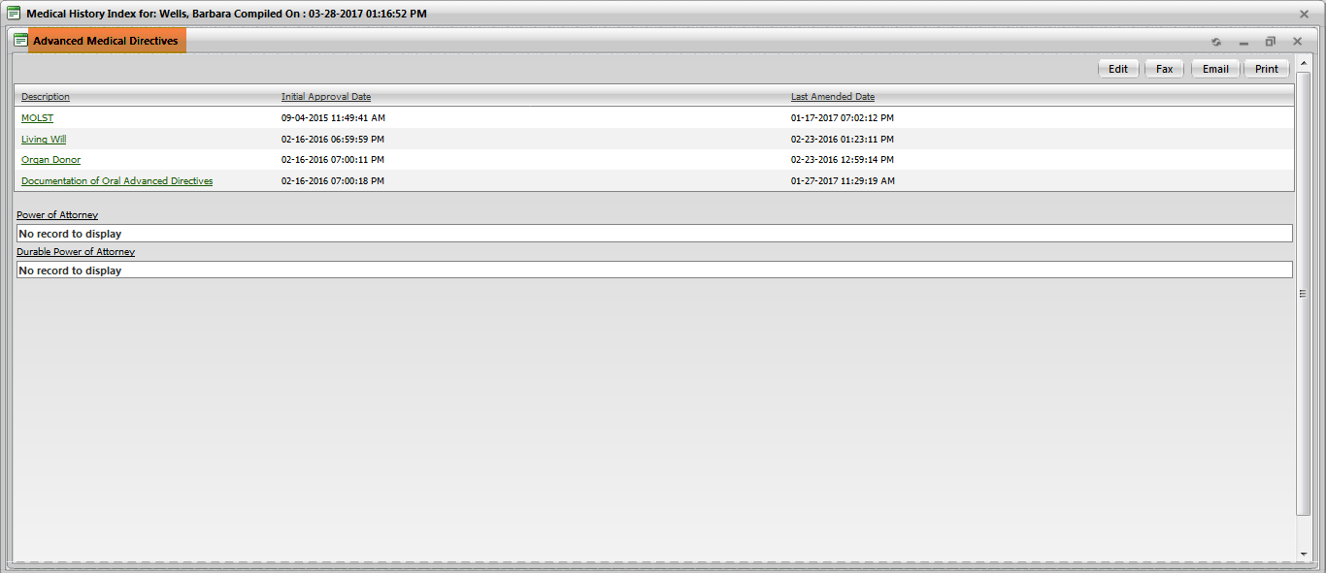

**(Image 13.1.8: Advanced Medical Directives)**

**NOTE: Fax, Email and Print links are related to Fax(Image 13.1.3.2), Email(Image 13.1.3.3) and Print(Image 13.1.3.1).**

**13.1.8.1)** [**http://umrtest.com/UMRPortals/PatientFeatures/PatientFeaturesSearch.aspx**](http://umrtest.com/UMRPortals/PatientFeatures/PatientFeaturesSearch.aspx)

[**http://umrtest.com/UMRPortals/DataRecord/Report/MOLSTReport.aspx?PatientKey=3**](http://umrtest.com/UMRPortals/DataRecord/Report/MOLSTReport.aspx?PatientKey=3)

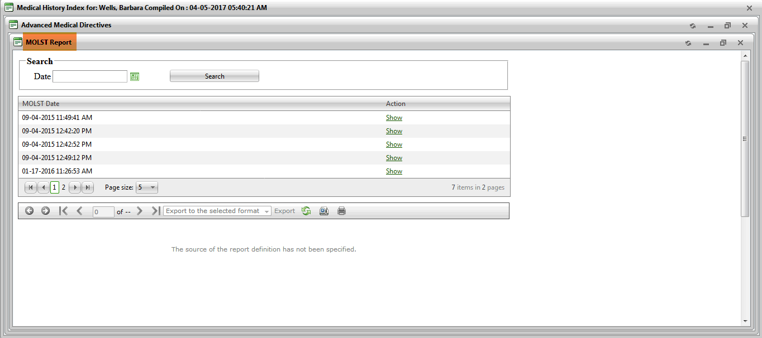

**(Image 13.1.8.1: MOLST Report)**

**13.1.8.2)** [**http://umrtest.com/UMRPortals/PatientFeatures/PatientFeaturesSearch.aspx**](http://umrtest.com/UMRPortals/PatientFeatures/PatientFeaturesSearch.aspx)

[**http://umrtest.com/UMRPortals/DataRecord/Report/MOLSTReport.aspx?PatientKey=3**](http://umrtest.com/UMRPortals/DataRecord/Report/MOLSTReport.aspx?PatientKey=3)

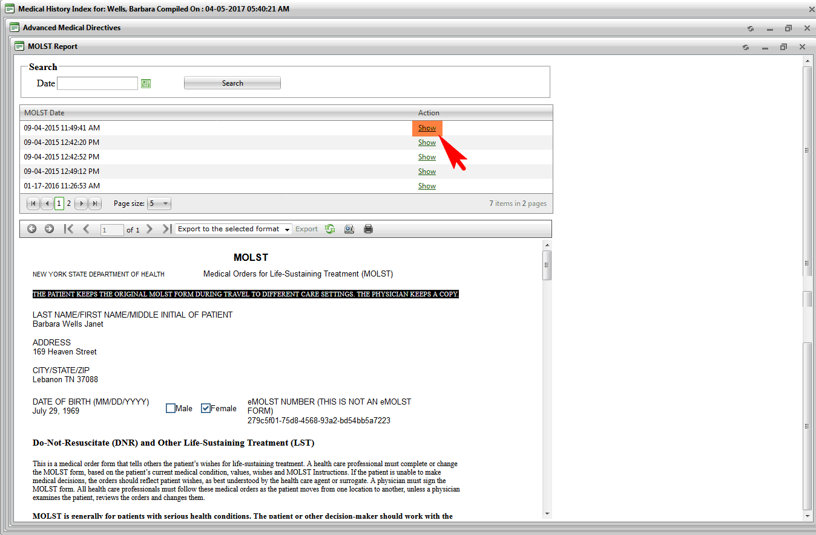

**(Image 13.1.8.2: MOLST Report - Show)**

**13.1.8.3)** [**http://umrtest.com/UMRPortals/PatientFeatures/PatientFeaturesSearch.aspx**](http://umrtest.com/UMRPortals/PatientFeatures/PatientFeaturesSearch.aspx)

[**http://umrtest.com/UMRPortals/PatientFeatures/AMDEditor.aspx?PatientKey=3**](http://umrtest.com/UMRPortals/PatientFeatures/AMDEditor.aspx?PatientKey=3)

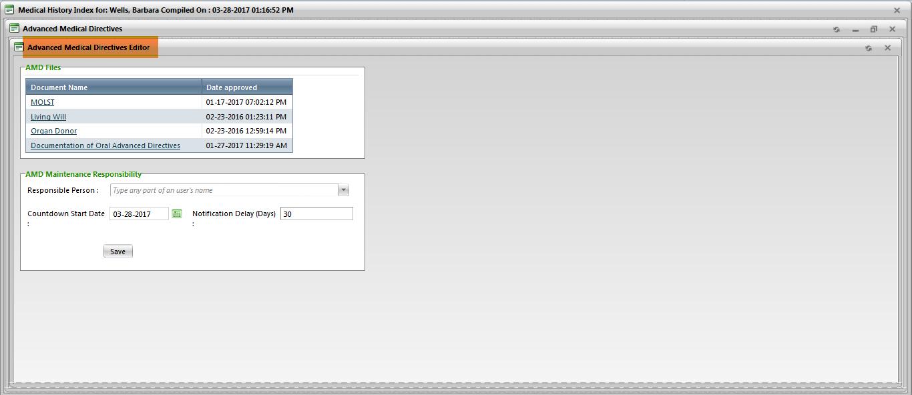

**(Image 13.1.8.3: Advanced Medical Directives Editor)**

**13.1.8.4)** [**http://umrtest.com/UMRPortals/PatientFeatures/PatientFeaturesSearch.aspx**](http://umrtest.com/UMRPortals/PatientFeatures/PatientFeaturesSearch.aspx)

[**http://umrtest.com/UMRPortals/DataRecord/PatientMOLSTViewer.aspx?PatientKey=3**](http://umrtest.com/UMRPortals/DataRecord/PatientMOLSTViewer.aspx?PatientKey=3)

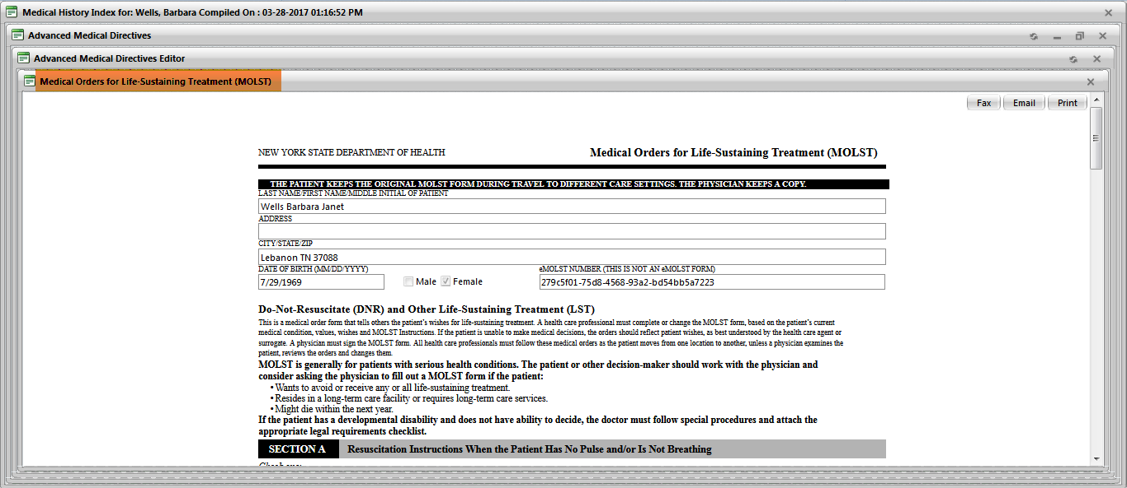

**(Image 13.1.8.4: MOLST)**

**NOTE: Fax, Email and Print links are related to Fax(Image 13.1.3.2), Email(Image 13.1.3.3) and Print(Image 13.1.3.1).**

**13.1.9)** [**http://umrtest.com/UMRPortals/PatientFeatures/PatientFeaturesSearch.aspx**](http://umrtest.com/UMRPortals/PatientFeatures/PatientFeaturesSearch.aspx)

[**http://umrtest.com/UMRPortals/PatientFeatures/Emergency.aspx?PatientKey=3**](http://umrtest.com/UMRPortals/PatientFeatures/Emergency.aspx?PatientKey=3)

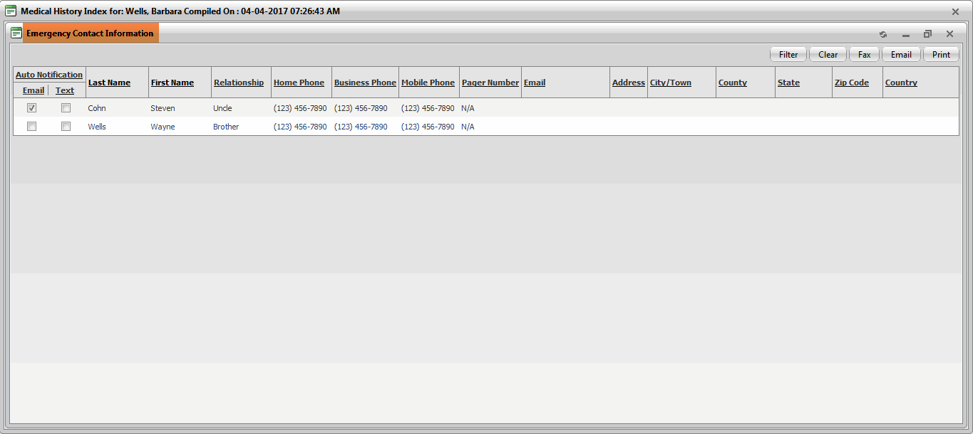

**(Image 13.1.9: Emergency Information)**

**NOTE: Filter, Fax, Clear, Email and Print links are related to Filter(Image 13.1.2.3), Fax(Image 13.1.3.2), Clear(Image 13.1.1.11), Email(Image 13.1.3.3) and Print(Image 13.1.3.1).**

**13.1.10)** [**http://umrtest.com/UMRPortals/PatientFeatures/PatientFeaturesSearch.aspx**](http://umrtest.com/UMRPortals/PatientFeatures/PatientFeaturesSearch.aspx)

[**http://umrtest.com/UMRPortals/AlertNetwork/AlertChronologyList.aspx?PatientKey=3**](http://umrtest.com/UMRPortals/AlertNetwork/AlertChronologyList.aspx?PatientKey=3)

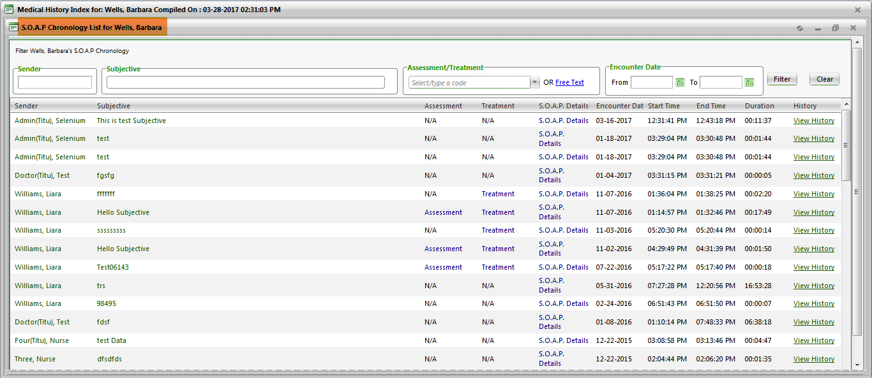

**(Image 13.1.10: S.O.A.P. Chronology)**

**13.1.10.1)** [**http://umrtest.com/UMRPortals/PatientFeatures/PatientFeaturesSearch.aspx**](http://umrtest.com/UMRPortals/PatientFeatures/PatientFeaturesSearch.aspx)

[**http://umrtest.com/UMRPortals/AlertNetwork/ViewAssessmentDetails.aspx?AlertId=171058**](http://umrtest.com/UMRPortals/AlertNetwork/ViewAssessmentDetails.aspx?AlertId=171058)

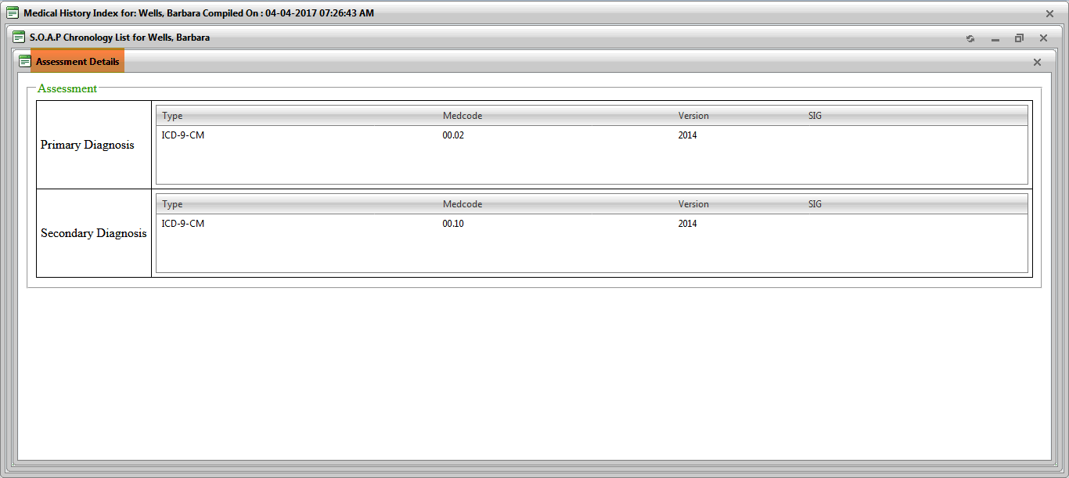

**(Image 13.1.10.1: Assessment)**

**13.1.10.2)** [**http://umrtest.com/UMRPortals/PatientFeatures/PatientFeaturesSearch.aspx**](http://umrtest.com/UMRPortals/PatientFeatures/PatientFeaturesSearch.aspx)

[**http://umrtest.com/UMRPortals/AlertNetwork/ViewTreatmentDetails.aspx?AlertId=171058**](http://umrtest.com/UMRPortals/AlertNetwork/ViewTreatmentDetails.aspx?AlertId=171058)

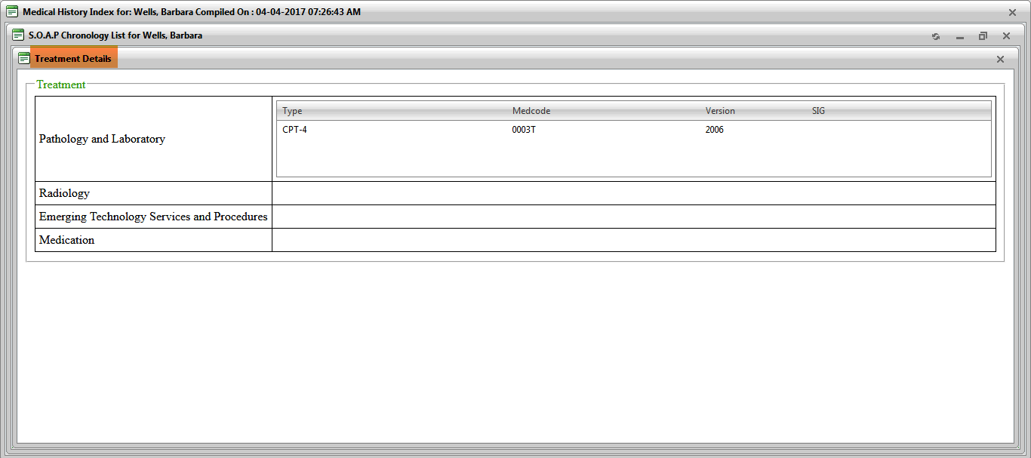

**(Image 13.1.10.2: Treatment)**

**NOTE: S.O.A.P. Details link is related to S.O.A.P. Details(Image 13.1.1.6).**

**13.1.10.3)** [**http://umrtest.com/UMRPortals/PatientFeatures/PatientFeaturesSearch.aspx**](http://umrtest.com/UMRPortals/PatientFeatures/PatientFeaturesSearch.aspx)

[**http://umrtest.com/UMRPortals/AlertNetwork/AlertHistory.aspx?AlertId=171058**](http://umrtest.com/UMRPortals/AlertNetwork/AlertHistory.aspx?AlertId=171058)

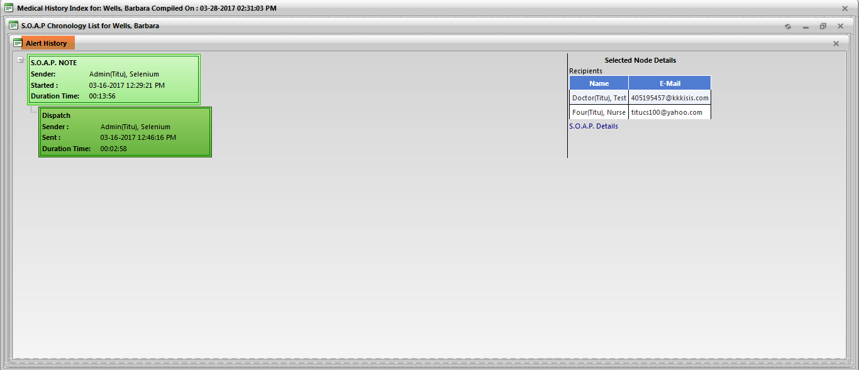

**(Image 13.1.10.3: Alert History)**

**NOTE: S.O.A.P. Details link is related to S.O.A.P. Details(Image 13.1.1.6).**

**13.1.11)** [**http://umrtest.com/UMRPortals/PatientFeatures/PatientFeaturesSearch.aspx**](http://umrtest.com/UMRPortals/PatientFeatures/PatientFeaturesSearch.aspx)

[**http://umrtest.com/UMRPortals/PatientFeatures/Demographic.aspx?PatientKey=3**](http://umrtest.com/UMRPortals/PatientFeatures/Demographic.aspx?PatientKey=3)

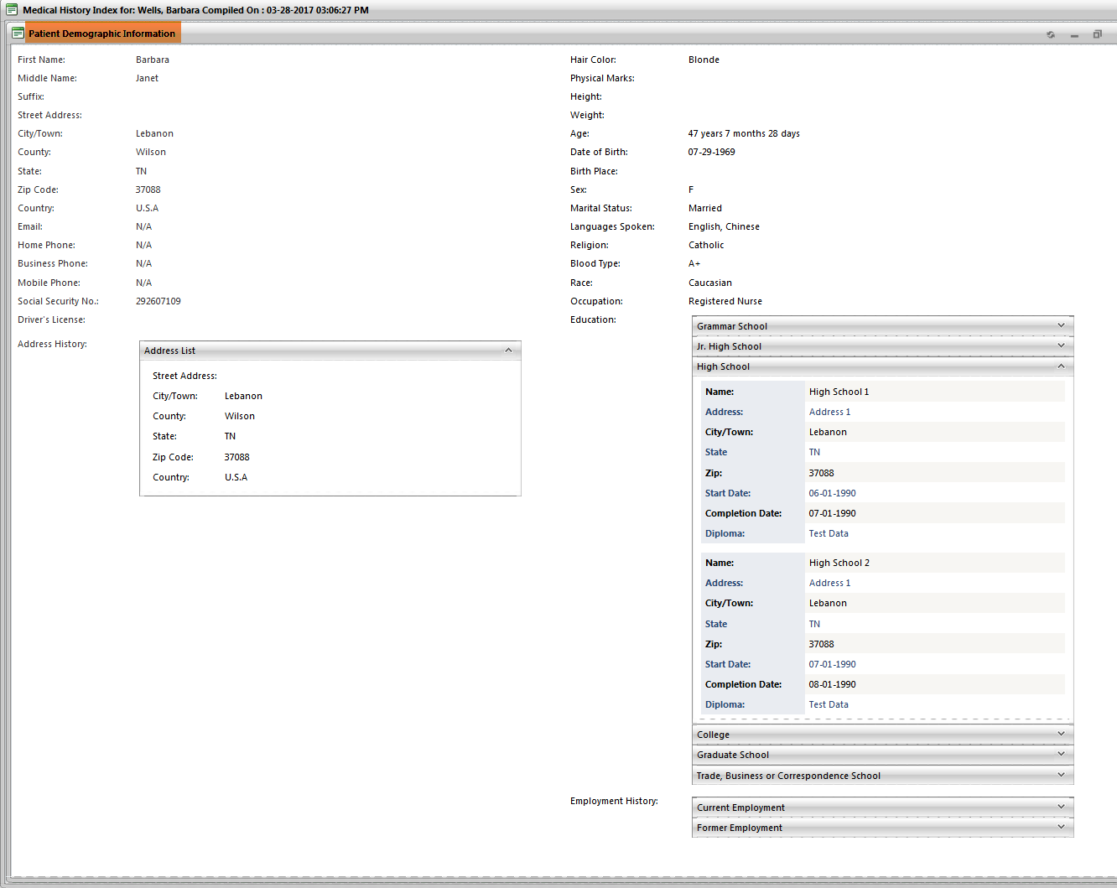

**(Image 13.1.11: Patient Demographics)**

**NOTE: Fax, Email and Print links are related to Fax(Image 13.1.3.2), Email(Image 13.1.3.3) and Print(Image 13.1.3.1).**

**13.1.12)** [**http://umrtest.com/UMRPortals/PatientFeatures/PatientFeaturesSearch.aspx**](http://umrtest.com/UMRPortals/PatientFeatures/PatientFeaturesSearch.aspx)

[**http://umrtest.com/UMRPortals/PatientFeatures/Insurance.aspx?PatientKey=3**](http://umrtest.com/UMRPortals/PatientFeatures/Insurance.aspx?PatientKey=3)

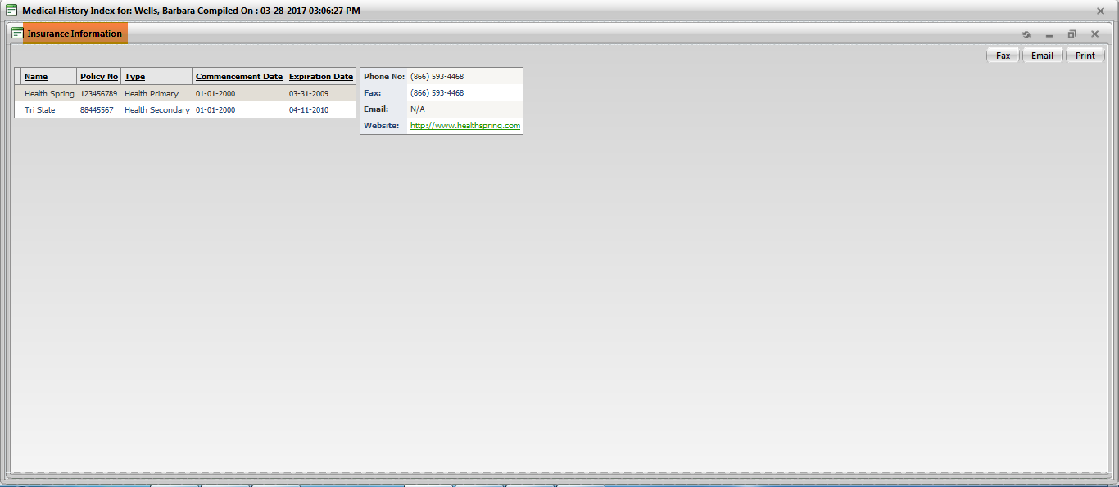

**(Image 13.1.12: Insurance Information)**

**NOTE: Fax, Email and Print links are related to Fax(Image 13.1.3.2), Email(Image 13.1.3.3) and Print(Image 13.1.3.1).**

**13.1.13)** [**http://umrtest.com/UMRPortals/PatientFeatures/PatientFeaturesSearch.aspx**](http://umrtest.com/UMRPortals/PatientFeatures/PatientFeaturesSearch.aspx)

[**http://umrtest.com/UMRPortals/PatientFeatures/PatientSchedule.aspx?PatientKey=3**](http://umrtest.com/UMRPortals/PatientFeatures/PatientSchedule.aspx?PatientKey=3)

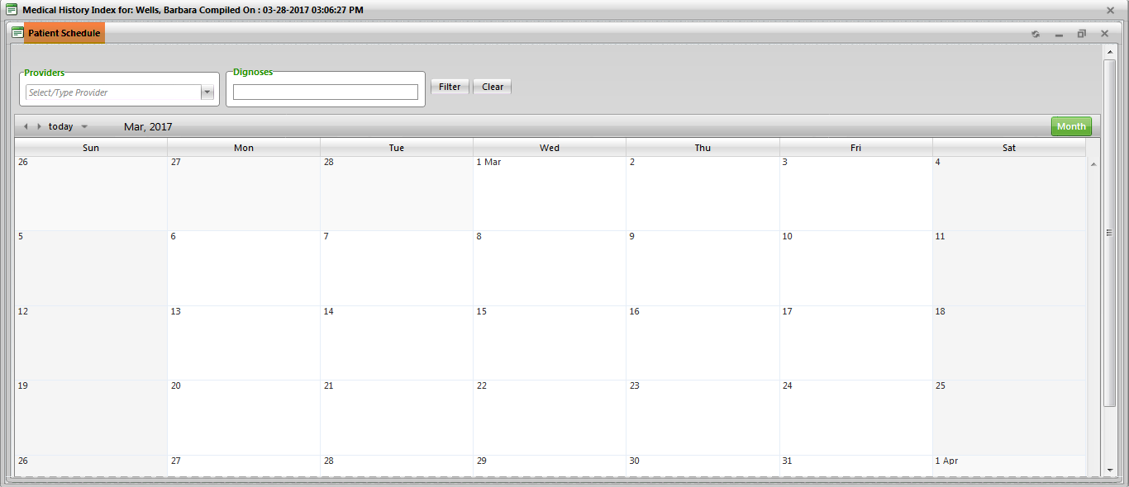

**(Image 13.1.13: Patient Schedule)**

**13.1.14)** [**http://umrtest.com/UMRPortals/PatientFeatures/PatientFeaturesSearch.aspx**](http://umrtest.com/UMRPortals/PatientFeatures/PatientFeaturesSearch.aspx)

[**http://umrtest.com/UMRPortals/PatientFeatures/Legend.aspx?PatientKey=3**](http://umrtest.com/UMRPortals/PatientFeatures/Legend.aspx?PatientKey=3)

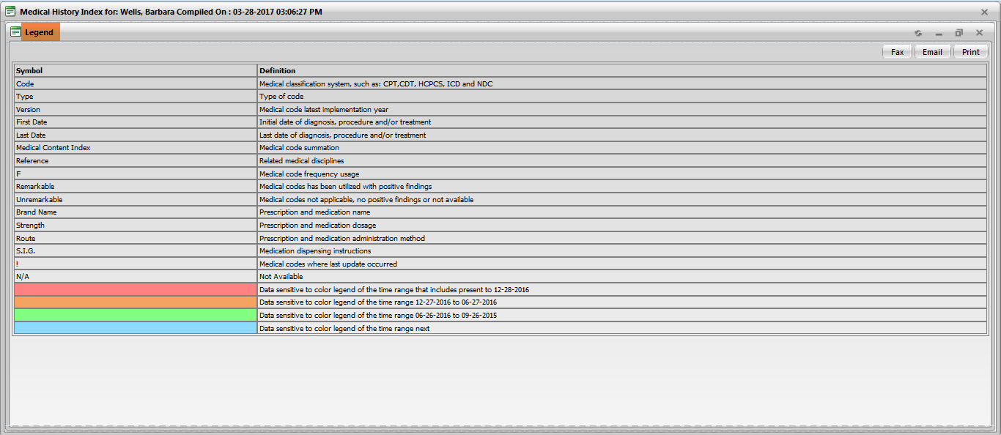

**(Image 13.1.14: Legend)**

**NOTE: Fax, Email and Print links are related to Fax(Image 13.1.3.2), Email(Image 13.1.3.3) and Print(Image 13.1.3.1).**

**13.1.15)** [**http://umrtest.com/UMRPortals/PatientFeatures/PatientFeaturesSearch.aspx**](http://umrtest.com/UMRPortals/PatientFeatures/PatientFeaturesSearch.aspx)

[**http://umrtest.com/UMRPortals/PatientFeatures/Disclaimer.aspx**](http://umrtest.com/UMRPortals/PatientFeatures/Disclaimer.aspx)

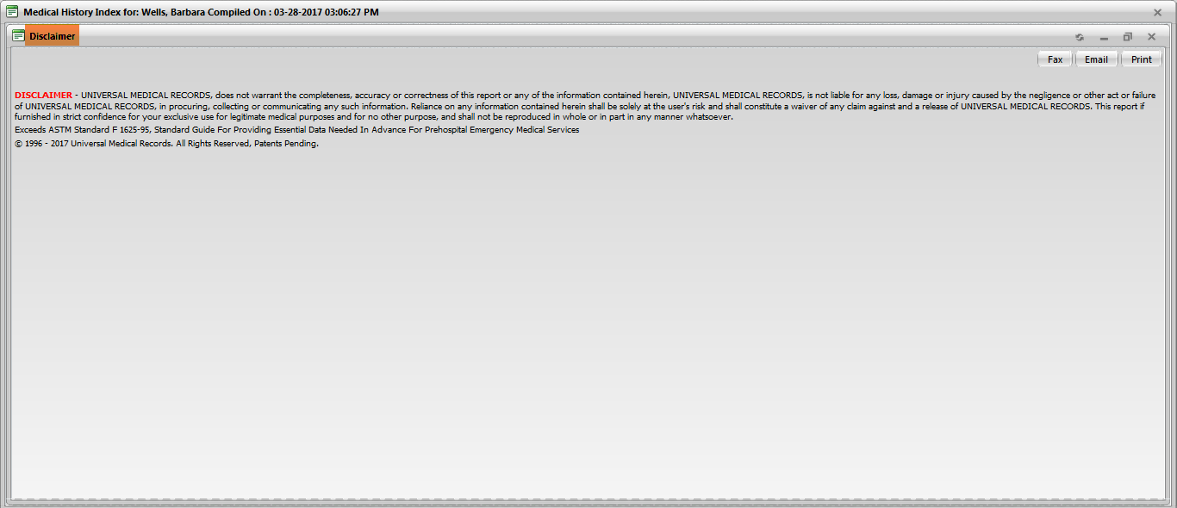

**(Image 13.1.15: Disclaimer)**

**NOTE: Fax, Email and Print links are related to Fax(Image 13.1.3.2), Email(Image 13.1.3.3) and Print(Image 13.1.3.1).**

**13.1.16)** [**http://umrtest.com/UMRPortals/PatientFeatures/PatientFeaturesSearch.aspx**](http://umrtest.com/UMRPortals/PatientFeatures/PatientFeaturesSearch.aspx)

[**http://umrtest.com/UMRPortals/PatientFeatures/RDNew.aspx?PatientKey=3&DisCode=9&DisType=D&DisName=Gastroenterology&CodeType=(CODE_TYPE=@1@%20OR%20CODE_TYPE=@2@%20OR%20CODE_TYPE=@3@%20OR%20CODE_TYPE=@5@)**](http://umrtest.com/UMRPortals/PatientFeatures/RDNew.aspx?PatientKey=3&DisCode=9&DisType=D&DisName=Gastroenterology&CodeType=(CODE_TYPE=@1@%20OR%20CODE_TYPE=@2@%20OR%20CODE_TYPE=@3@%20OR%20CODE_TYPE=@5@))

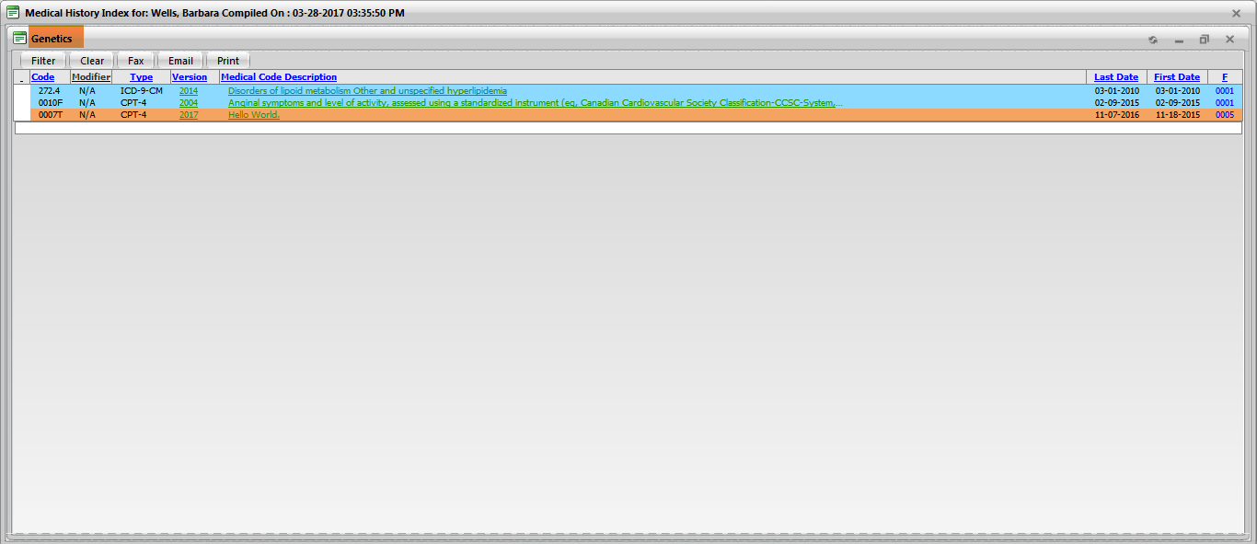

**(Image 13.1.16: Remarkable Disciplines)**

**NOTE: Medcode History, Related Disciplines, Diagnosis Details, Filter, Clear, Fax, Email and Print links are related to Medcode History(Image 13.1.1.1), Related Disciplines(Image 13.1.1.2), Diagnosis Details(Image 13.1.1.3), Filter(Image 13.1.1.10), Clear(Image 13.1.1.11), Fax(Image 13.1.3.2), Email(Image 13.1.3.3) and Print(Image 13.1.3.1).**

**13.1.17)** [**http://umrtest.com/UMRPortals/PatientFeatures/PatientFeaturesSearch.aspx**](http://umrtest.com/UMRPortals/PatientFeatures/PatientFeaturesSearch.aspx)

[**http://umrtest.com/UMRPortals/PatientFeatures/PrintPreview.aspx?PatientKey=3&SelectedCodeIndex=0,1,2,4**](http://umrtest.com/UMRPortals/PatientFeatures/PrintPreview.aspx?PatientKey=3&SelectedCodeIndex=0,1,2,4)

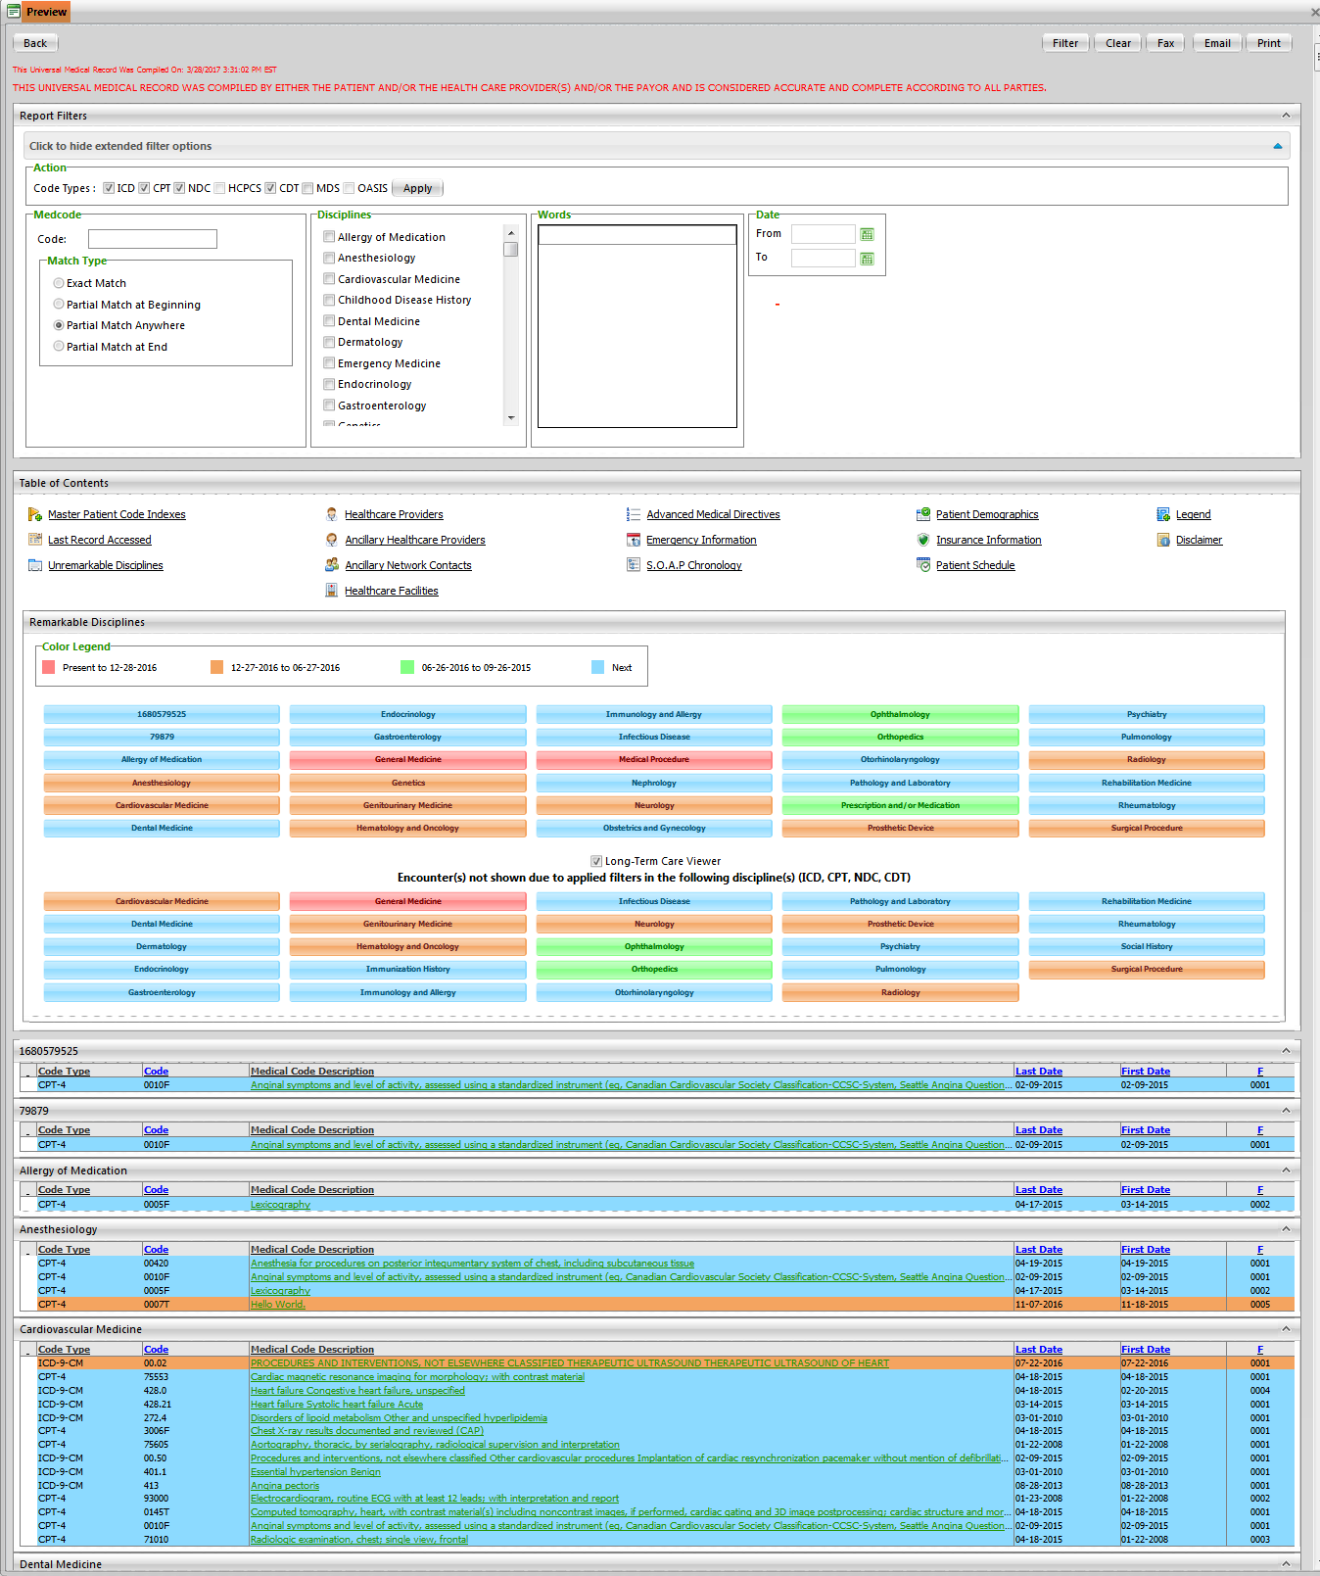

**(Image 13.1.17: Preview)**

**13.2)** [**http://umrtest.com/UMRPortals/PatientFeatures/PatientFeaturesSearch.aspx**](http://umrtest.com/UMRPortals/PatientFeatures/PatientFeaturesSearch.aspx)

[**http://umrtest.com/UMRPortals/PatientFeatures/PatientFeaturesSearch.aspx**](http://umrtest.com/UMRPortals/PatientFeatures/PatientFeaturesSearch.aspx)

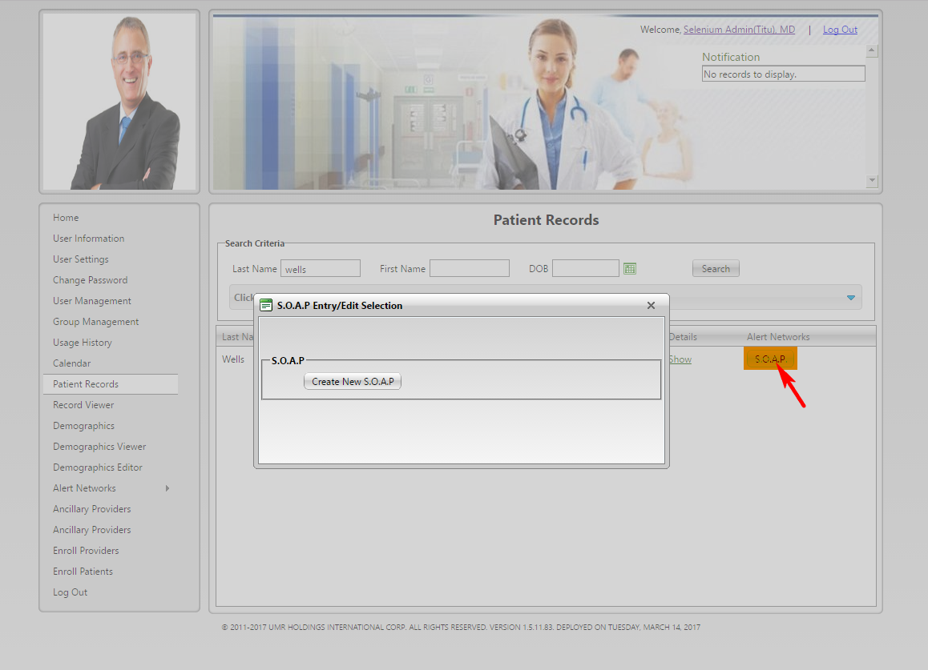

**(Image 13.2: S.O.A.P. Entry/Edit Selection-1)**

**13.2.1)** [**http://umrtest.com/UMRPortals/PatientFeatures/PatientFeaturesSearch.aspx**](http://umrtest.com/UMRPortals/PatientFeatures/PatientFeaturesSearch.aspx)

[**http://umrtest.com/UMRPortals/AlertNetwork/ProviderNotesPop.aspx?PatientKey=3**](http://umrtest.com/UMRPortals/AlertNetwork/ProviderNotesPop.aspx?PatientKey=3)

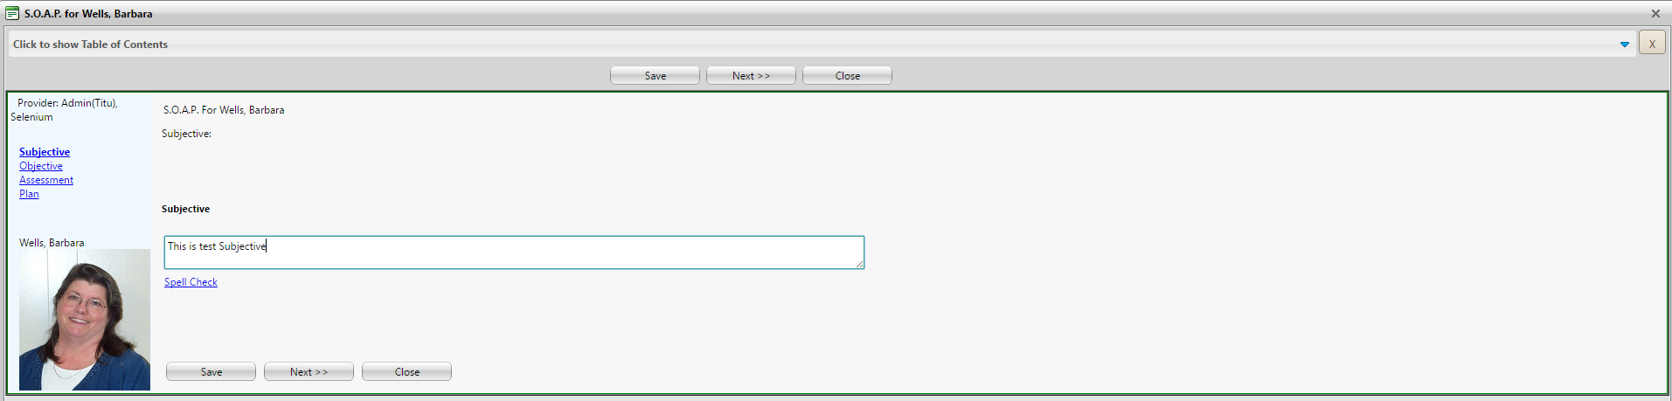

**(Image 13.2.1: S.O.A.P. Entry/Edit Selection-2)**

**13.2.2)** [**http://umrtest.com/UMRPortals/PatientFeatures/PatientFeaturesSearch.aspx**](http://umrtest.com/UMRPortals/PatientFeatures/PatientFeaturesSearch.aspx)

[**http://umrtest.com/UMRPortals/AlertNetwork/ProviderNotesPop.aspx?AlertIdToEdit=171065**](http://umrtest.com/UMRPortals/AlertNetwork/ProviderNotesPop.aspx?AlertIdToEdit=171065)

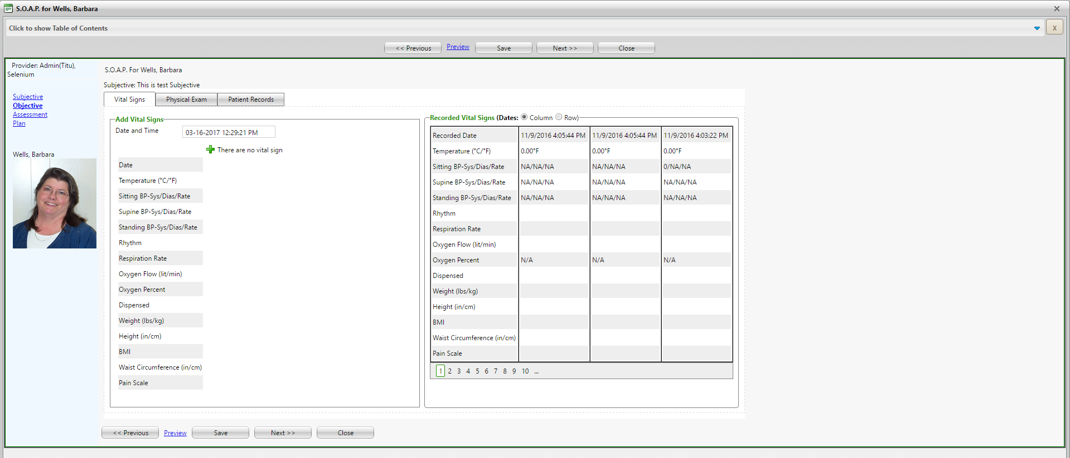

**(Image 13.2.2: S.O.A.P. Entry/Edit Selection-3)**

**13.2.3)** [**http://umrtest.com/UMRPortals/PatientFeatures/PatientFeaturesSearch.aspx**](http://umrtest.com/UMRPortals/PatientFeatures/PatientFeaturesSearch.aspx)

[**http://umrtest.com/UMRPortals/AlertNetwork/ProviderNotesPop.aspx?AlertIdToEdit=171065**](http://umrtest.com/UMRPortals/AlertNetwork/ProviderNotesPop.aspx?AlertIdToEdit=171065)

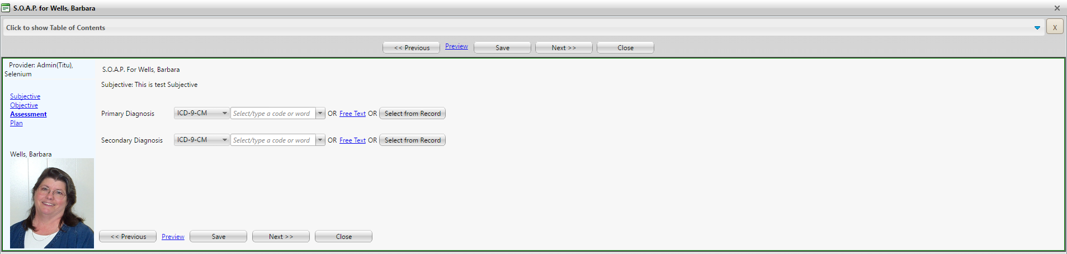

**(Image 13.2.3: S.O.A.P. Entry/Edit Selection-4)**

**13.2.4)** [**http://umrtest.com/UMRPortals/PatientFeatures/PatientFeaturesSearch.aspx**](http://umrtest.com/UMRPortals/PatientFeatures/PatientFeaturesSearch.aspx)

[**http://umrtest.com/UMRPortals/AlertNetwork/ProviderNotesPop.aspx?AlertIdToEdit=171065**](http://umrtest.com/UMRPortals/AlertNetwork/ProviderNotesPop.aspx?AlertIdToEdit=171065)

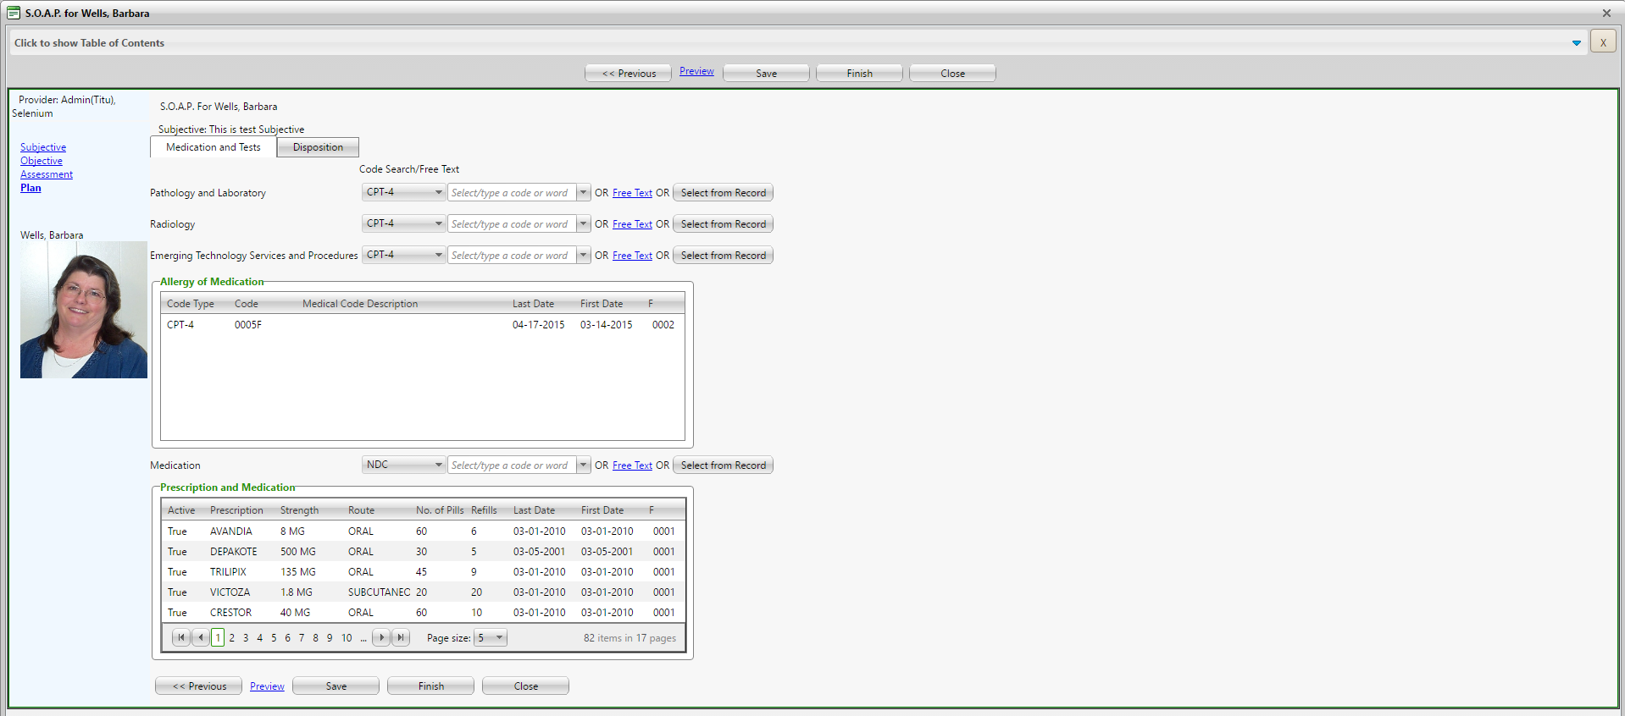

**(Image 13.2.4: S.O.A.P. Entry/Edit Selection-5)**

**13.2.5)** [**http://umrtest.com/UMRPortals/PatientFeatures/PatientFeaturesSearch.aspx**](http://umrtest.com/UMRPortals/PatientFeatures/PatientFeaturesSearch.aspx)

[**http://umrtest.com/UMRPortals/AlertNetwork/ProviderNotesPop.aspx?AlertIdToEdit=171065**](http://umrtest.com/UMRPortals/AlertNetwork/ProviderNotesPop.aspx?AlertIdToEdit=171065)

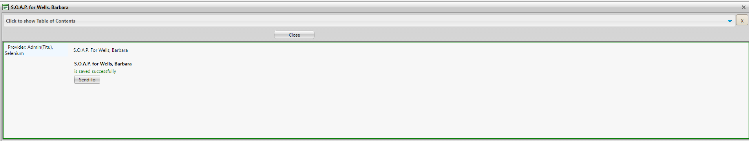

**(Image 13.2.5: S.O.A.P. Entry/Edit Selection-6)**

**12.2.6)** [**http://umrtest.com/UMRPortals/PatientFeatures/PatientFeaturesSearch.aspx**](http://umrtest.com/UMRPortals/PatientFeatures/PatientFeaturesSearch.aspx)

[**http://umrtest.com/UMRPortals/AlertNetwork/ProviderNotesPop.aspx?AlertIdToEdit=171065**](http://umrtest.com/UMRPortals/AlertNetwork/ProviderNotesPop.aspx?AlertIdToEdit=171065)

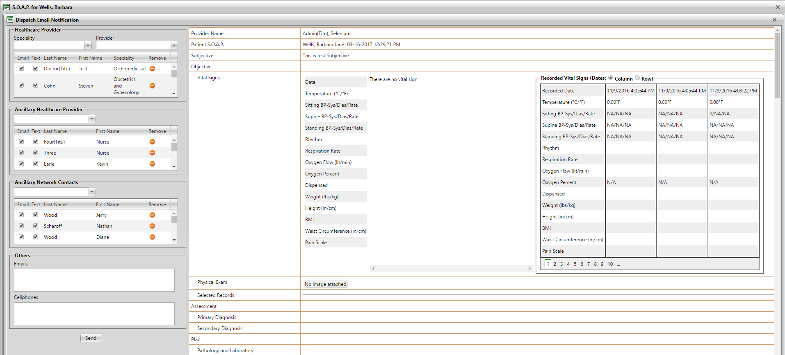

**(Image 13.2.6: S.O.A.P. Entry/Edit Selection-7)**

**NOTE: Prescription and Medication Details, Refill Details, Provider Locator and Facility Locator links are related to Prescription and Medication Details(Image 13.1.1.7), Refill Details(Image 13.1.1.8), Provider Locator(Image 13.1.1.3) and Facility Locator(Image 13.1.1.4).**

**14)** [**http://umrtest.com/UMRPortals/PatientFeatures/PatientFeatures.aspx**](http://umrtest.com/UMRPortals/PatientFeatures/PatientFeatures.aspx)

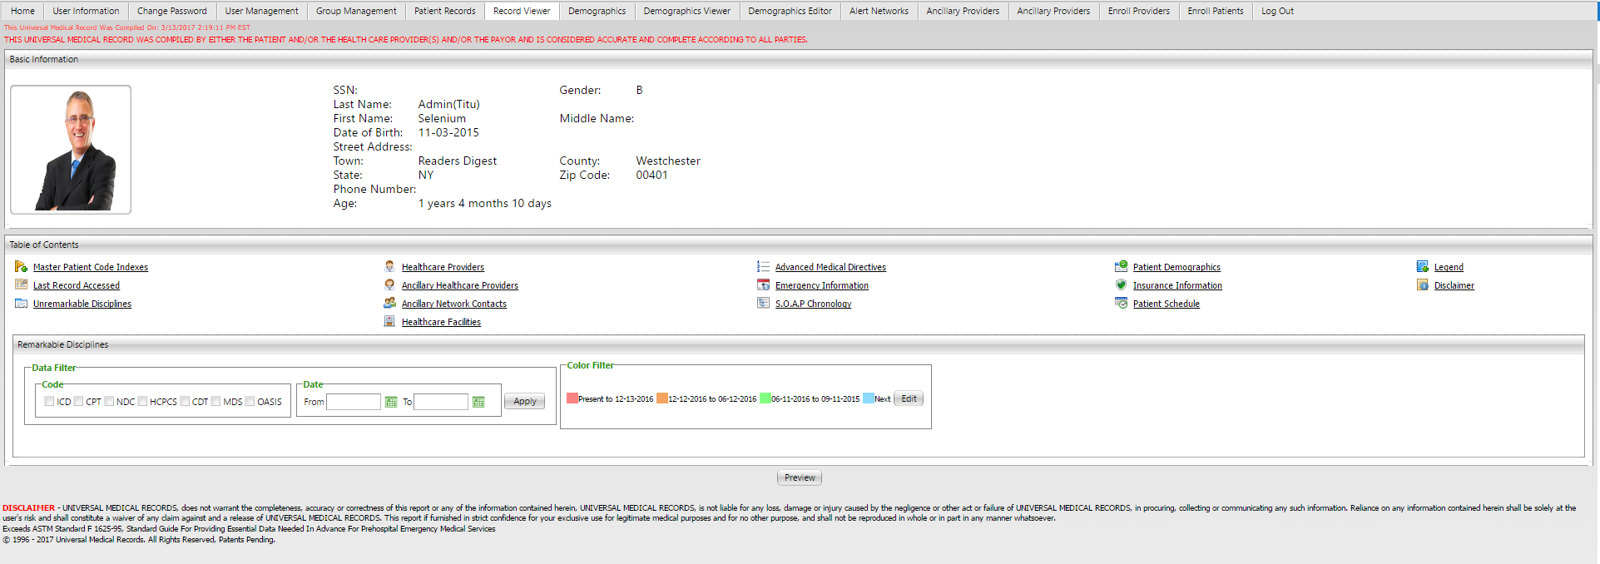

**(Image 14: Record Viewer)**

**NOTE: Other links are related to Medical History Indexes (Image 13.1 All)**

**15)** [**http://umrtest.com/UMRPortals/DataRecord/PatientDemographics.aspx**](http://umrtest.com/UMRPortals/DataRecord/PatientDemographics.aspx)

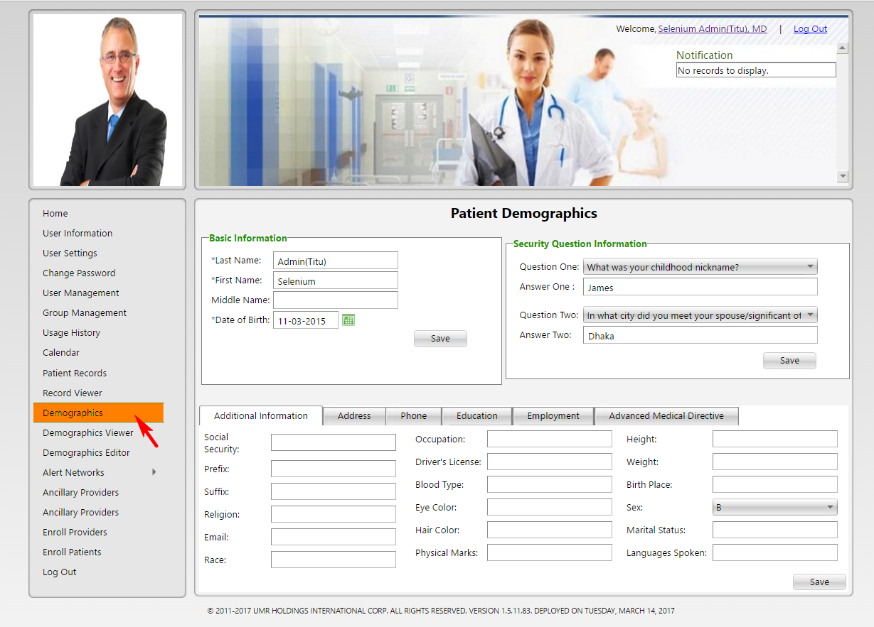

**(Image 15: Demographics - Additional Information)**

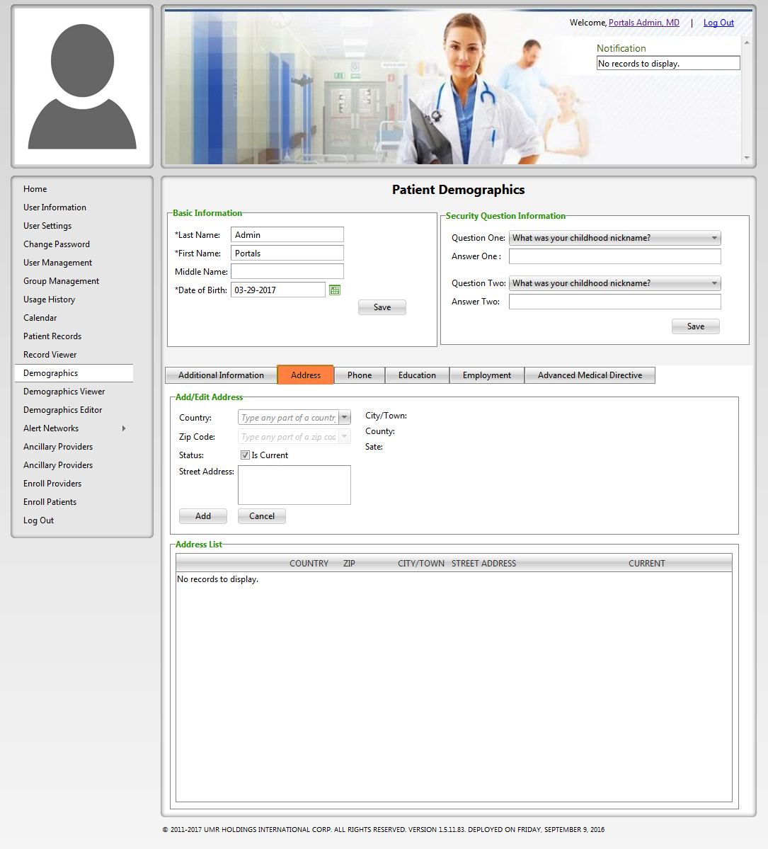

**(Image 15.1: Demographics - Address)**

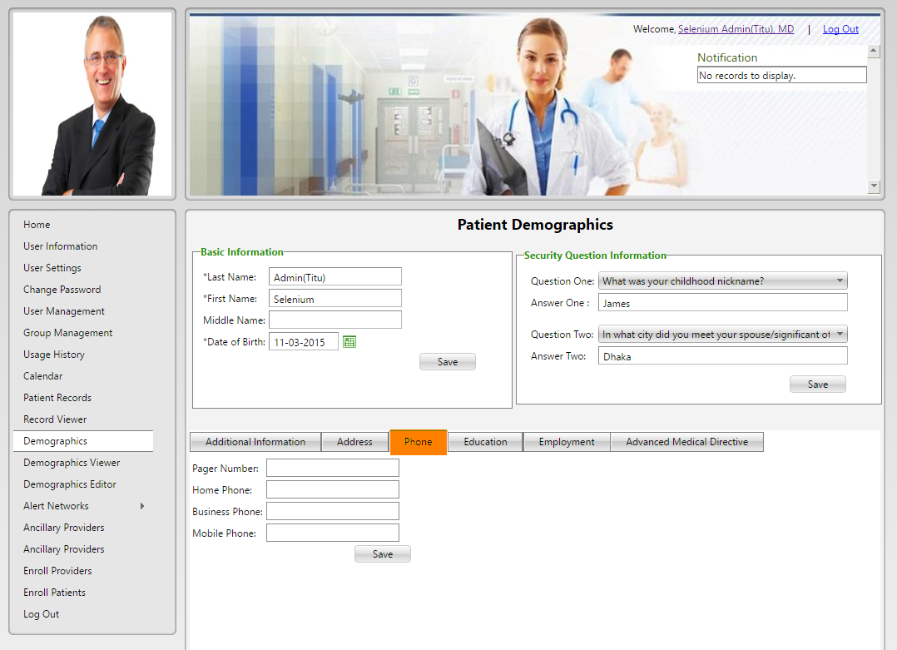

**(Image 15.2: Demographics - Phone)**

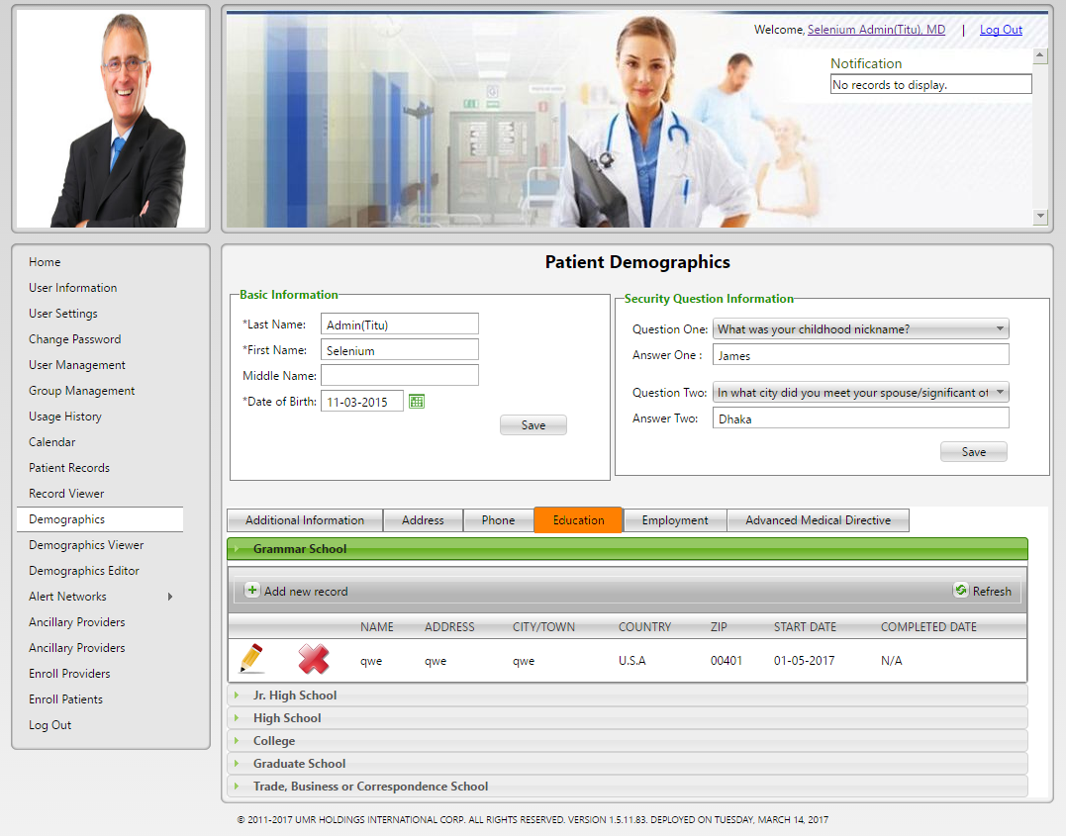

**(Image 15.3: Demographics - Education)**

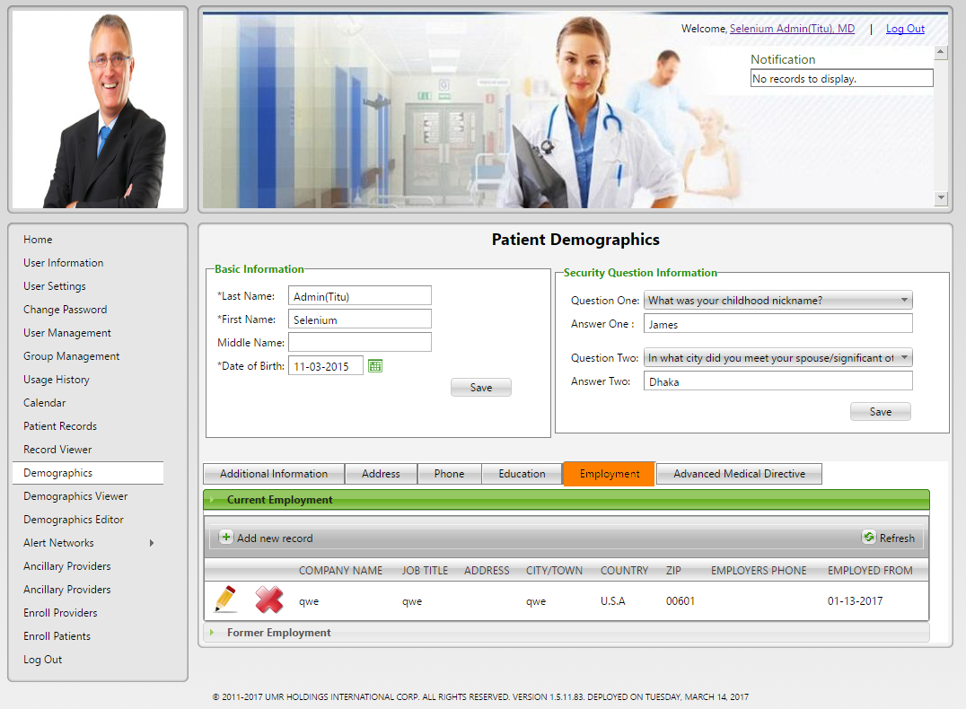

**(Image 15.4: Demographics - Employment)**

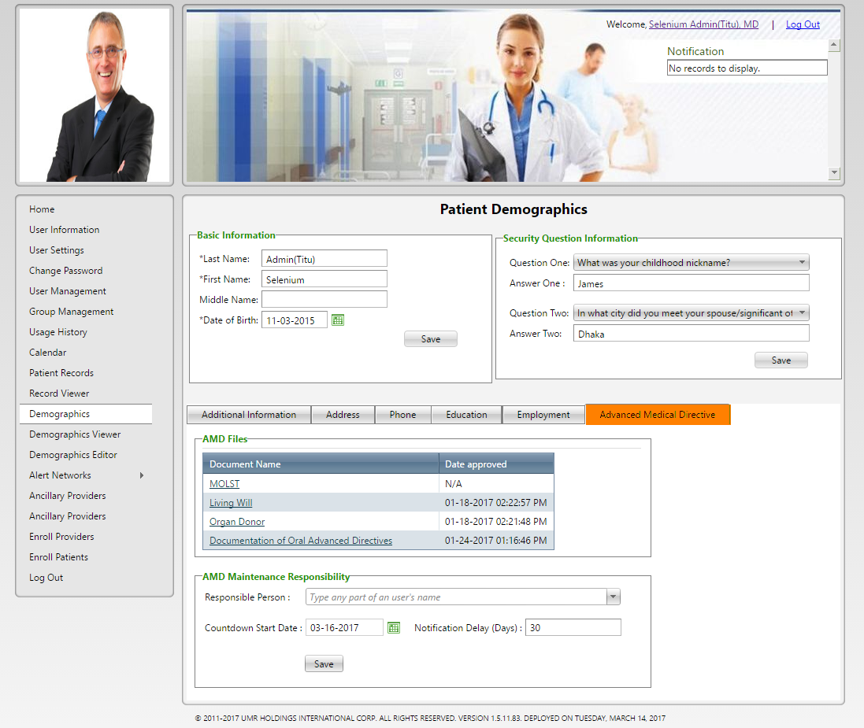

**(Image 15.5: Demographics - Advanced Medical Directive)**

**16)** [**http://umrtest.com/UMRPortals/DataRecord/DemographicsViewer.aspx**](http://umrtest.com/UMRPortals/DataRecord/DemographicsViewer.aspx)

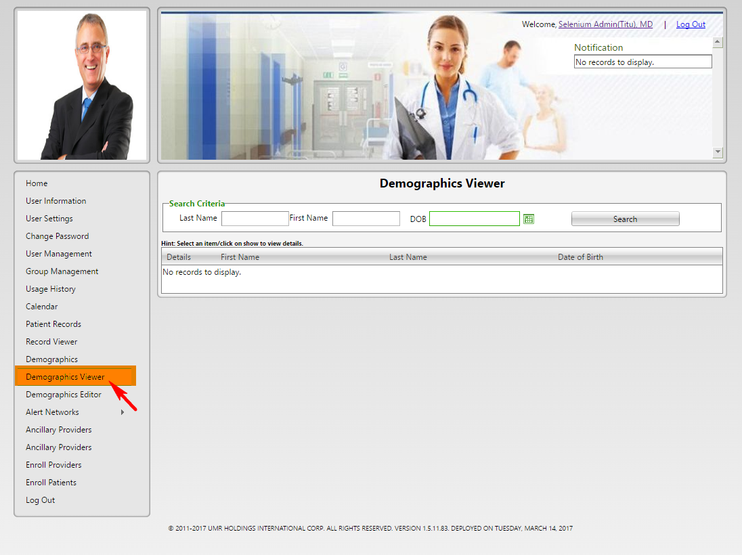

**(Image 16: Demographics Viewer )**

**16.1)** [**http://umrtest.com/UMRPortals/DataRecord/DemographicsViewer.aspx**](http://umrtest.com/UMRPortals/DataRecord/DemographicsViewer.aspx)

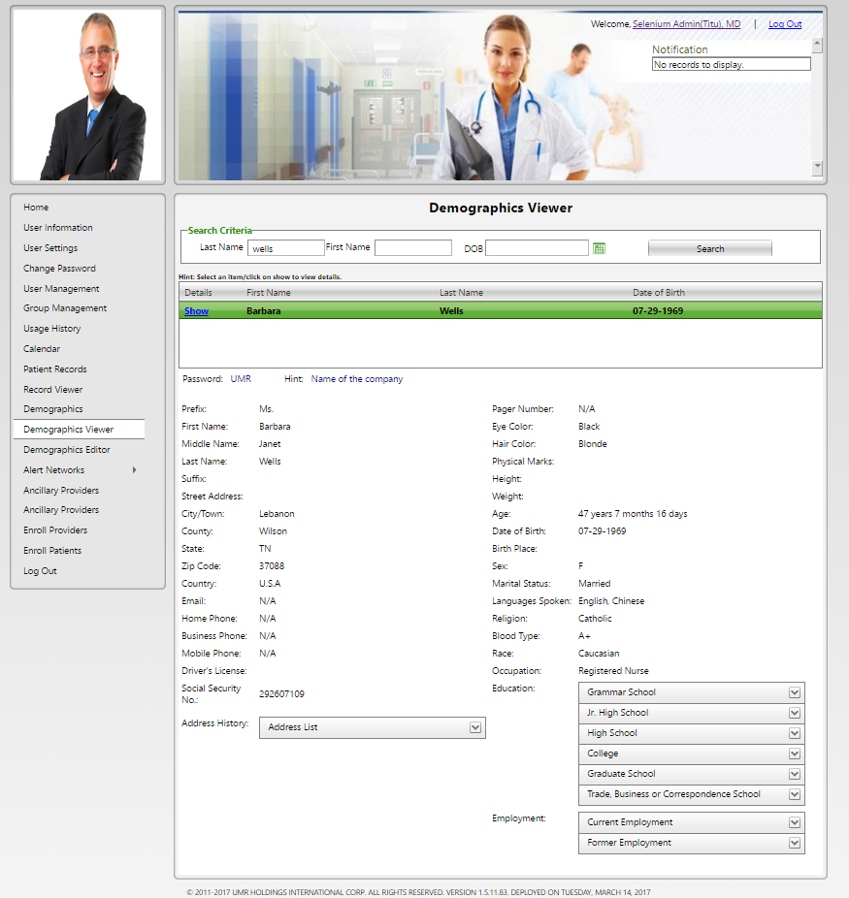

**(Image 16.1: Demographics Viewer Show)**

**17)** [**http://umrtest.com/UMRPortals/DataRecord/DemographicsEditor.aspx**](http://umrtest.com/UMRPortals/DataRecord/DemographicsEditor.aspx)

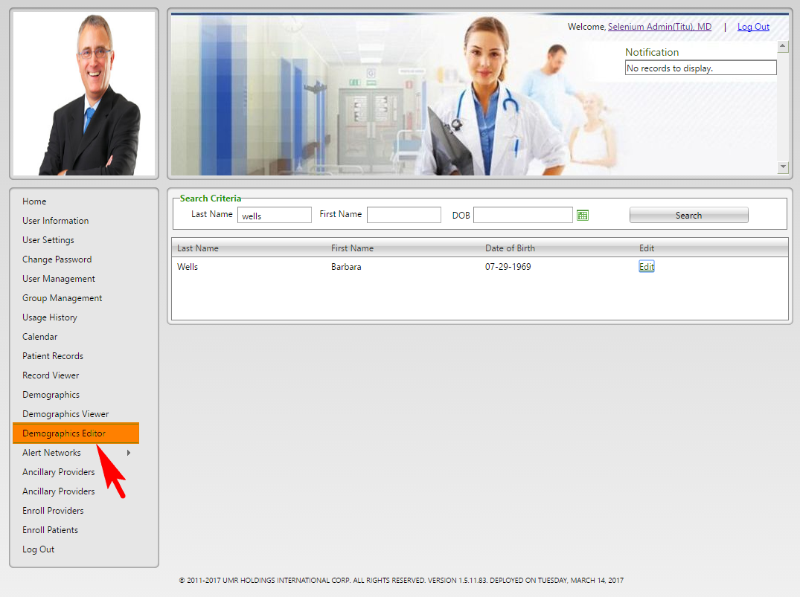

**(Image 17: Demographics Editor )**

**17.1)** [**http://umrtest.com/UMRPortals/DataRecord/DemographicsEditor.aspx**](http://umrtest.com/UMRPortals/DataRecord/DemographicsEditor.aspx)

[**http://umrtest.com/UMRPortals/DataRecord/PatientDemographicsPop.aspx?PatientKey=3**](http://umrtest.com/UMRPortals/DataRecord/PatientDemographicsPop.aspx?PatientKey=3)

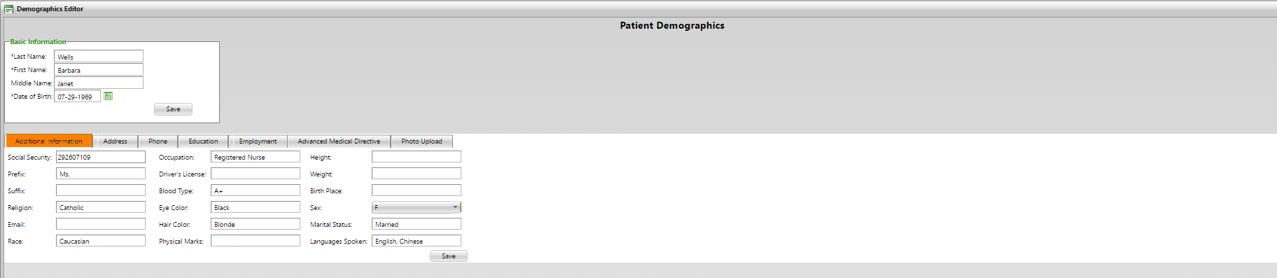

**(Image 17.1: Demographics Editor - Edit)**

**17.2)** [**http://umrtest.com/UMRPortals/DataRecord/DemographicsEditor.aspx**](http://umrtest.com/UMRPortals/DataRecord/DemographicsEditor.aspx)

[**http://umrtest.com/UMRPortals/DataRecord/PatientDemographicsPop.aspx?PatientKey=3**](http://umrtest.com/UMRPortals/DataRecord/PatientDemographicsPop.aspx?PatientKey=3)

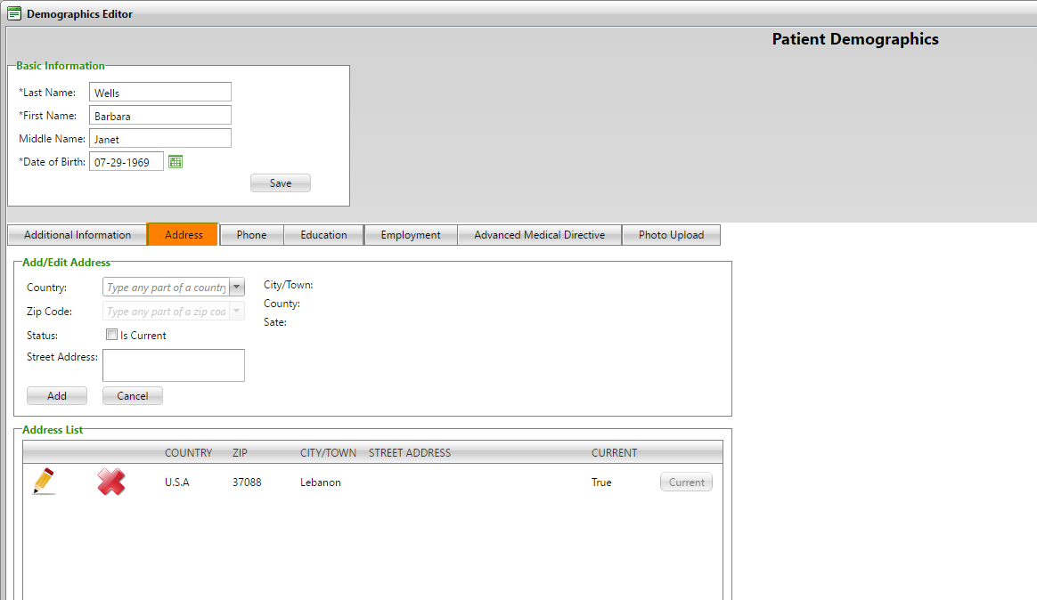

**(Image 17.2: Demographics Editor - Address)**

**17.3)** [**http://umrtest.com/UMRPortals/DataRecord/DemographicsEditor.aspx**](http://umrtest.com/UMRPortals/DataRecord/DemographicsEditor.aspx)

[**http://umrtest.com/UMRPortals/DataRecord/PatientDemographicsPop.aspx?PatientKey=3**](http://umrtest.com/UMRPortals/DataRecord/PatientDemographicsPop.aspx?PatientKey=3)

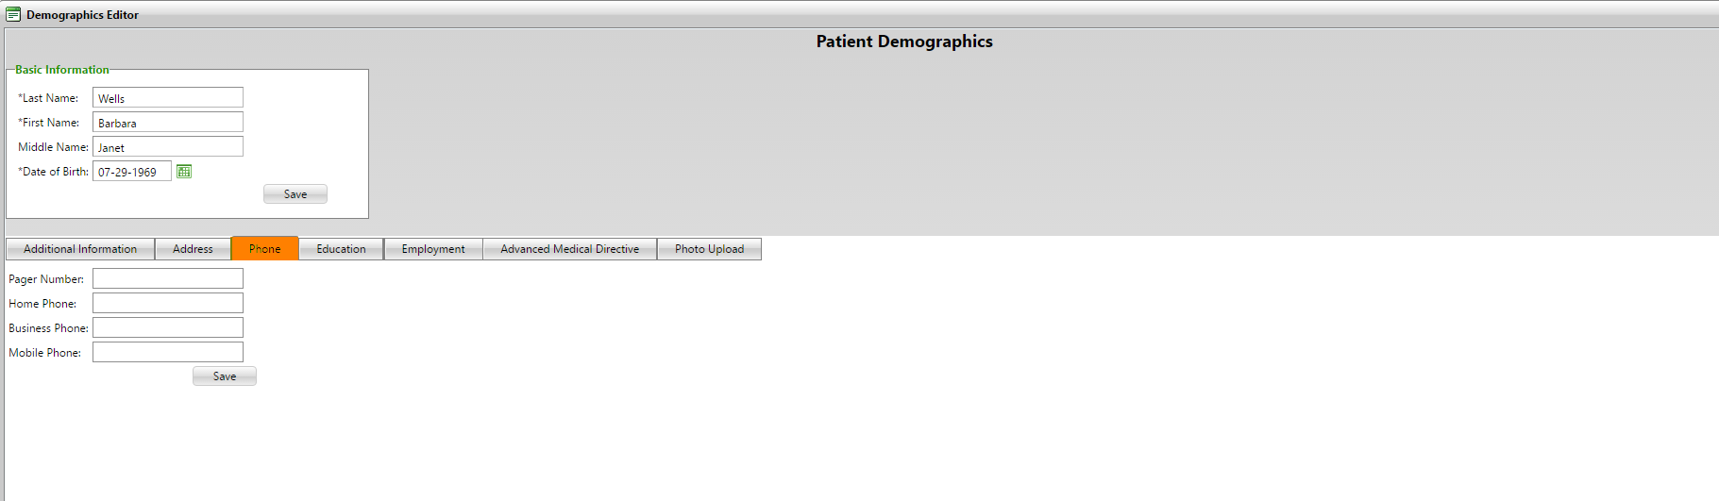

**(Image 17.3: Demographics Editor - Phone)**

**17.4)** [**http://umrtest.com/UMRPortals/DataRecord/DemographicsEditor.aspx**](http://umrtest.com/UMRPortals/DataRecord/DemographicsEditor.aspx)

[**http://umrtest.com/UMRPortals/DataRecord/PatientDemographicsPop.aspx?PatientKey=3**](http://umrtest.com/UMRPortals/DataRecord/PatientDemographicsPop.aspx?PatientKey=3)

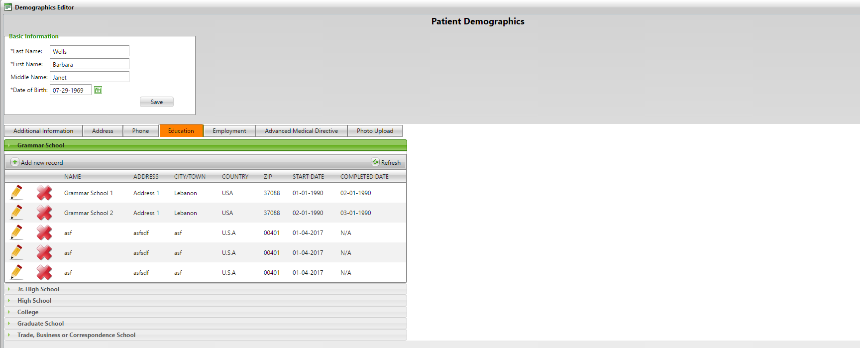

**(Image 17.4: Demographics Editor - Education)**

**17.5)** [**http://umrtest.com/UMRPortals/DataRecord/DemographicsEditor.aspx**](http://umrtest.com/UMRPortals/DataRecord/DemographicsEditor.aspx)

[**http://umrtest.com/UMRPortals/DataRecord/PatientDemographicsPop.aspx?PatientKey=3**](http://umrtest.com/UMRPortals/DataRecord/PatientDemographicsPop.aspx?PatientKey=3)

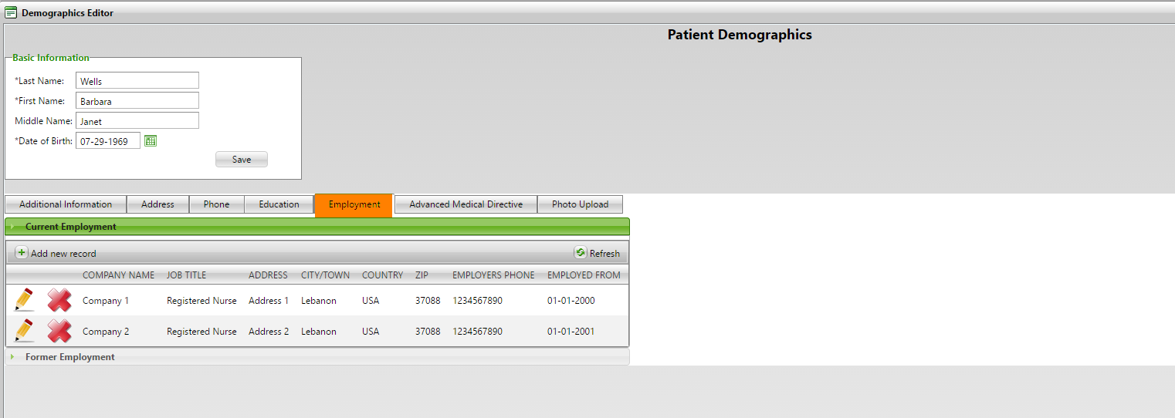

**(Image 17.5: Demographics Editor - Employment)**

**17.6)** [**http://umrtest.com/UMRPortals/DataRecord/DemographicsEditor.aspx**](http://umrtest.com/UMRPortals/DataRecord/DemographicsEditor.aspx)

[**http://umrtest.com/UMRPortals/DataRecord/PatientDemographicsPop.aspx?PatientKey=3**](http://umrtest.com/UMRPortals/DataRecord/PatientDemographicsPop.aspx?PatientKey=3)

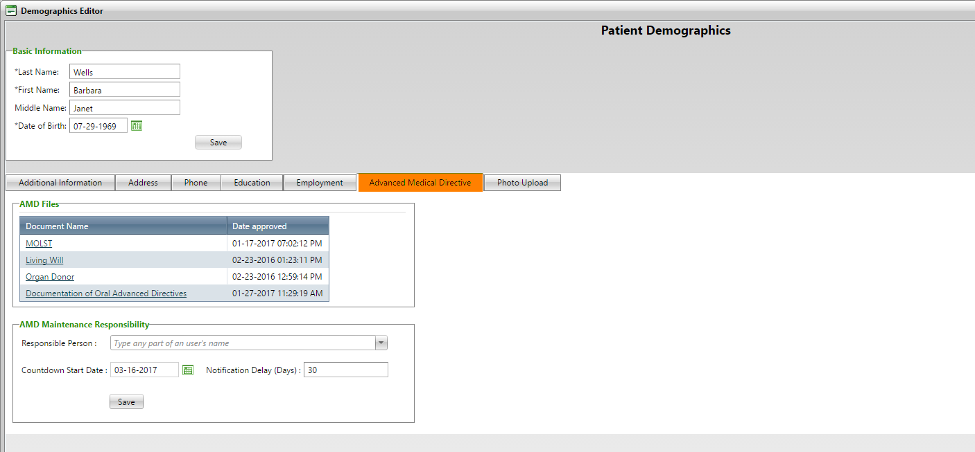

**(Image 17.6: Demographics Editor - Advanced Medical Directive)**

**17.7)** [**http://umrtest.com/UMRPortals/DataRecord/DemographicsEditor.aspx**](http://umrtest.com/UMRPortals/DataRecord/DemographicsEditor.aspx)

[**http://umrtest.com/UMRPortals/DataRecord/PatientDemographicsPop.aspx?PatientKey=3**](http://umrtest.com/UMRPortals/DataRecord/PatientDemographicsPop.aspx?PatientKey=3)

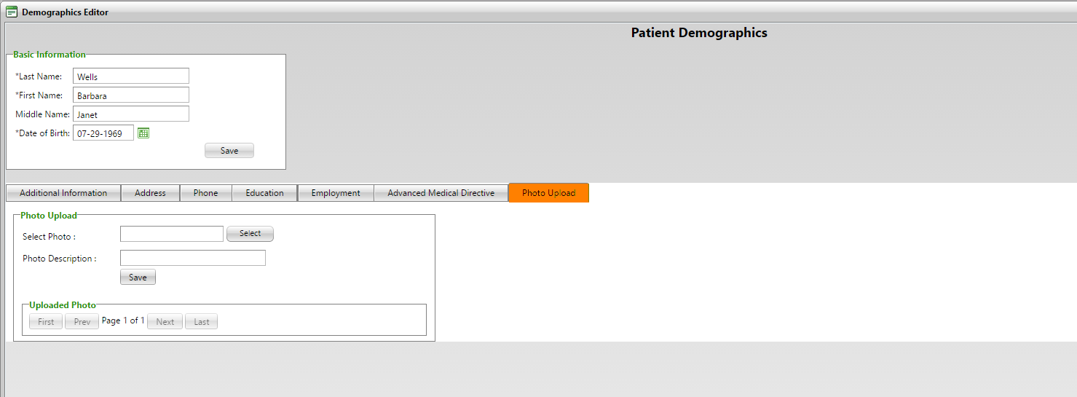

**(Image 17.7: Demographics Editor - Photo Upload)**

**18)** [**http://umrtest.com/UMRPortals/AlertNetwork/ProviderNotes.aspx**](http://umrtest.com/UMRPortals/AlertNetwork/ProviderNotes.aspx)

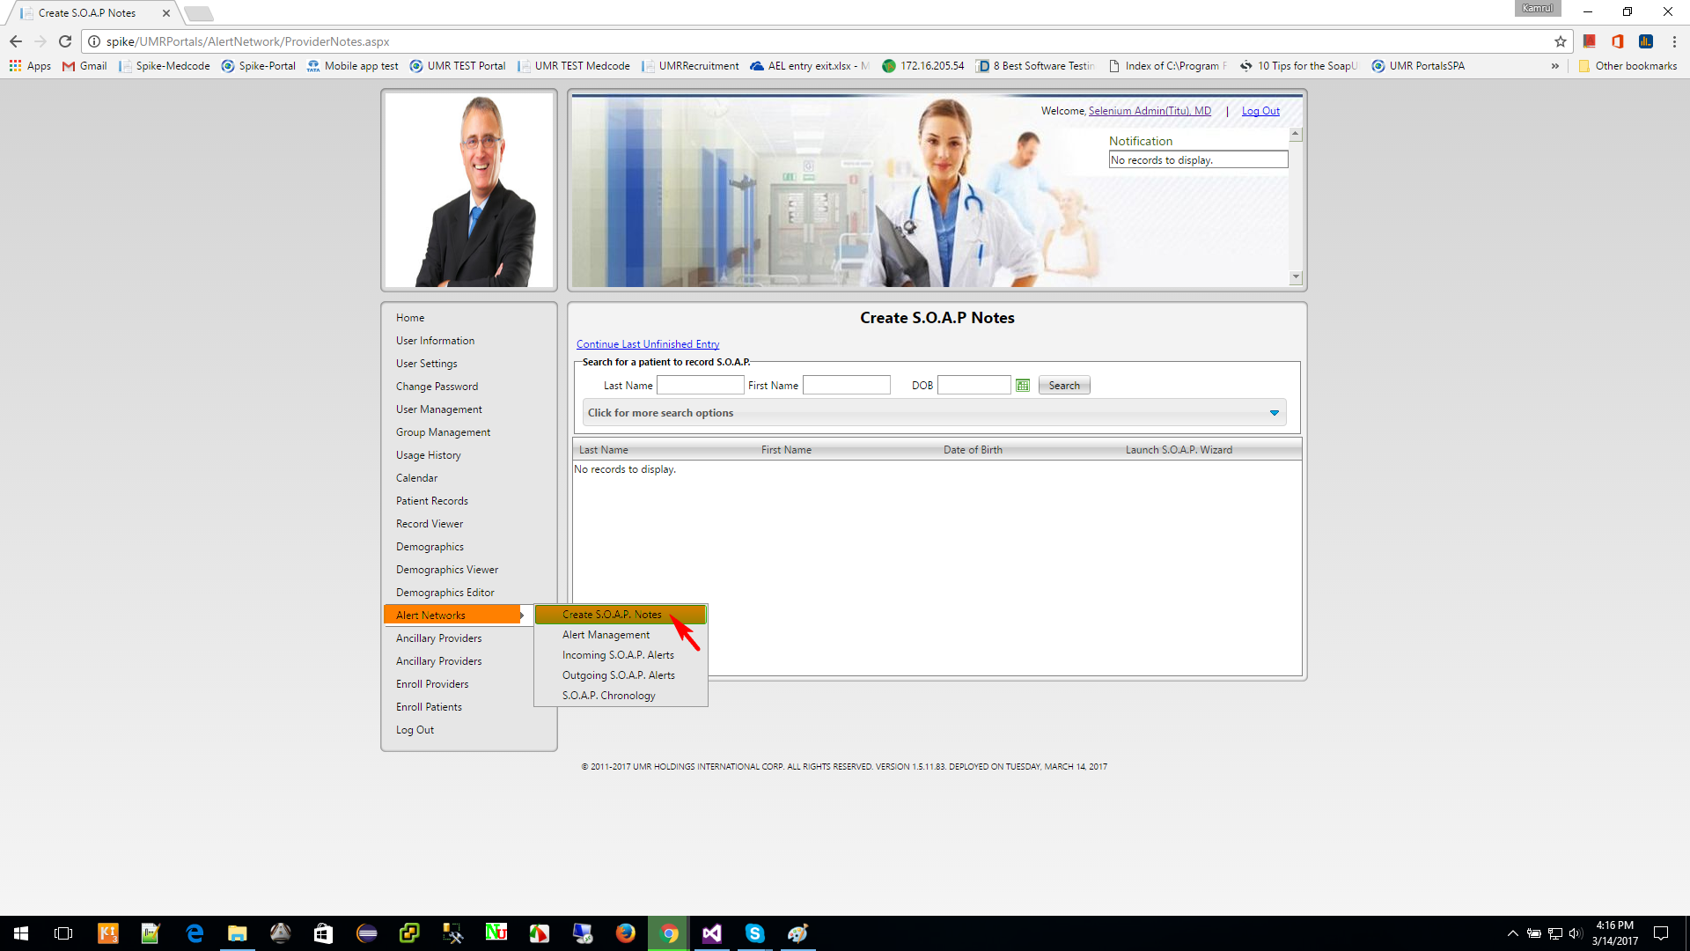

**(Image 18: Alert Networks >> Create S.O.A.P. Notes)**

**18.1)** [**http://umrtest.com/UMRPortals/AlertNetwork/AlertNetworkManagement.aspx**](http://umrtest.com/UMRPortals/AlertNetwork/AlertNetworkManagement.aspx)

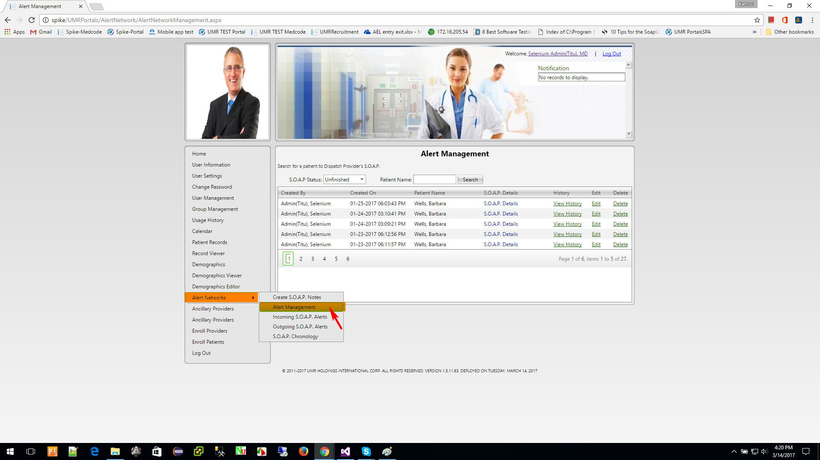

**(Image 18.1: Alert Networks >> Alert Management)**

**18.1.1)** [**http://umrtest.com/UMRPortals/AlertNetwork/AlertNetworkManagement.aspx**](http://umrtest.com/UMRPortals/AlertNetwork/AlertNetworkManagement.aspx)

[**http://umrtest.com/UMRPortals/AlertNetwork/ViewProviderSoap.aspx?AlertId=171063**](http://umrtest.com/UMRPortals/AlertNetwork/ViewProviderSoap.aspx?AlertId=171063)

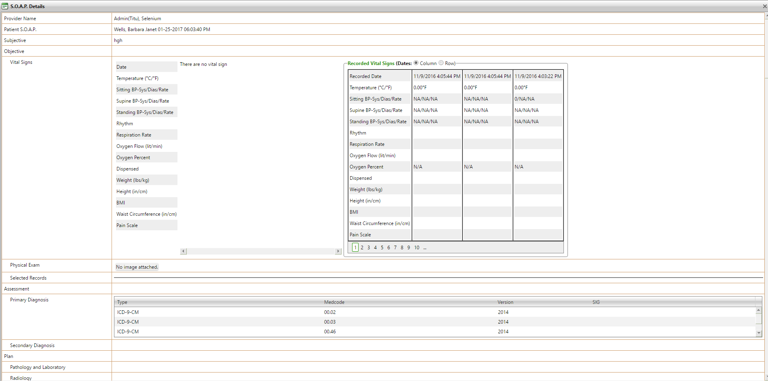

**(Image 18.1.1: Alert Networks >> Alert Management – S.O.A.P. Details)**

**18.1.2)** [**http://umrtest.com/UMRPortals/AlertNetwork/AlertNetworkManagement.aspx**](http://umrtest.com/UMRPortals/AlertNetwork/AlertNetworkManagement.aspx)

[**http://umrtest.com/UMRPortals/AlertNetwork/AlertHistory.aspx?AlertId=171063**](http://umrtest.com/UMRPortals/AlertNetwork/AlertHistory.aspx?AlertId=171063)

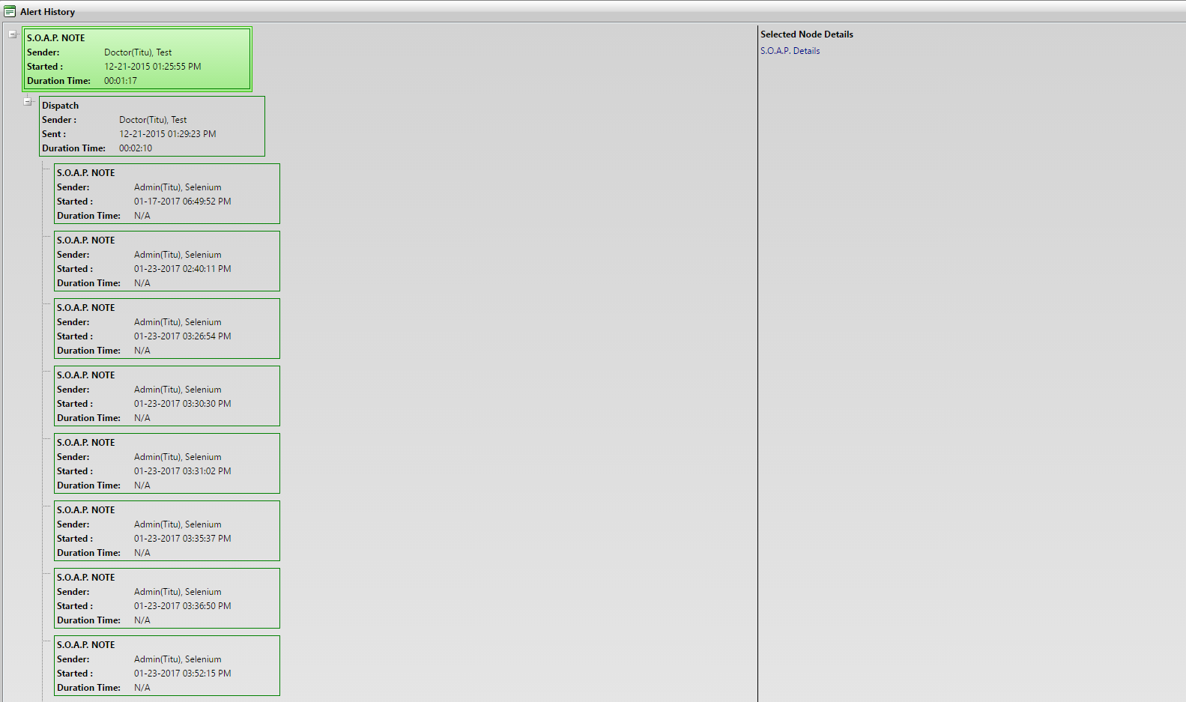

**(Image 18.1.2: Alert Networks >> Alert Management - View History)**

**18.1.3)** [**http://umrtest.com/UMRPortals/AlertNetwork/AlertNetworkManagement.aspx**](http://umrtest.com/UMRPortals/AlertNetwork/AlertNetworkManagement.aspx)

[**http://umrtest.com/UMRPortals/AlertNetwork/Dispatcher.aspx?AlertId=171063**](http://umrtest.com/UMRPortals/AlertNetwork/Dispatcher.aspx?AlertId=171063)

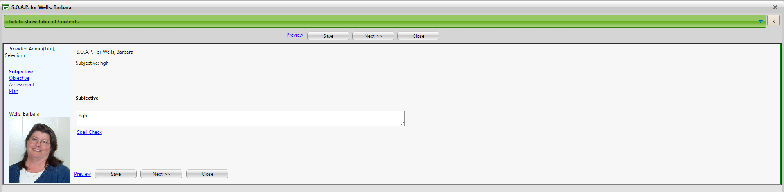

**(Image 18.1.3: Alert Networks >> Alert Management - Edit)**

**18.2)** [**http://umrtest.com/UMRPortals/AlertNetwork/IncomingAlert.aspx**](http://umrtest.com/UMRPortals/AlertNetwork/IncomingAlert.aspx)

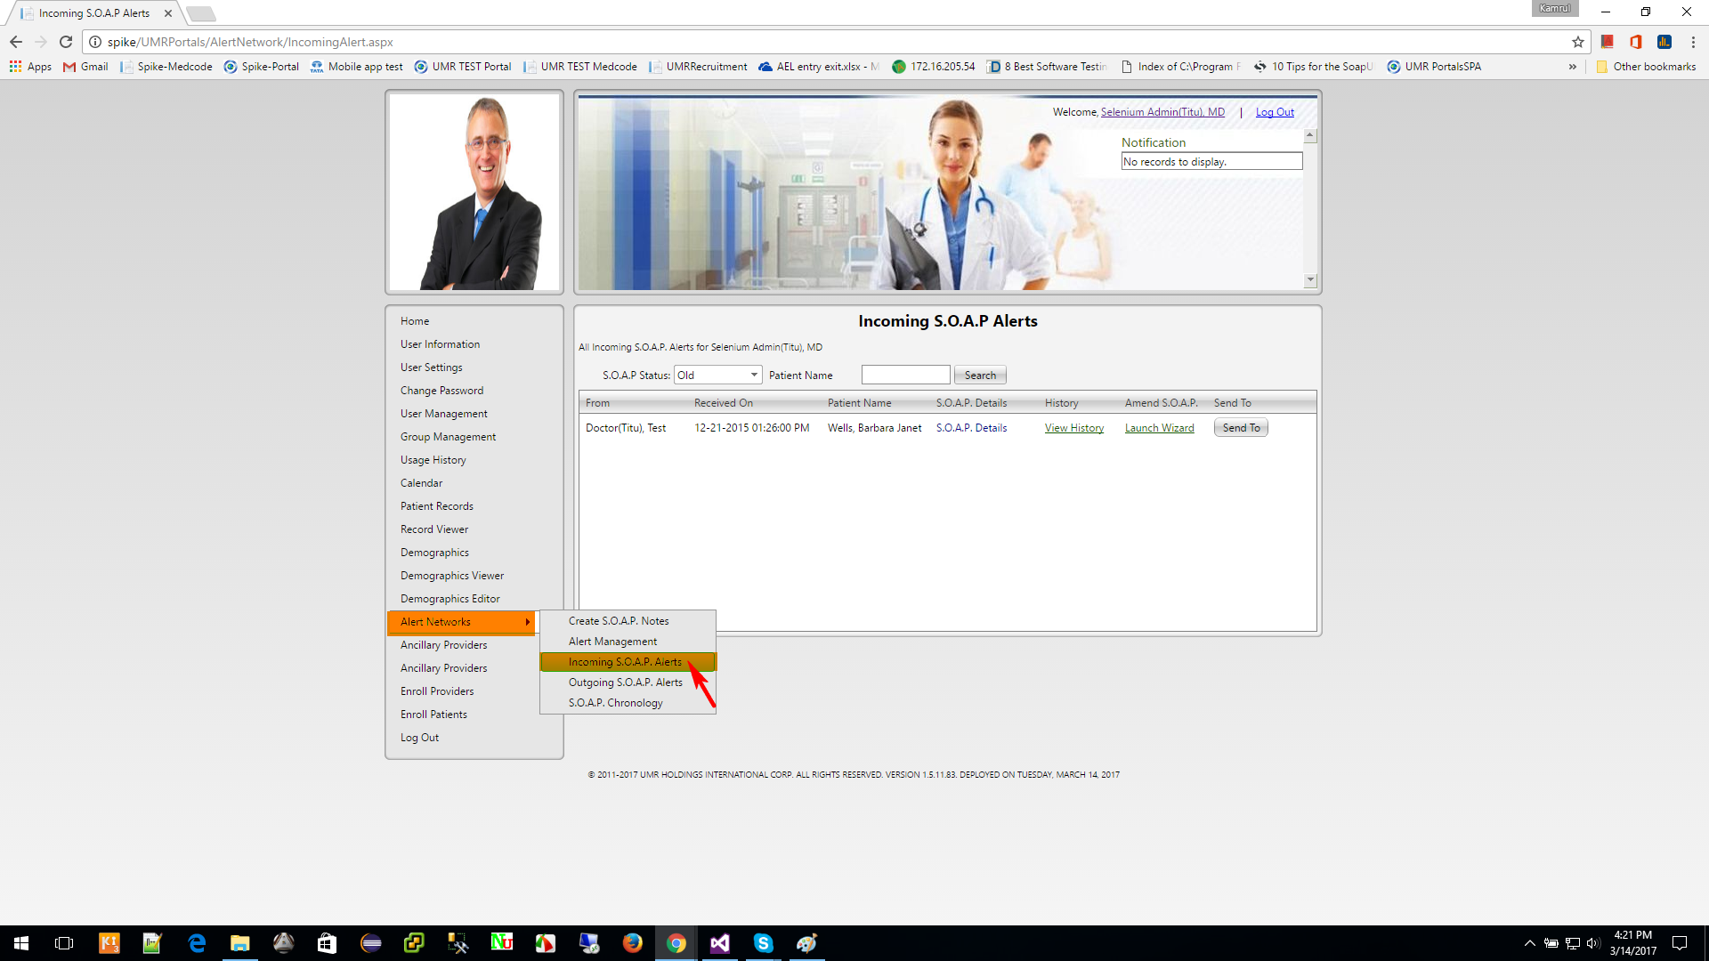

**(Image 18.2: Alert Networks >> Incoming S.O.A.P. Alerts)**

**NOTE: Other links are related to Create SOAP (Image 13.2 (1 to 7) And (Image 18.1.2: Alert Networks >> Alert Management - View History)**

**18.3)** [**http://umrtest.com/UMRPortals/AlertNetwork/OutgoingAlert.aspx**](http://umrtest.com/UMRPortals/AlertNetwork/OutgoingAlert.aspx)

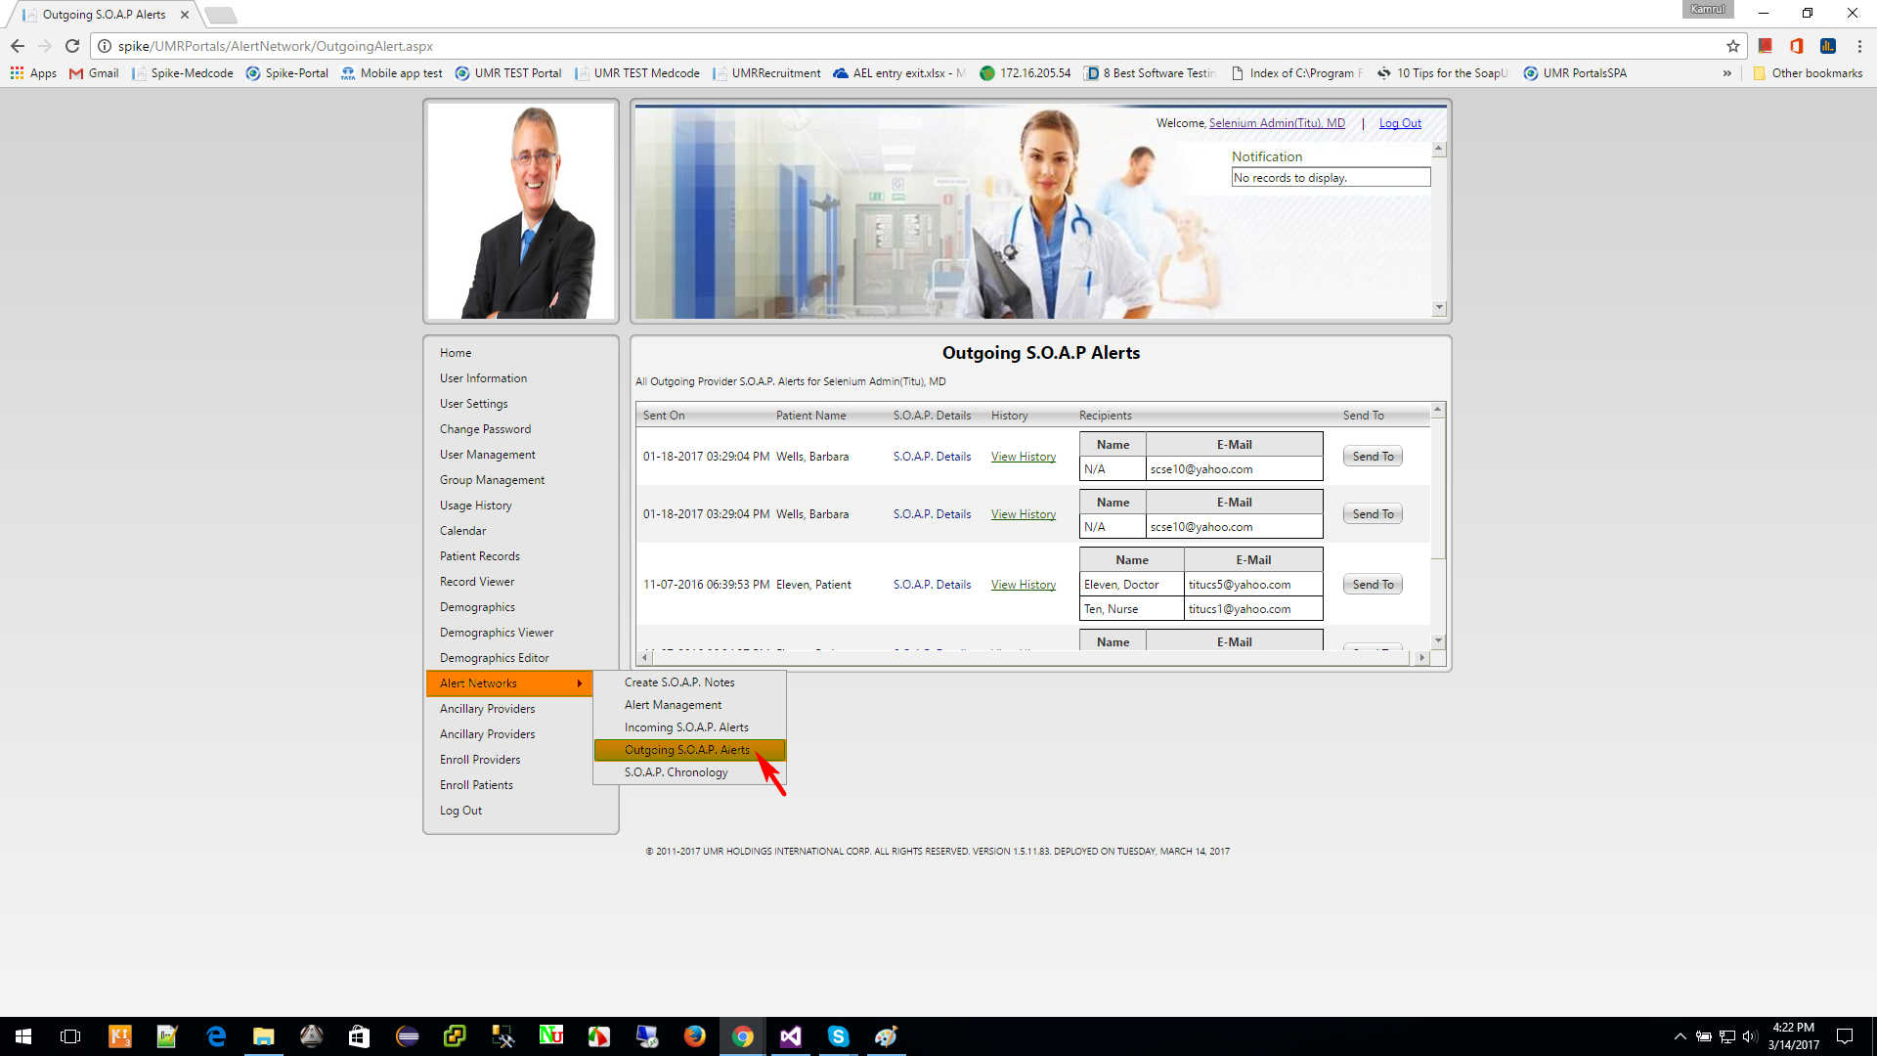

**(Image 18.3: Alert Networks >> Outgoing S.O.A.P. Alerts)**

**NOTE: Other links are related to Create SOAP (Image 13.2 (1 to 7) And (Image 18.1.2: Alert Networks >> Alert Management - View History)**

**18.4)** [**http://umrtest.com/UMRPortals/AlertNetwork/AlertChronology.aspx**](http://umrtest.com/UMRPortals/AlertNetwork/AlertChronology.aspx)

[**http://umrtest.com/UMRPortals/AlertNetwork/AlertChronologyList.aspx?PatientKey=3**](http://umrtest.com/UMRPortals/AlertNetwork/AlertChronologyList.aspx?PatientKey=3)

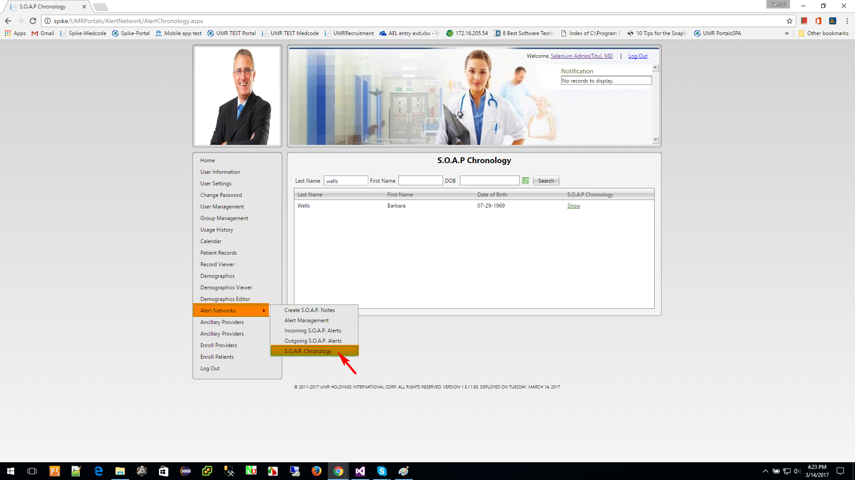

**(Image 18.4: Alert Networks >> S.O.A.P. Chronology)**

**18.4.1)** [**http://umrtest.com/UMRPortals/AlertNetwork/AlertChronology.aspx**](http://umrtest.com/UMRPortals/AlertNetwork/AlertChronology.aspx)

[**http://umrtest.com/UMRPortals/AlertNetwork/AlertChronologyList.aspx?PatientKey=3**](http://umrtest.com/UMRPortals/AlertNetwork/AlertChronologyList.aspx?PatientKey=3)

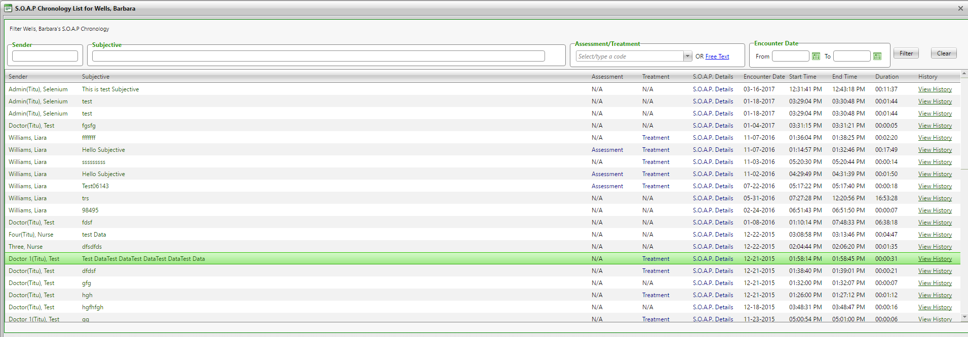

**(Image 18.4.1: Alert Networks >> S.O.A.P. Chronology - List)**

**NOTE: Other links are related to Create SOAP (Image 13.2 (1 to 7) And (Image 18.1.2: Alert Networks >> Alert Management - View History)**

**19)** [**http://umrtest.com/UMRPortals/PatientFeatures/PatientSecondUserMgt.aspx**](http://umrtest.com/UMRPortals/PatientFeatures/PatientSecondUserMgt.aspx)

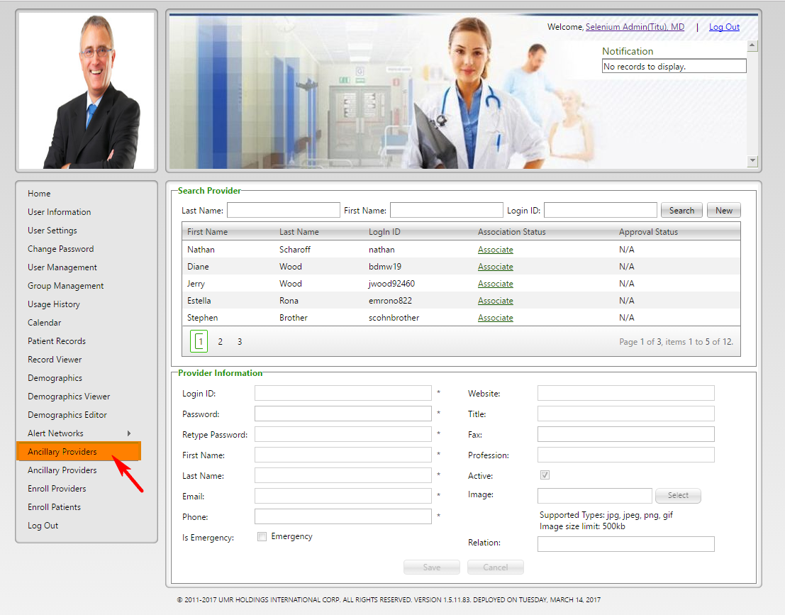

**(Image 19: Patient's Ancillary Providers)**

**20)** [**http://umrtest.com/UMRPortals/Administrative/ManageSecondaryUser.aspx**](http://umrtest.com/UMRPortals/Administrative/ManageSecondaryUser.aspx)

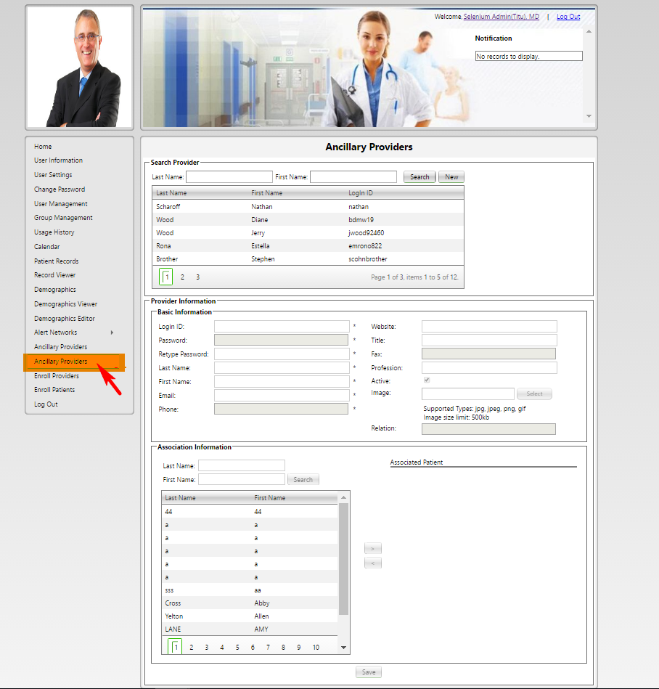

**(Image 20: Admin's Ancillary Providers)**

**21)** [**http://umrtest.com/UMRPortals/Administrative/SignUpAprroval.aspx**](http://umrtest.com/UMRPortals/Administrative/SignUpAprroval.aspx)

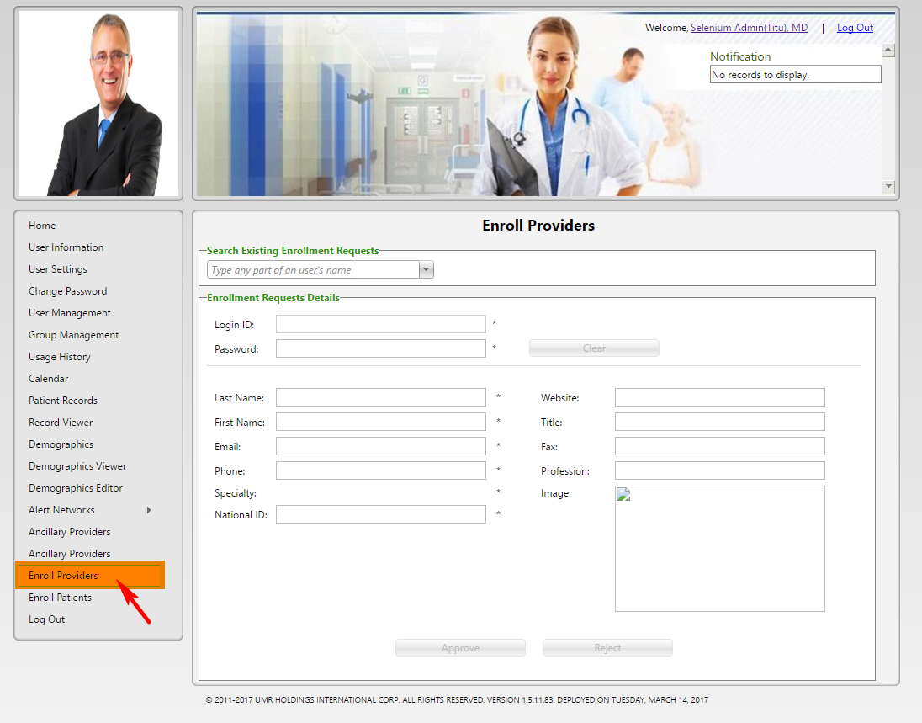

**(Image 21: Enroll Providers)**

**22)** [**http://umrtest.com/UMRPortals/Administrative/SingUpApprovalPatient.aspx**](http://umrtest.com/UMRPortals/Administrative/SingUpApprovalPatient.aspx)

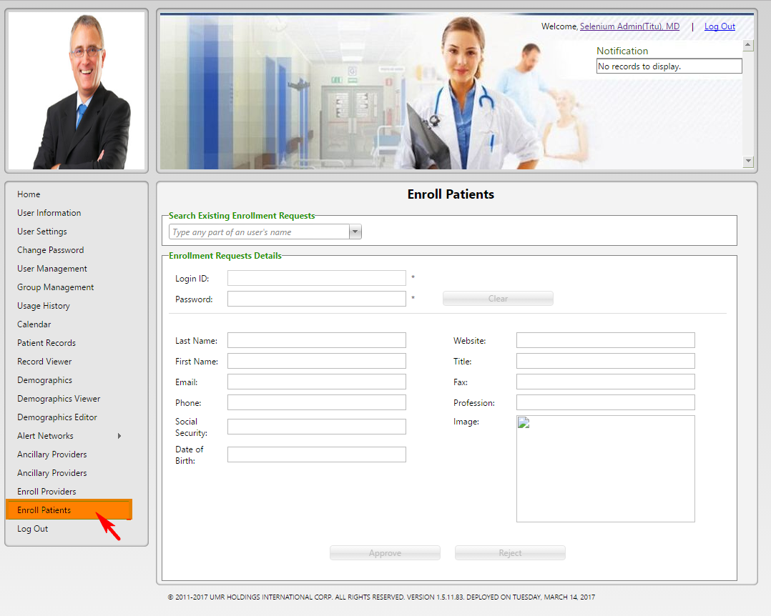

**(Image 22: Enroll Patients)**